Personal Time Capsule Pyramid

- Trace and cut out pyramid from posterboard.
- On the first triangle inside, write the timeline of your life with at least 5 events.
- On the next triangle, write about your family, either immediate or extended.
- On the next triangle, write about your friends, both the ones you have now and possibly friends from your past.
- On the last triangle, write about what you think you will be doing in ten years from now. Mention job, family, where you will be living, etc.
- Then, on the square in the middle, create a work of art. You can draw, paint, or collage. The work of art should tell more about who you are.
- Collect some small artifacts that can be saved inside your time capsule. Possibilities could be a key ring, a gum wrapper, a photo, a newspaper clipping, a CD, even a small flash drive. You could also include broken jewelry, business cards, small toys, etc.
- Fold and use the tabs to close and glue your pyramid. Insert a string on the top attached to a paper clip inside. Cover well with duct tape.

- Cover the pyramid with wallboard mud, or possibly plaster. You can create some interesting textures, if you like. Leave the bottom uncovered or cover it when the rest has dried. This process may take several days.
- Paint the dry surface with watercolors or acrylic paints.
- On the bottom, write your name and the date, in ten years, that you would like to open this time capsule. That may be exactly 10 years from today, or it may be a special day like a birthday or New Year’s.
- Put in a safe place, away from small children and pets. You could use the string to hang your pyramid. Open in 10 years and enjoy the time travel memories!

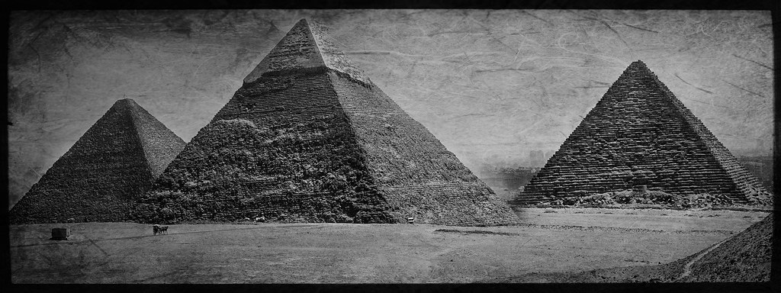

"Giza Pyramids" by Tim Moffatt is licensed under CC BY 2.0
Altered by Helen Nagan

