Fencing Your Property
POSSIBLE SOLUTION:
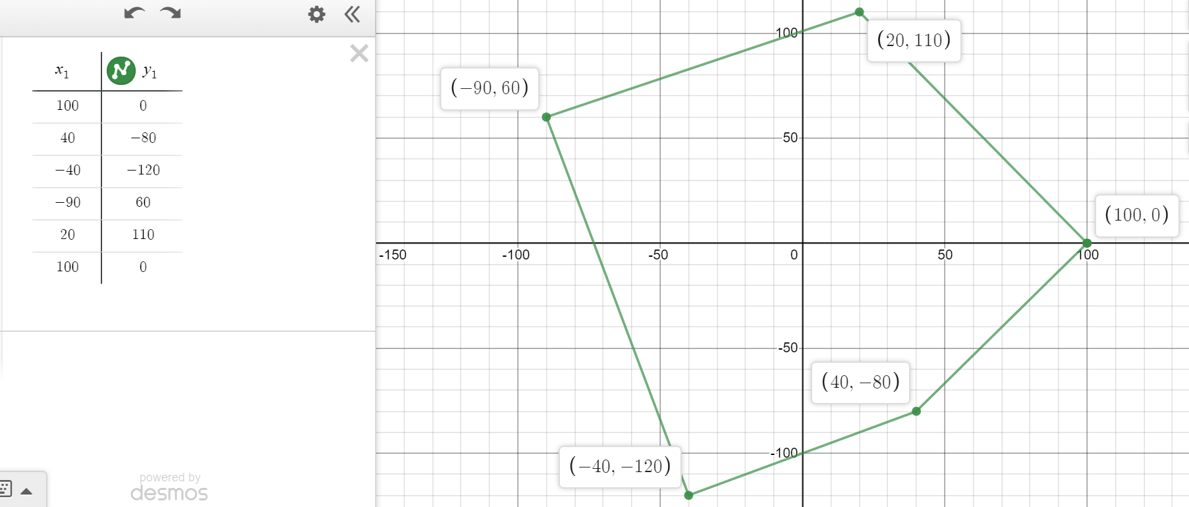
Perimeter (individual distances rounded to hundredths as calculations are done): 633.1 ft
Fence Masters: 633.1(12) = $7,597.20
Good Neighbor Fencing: 200 + (633.1-100)14 = $7,663.40
Fence Masters has the better price.

