How to set up Grade Sync from Canvas to Power Teacher Pro
- Using the Edge or Chrome browser
- Open Canvas 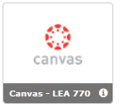
- Click on the course card that you would like to sync grades
- Click on Assignments (left side)
- Click on the ellipsis or “hotdog” menu at the top right beside the + Assignment button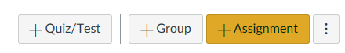
- Select - Import Assignment Groups
- Click Add 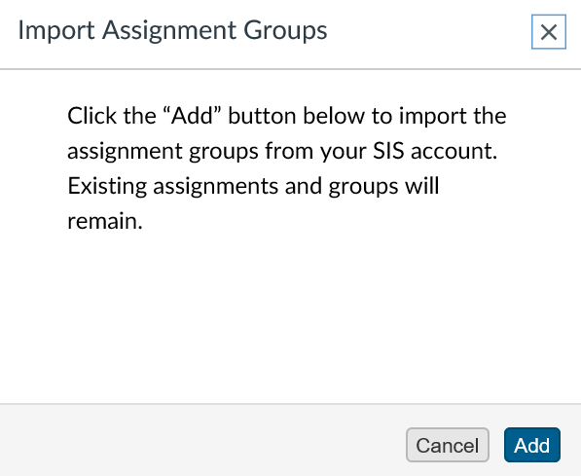
- You will see a notification at the top -
You MUST refresh your page (several times). It could also take a few minutes to populate.
- The Assignment Groups “categories” will have an import symbol beside the title
*All the contents from the old groups will need to be moved to the Assignment groups that will sync to PTP

- . Click on the ellipsis or “hotdog” menu at the end of the original group and select MOVE CONTENTS
- Select the category or Assignment Group you would like to the contents into and click the yellow MOVE button
- All the contents will move to a PTP category.
You will need to delete the old/original group by clicking on the ellipsis or “hotdog” menu at the end of the original group and select delete. ONLY after you’ve moved the contents.
- Click on the left and select Sync at the top
- From the Sync tab, you may select for Everything or Certain items to sync daily. For the grades to sync automatically, check the daily sync box and select save. Last, select Submit.
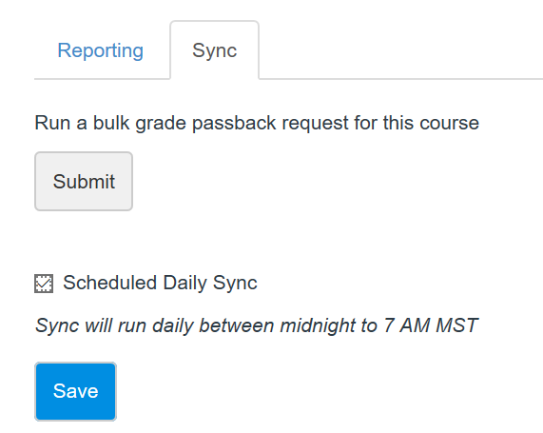

Images:
https://support.microsoft.com/products/windows
Unknown - Google Inc. http://www.google.com/press/images.html

