Flipgrid

Flipgrid is a tool that allows students to add simple video responses on to a common page. Go to www.flipgrid.com to Sign up or Sign In.
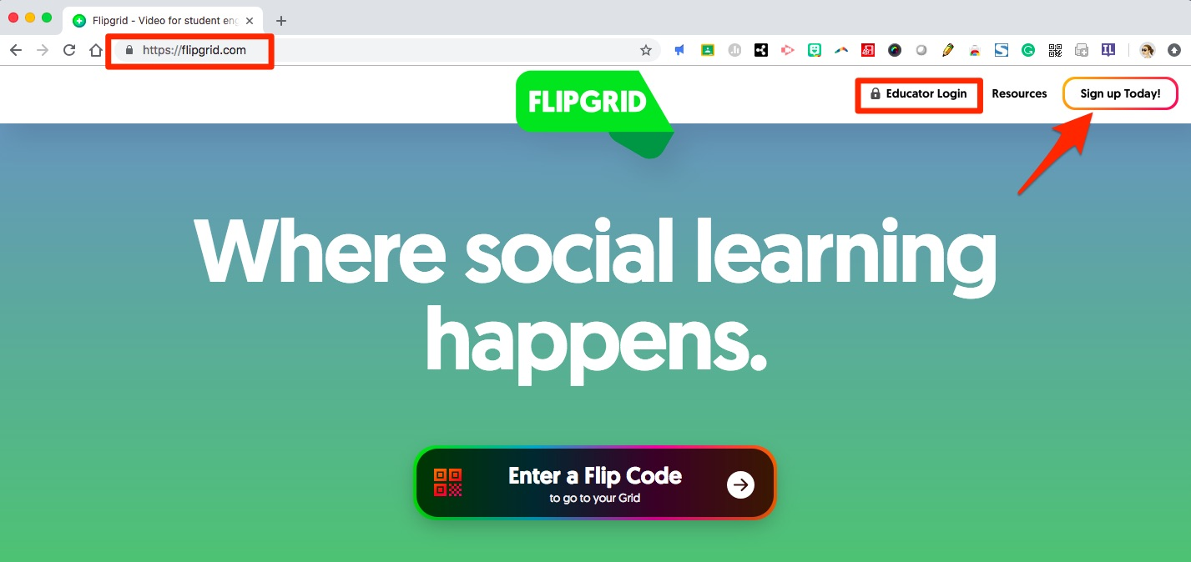
Sign up for a FREE account and then use the Educator Login with your Google credentials to access their site.
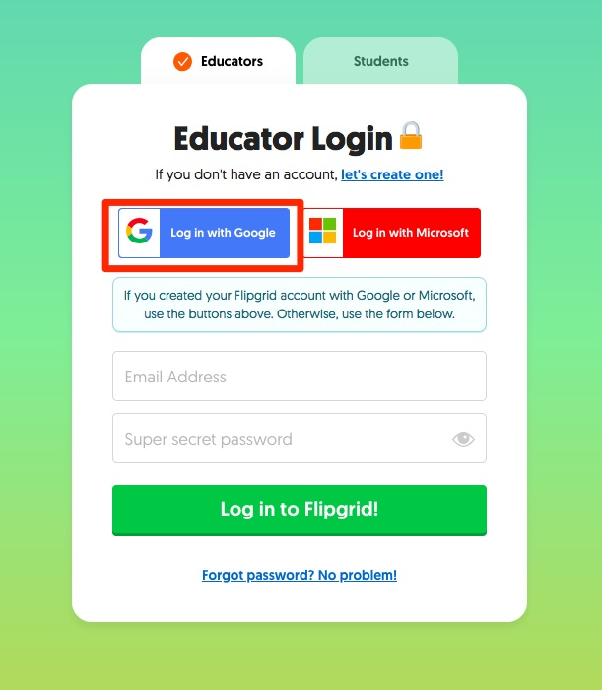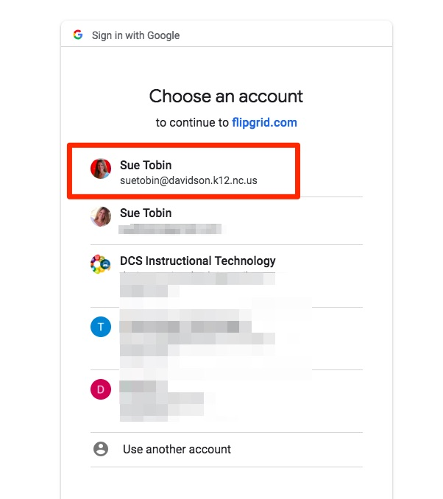
Start by adding a Grid - this is like your class or audience. Topics will be added under the grid.
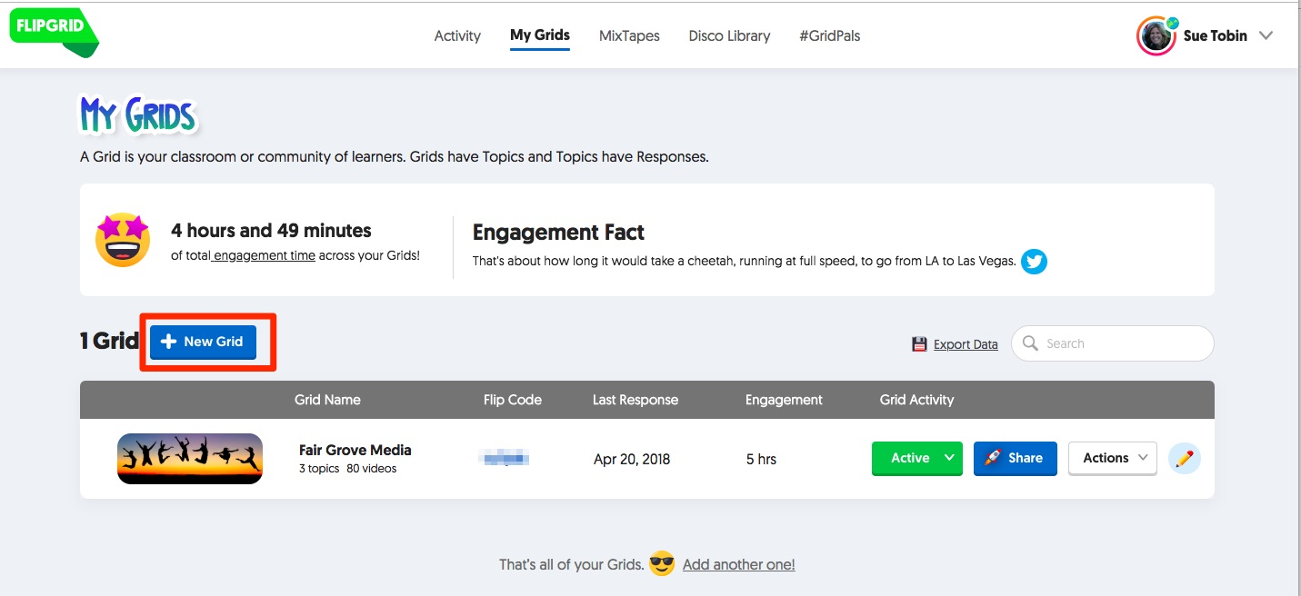

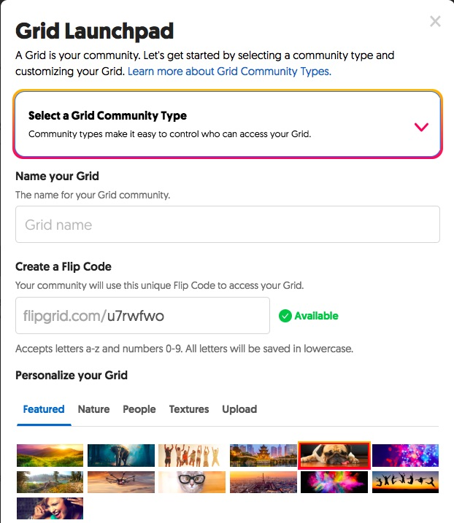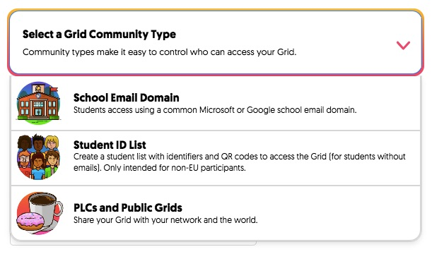

- Select a Community type. This is determining who will access your grid and how they will get there. For students, it is best to use the School Email Domain.
- Name your grid. This could be your name or a subject like math, language, social studies.
- Determine your Flip Code. You can use the auto-generated code or personalize one to fit your needs.
- Choose your background scene to personalize your grid.
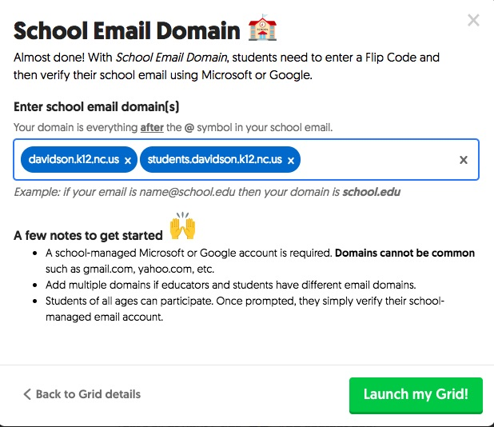

If you chose “School email domain” as your community type, you will be asked to enter the domain. Make sure you include the proper student domain (e.g.,students.davidson.k12.nc.us).
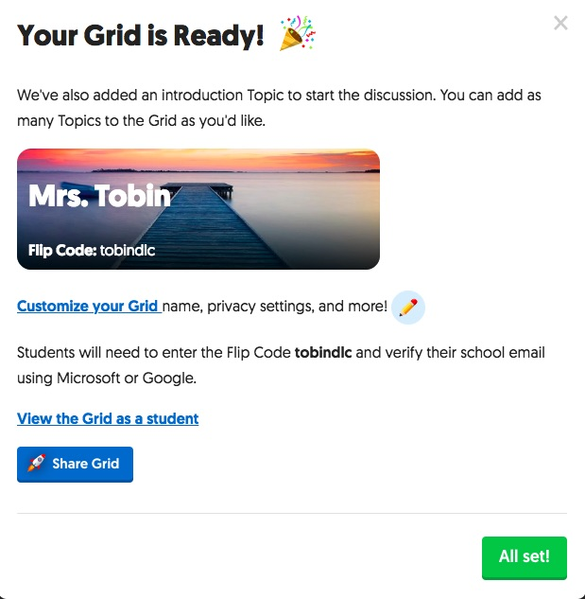

When your grid is ready you will see this message and links to go back and customize your grid, view it as a student or share it!

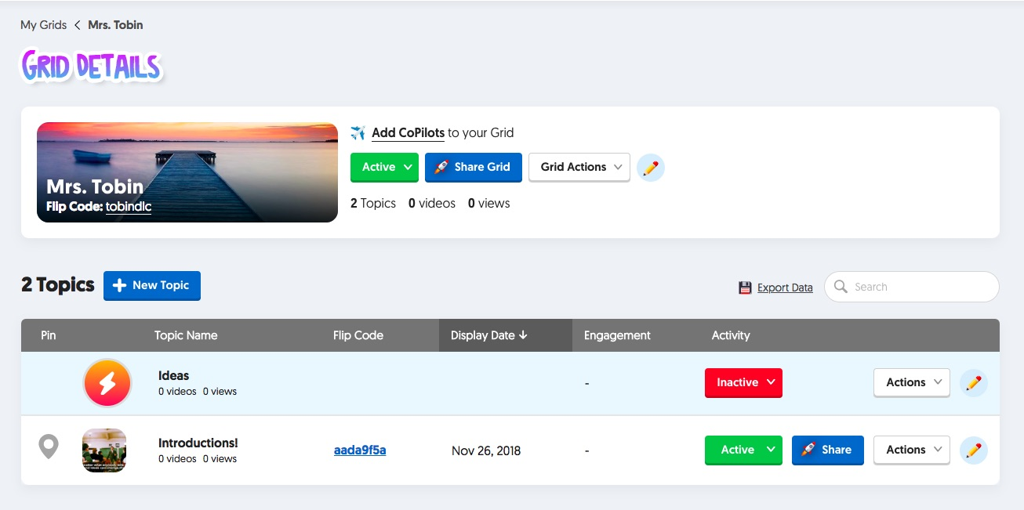
Once my grid has been created I can start creating topics! You may notice that 2 topics are already under my new grid. These are default topics named Ideas and Introductions.
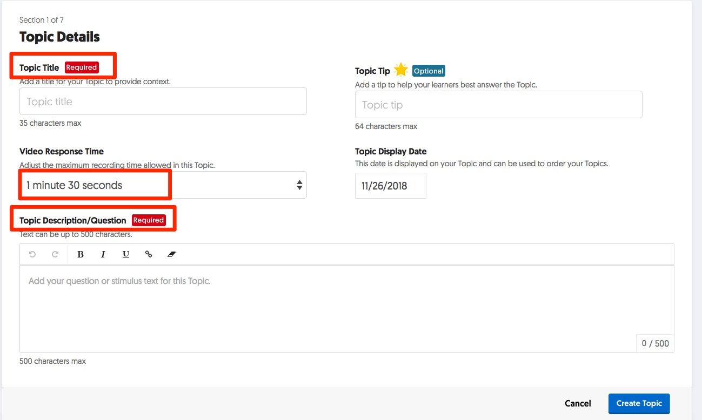
Once you add a topic, you need to name it and add a short description. Video clip response times range from 15 seconds to 5 minutes in length.

While the only REQUIRED information to create a topic is the Title and Description, if you scroll down you will notice 6 more sections that allow more specific controls set which include: Privacy, Status, Resources, Attachments, Video Features and Feedback.
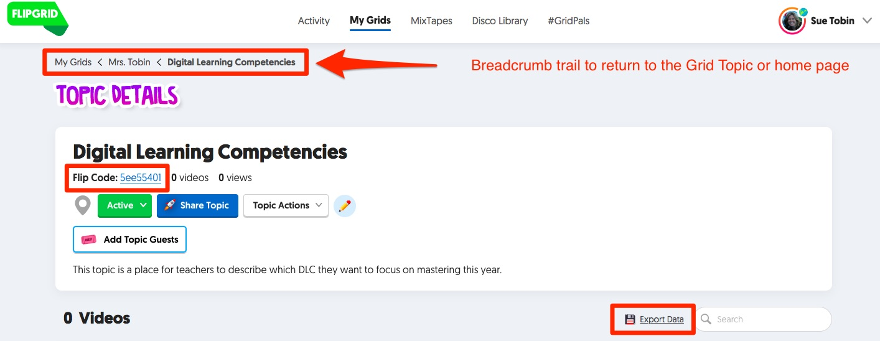
Once your topic has been created you can see the FlipCode and navigate back through the breadcrumb trail to go back to your Grid page or your home page.
Student Guide
For students/users to go to a topic they will simply go to the www.flipgrid.com home page and instead of logging in, enter the code in the center of the page.
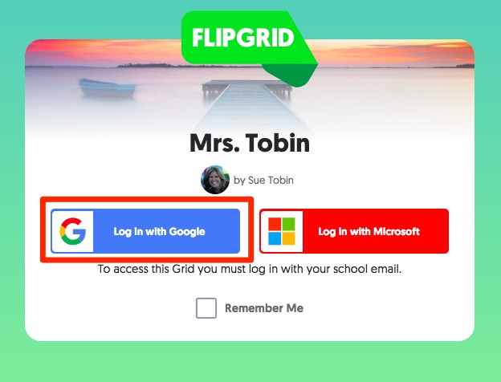

Students will be prompted to login with their Google accounts and select their account or enter their credentials just like teachers do when they login.
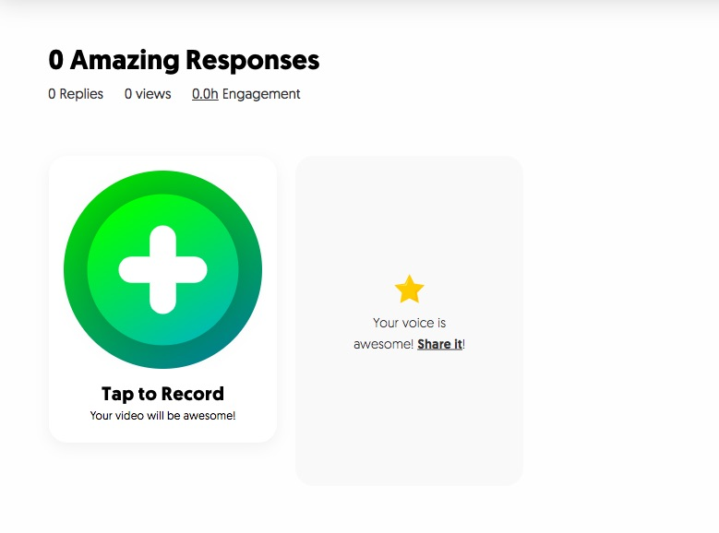

Once logged in, the student will click on the giant green plus sign to begin recording. If other students have already recorded, videos can be seen on this same screen.

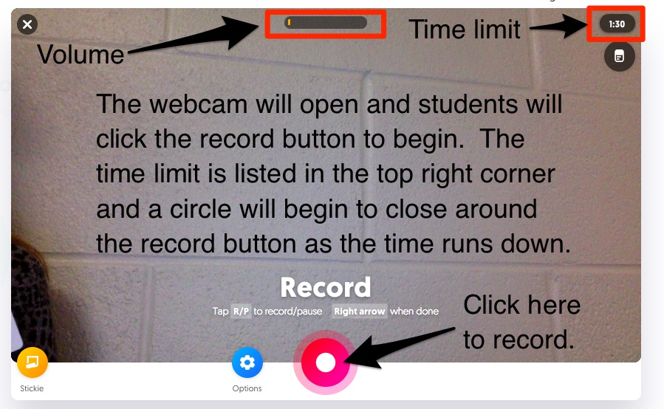

Screenshots taken by Sue Tobin from the
Flipgrid platform per terms.

