Using Google My Maps
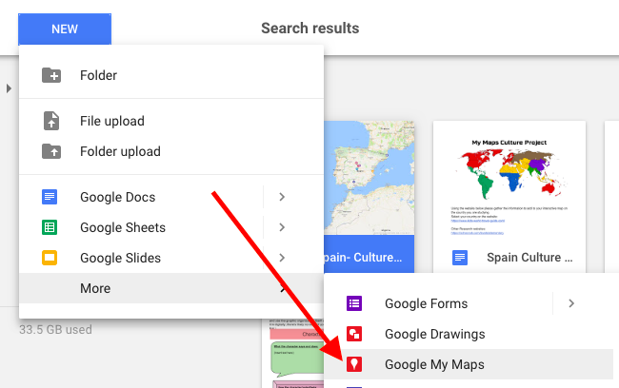

- Getting started
- Click the Waffle
- Open Google Drive
  - Click New
  - Click More
  - Select “Google My
Maps”

- Title your map
- Click on “Untitled map” to enter your title and a description for your map
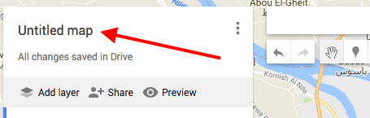

- Set default view (this is the automatic view when viewing your map)
- Search the country/general area you are wanting to use for your map
- Zoom in/out or drag your view if needed
- Once correct, click the three dots and select “Set default view”
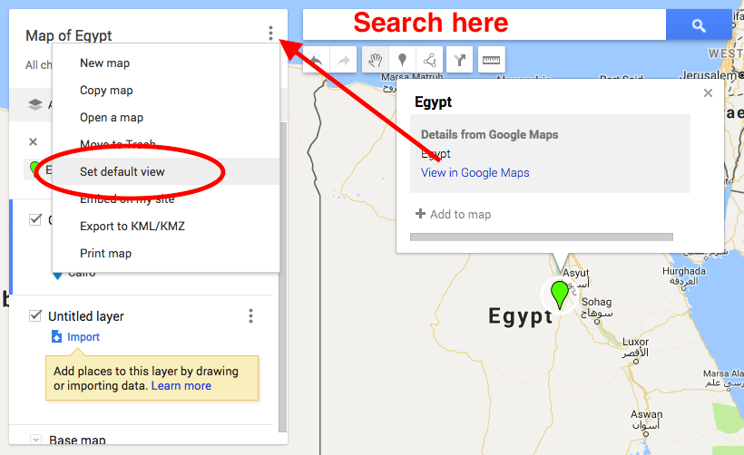

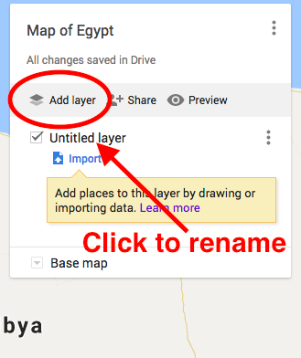

- Title/add your “layers” (layers identify or group your pins based on given criteria)
- Click “Untitled layer”
- Rename the layer and click “Save”
- Select “Add layer” to create another

- Create pins
- Search for the city/place
- Click “Add to map”
- Click on the Pin to edit the place marker by adding a description, pictures, or video related to that area (use the Google image search to easily add visuals to your map)
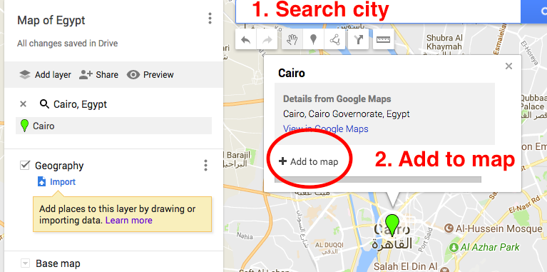
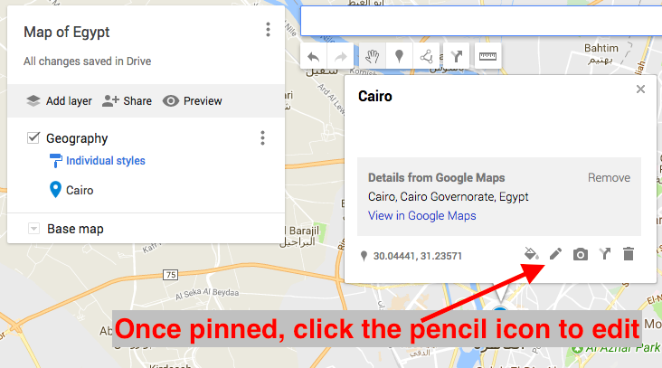

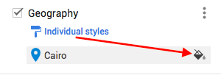
Editing your icons and pinned locations

After pinning your location, you can select the paint bucket to change the color of the pin icon. This helps to easily identify different types of places.

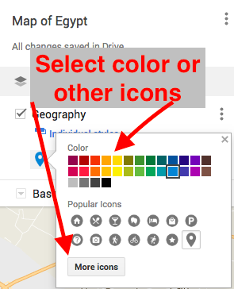

Select different colors or icons from
the menu. See what a completed
map looks like here.

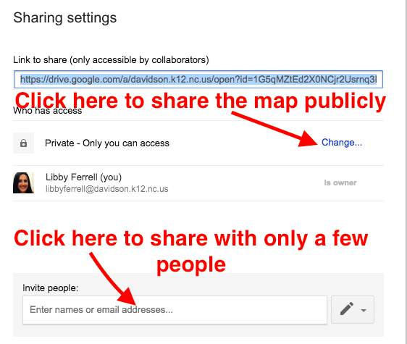

Notes about Sharing My Maps
- Any map you create using Google My Maps is automatically stored and saved in your Google Drive
- These maps, just as other files you create in Google Drive are PRIVATE until you change the sharing settings
- The simplest way to share these maps is by locating the map in your Drive, right-clicking on the map and selecting the “Share” option
- Choose the appropriate settings, click save, and copy the URL link to share your map

Other helpful tips for using Google My Maps

Click “Preview” once you are ready to view your map.

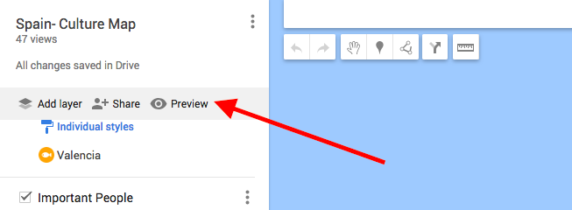

While navigating to different places on the map, you may wish to return to the map’s default view (how it is displayed when you first access it).

Follow these steps to return to the map’s default view:

