Family Letter
Learning to Tell Time

Dear Family Members,

During the week of <date> we will be starting a new math unit focused on telling time. The purpose of this letter is to give you some background information about our new unit.

Focus of the Unit
Our goal in second grade for telling time is to read analog and digital clocks to five minutes. In second grade we build on what students learned in first grade, writing and telling time to the hour and half-hour.
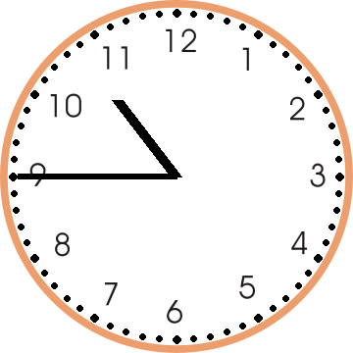
Strategies that Students Will Learn
In class students will work with telling and writing the time. They will learn to read the hour hand first and then the minute hand. Telling time to the nearest five minutes is the goal for second graders. One concept that’s difficult for many second graders is learning to read the hour hand when it is very close to the next hour. In this clock example, many students would look at the hour hand and read it as ll:45 instead of 10:45. We will talk about the passage of time and how the hour hand moves closer to the next hour as time passes. Another important time concept addressed will be a.m. and p.m.

Ideas for Home Support
At home you can talk with your child about activities he/she does in the a.m. and p.m. Talk about times that your family needs to be places such as school, sports practice, music practice, play date, etc. Use the attached clock and have your child place the clock’s hands in the appropriate place for the time you are discussing. After placing the hands correctly, write the time.

It is helpful for your child to see both analog and digital clocks. Look at a digital clock, say the time, and then using the attached clock have your child place the clock’s hands correctly. You can tell your child a time and have him/her place the hands correctly on the paper clock.

Please let me know if you have any questions about how to help your child tell time. Thank you for serving as partners in your child’s success as a mathematician!

<signature>

Cut out the blue and red clock hands. Place these arrows in the correct position.

