Arrays in Our Classroom
In this lesson, students create arrays to solve a problem within a real-life context and write repeated addition equations that represent the arrays they have created.

NC Mathematics Standard(s):
Operations and Algebraic Thinking
NC.2.OA.4 Use addition to find the total number of objects arranged in rectangular arrays with up to 5 rows and up to 5 columns; write an equation to express the total as a sum of equal addends.

Additional/Supporting Standards:
Number and Operations in Base Ten
NC.2.NBT.5 Fluently add and subtract within 100 using strategies based on place value, properties of operations, and/or the relationships between addition and subtraction.

Standards for Mathematical Practice:
- Make sense of problems and persevere in solving them.
- Reason abstractly and quantitatively
4. Model with mathematics

Student Outcomes:
- I can create an array using objects.
- I can write a repeated addition equation to show the total amount of objects in an array.
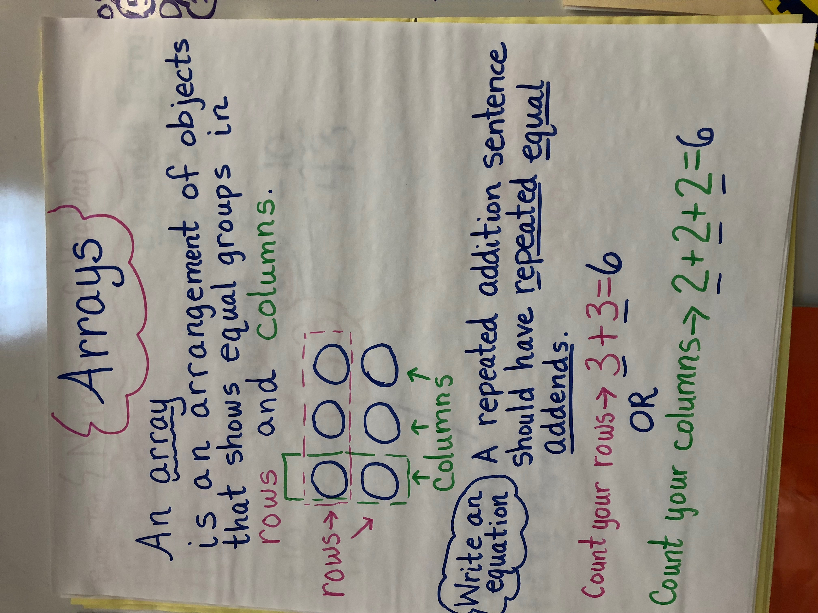
Math Language:
- array
- column
- row
- repeated addition
- equation

Materials:
- a muffin tin or another real-life array
- anchor chart (like the example to the right)
- math manipulatives such as counters, inch tiles, etc. for students to model the chair problem with arrays
Advance Preparation:
- Anchor chart showing previously taught vocabulary, what an array looks like, and how to write a related equation for the array that uses repeated addition.
- During the explore part of the lessons, choose student solutions strategically to share during the discussion.

Launch: (5 minutes)
Show students a muffin tin (or egg carton or candy carton or other real-life array). Ask them: What do you notice about the tin and how the muffin cups are arranged? (rows and columns, there are 12, they are organized, it makes a pattern) Can you think of any other examples in which things are organized in rows and columns? Does this remind you of a math term you know? They should identify it as an array, but if they do not, briefly identify this pattern as an “array” formed with columns and rows.

Introduce the task:
Our parents are coming to see our science fair presentation (You can change the situation to fit your class.) and we want to arrange our chairs in an array for them to sit in. We have 18 chairs to set up. Work with your partner to determine how we should arrange the chairs.

Explore: (15 minutes)
Students will work with a partner to create arrays that show possible ways to organize chairs for their parents. Allow time for students to explore with manipulatives and/or draw out their arrays before writing their equations. Say: You may use our math manipulatives to explore how we can make an array out of 18 chairs. Draw your arrays to show how you think we should set up the chairs. Once you have drawn your arrays, write an equation to represent the sum of chairs in each array.

Observe: How are students organizing their thinking and arranging how to arrange objects into an array? Check with partners as they create their arrays with questions such as:
- Can you tell me why you decided to arrange your array this way?
- Will you describe this array to me?
- Are there other arrays you tried that I haven’t seen?
- Which of these arrays do you think would work best for our classroom? Why?
- How are these arrays similar? Different?
- Can you predict any problems with arranging the chairs this way?
- What does this equation represent?
- How did you come up with this equation?
- How could you write a different equation for the same array?
- What do you think your next step might be?
- What does this number mean in relation to the problem you’re solving?

Encourage early finishers to arrange 18 counters into a different array or to arrange another number such as 24 counters into an array.

Teacher Note: Watch and observe students as they arrange the counters into an array.

Observe and record:
- What are students doing as they arrange and rearrange arrays? Are they beginning with manipulatives, sketches or talking it through?
- Are they arranging them into equal rows and columns?
- Are they able to represent their array with a related repeated addition equation? Are they finding more than one equation for each array? Why or why not?

Carefully select students to share their arrays with the class. Select students who have solved the problem in different ways, as well as a student who can share non-example or an arrangement that didn’t work. For instance, a pair may have tried to put the chairs into rows of 4 and determined that this is not possible or another student pair may not have put the chairs into equal rows and columns.

Discuss: (20 Minutes)
Bring the class together and have selected partners share their work and thinking. Use the following questions to move the discussion along (you do not have to ask them all or in this order). Make decisions based on your observations from the explore section as well as what students share during the discussion.
Suggested Questions:
- How did you decide on this array?
- What do you notice about this array?
- What do you notice about how the array is arranged?
- How many rows does this array have?
- How many columns does this array have?
- How is this equation matched to the array? Are there other possible equations?
- How are the 2 equations for this array related?
- How many different arrays did we come up with? (For 18 chairs, there are 6 different arrays)
- How is _______’s array different than (or the same as) _________’s array?
- How does the array explain the total? How does the equation explain the total?
- Which array do you think would be the best for our classroom? Why?
Repeat similar questions with the other selected partner pairs and encourage students to identify patterns and draw conclusions. Build the discussion up to being able to explain how the arrays and the equations both represent the total number of chairs.

Evaluation of Student Understanding
Informal Evaluation: Observe and monitor students as they complete the task.
- How are they making sense of the task?
- Are they using mathematical vocabulary such as rows and columns as they complete the task?
- Are they arranging the counters into rows and columns?
- Do the equations show the sum using equal addends?

Formal Evaluation/Exit Ticket: Show students an array and have them write the 2 equations that show the sum using equal addends.

Meeting the Needs of the Range of Learners
Intervention:
Provide students with 10 cubes and have them arrange them in 2 rows that are the same length and have the same number of cubes in them. Guide the students in counting how many cubes are in each row to write an equation and then have them count the cubes in each column to write an additional equation.
Show additional examples of arrays in the classroom, such as cubbies, ceiling tiles, sides of baskets, and windows. Examine the rows and columns.

Extension:
- Have students explore making arrays for different numbers.
- Have students explore if any numbers only have 1 array that can be made (3, 5, 7, 11, 13, 17, 19, 23,…), whether it be a single row or a single column. These are prime numbers.
- Have students find what number of chairs can be arranged in a square-shaped array with equal rows and columns (4, 9, 16, 25…). These numbers are square numbers.

Possible Misconceptions/Suggestions:
Possible Misconceptions | Suggestions
Students do not arrange the objects in equal rows and columns when making arrays. | Directly teach students the concept of “arrays” using examples and nonexamples and having them explain that arrays must have equal-length rows and equal-length columns.
Students think they can write any equation that has the same sum. For instance:  6 + 6 + 6 is a correct solution for the array while 10 + 6 is not. | Show students that the addends all need to be the same number repeated, and that the numbers should match the rows and columns.

Array Solutions for 18:

****** 6 + 6+ 6=18 *** ********* 9+9=18 ** *
****** 3+3+3+3+3+3+3=18 *** ********* ** *
****** *** 2+2+2+2+2+2+2+2+2=18 ** * *** ** *
*** ** *
*** ** *
** *
** *
** *
* *
1+1+1+1+1+1+1+1+1+1+1+1+1+1+1+1+1+1=18 * * ****************** * *
*
*
*

Name__________________________________________
Arrays in Our Classroom
Our parents are coming to see our science fair presentation, and we want to arrange our chairs in an array for them to sit in. We have 18 chairs to set up. Work with your partner to determine how we should arrange the chairs. Draw arrays to show possible solutions and write repeated addition equations to show the total number of chairs that we have set up.

Name________________ Exit Ticket

Write 2 different equations to match the array.

*****
*****
*****
_____________________ ____________________
Equation 1 Equation 2

Name ______________ Exit Ticket

Write 2 different equations to match the array.

*****
*****
*****
_____________________ ____________________
Equation 1 Equation 2

