Is This an Array?
In this lesson, the students are analyzing arrangements of shapes and identifying whether or not they are arranged in an array. This lesson needs to be after the students have already learned the vocabulary associated with arrays and have worked with arrays.

NC Mathematics Standard:
Operations and Algebraic Thinking
NC.2.OA.4 Use addition to find the total number of objects arranged in rectangular arrays
with up to 5 rows and up to 5 columns; write an equation to express the total as a sum of
equal addends.

Standards for Mathematical Practice:
1. Make sense of problems and persevere in solving them.
2. Reason abstractly and quantitatively.
4. Model with mathematics.
5. Use appropriate tools strategically.

Student Outcomes:
- I can identify rows and columns of objects in an array.
- I can write a repeated addition equation that matches an array.
- I can add to find the total number of objects in an array.

Math Language:
array, rows, columns, vertical, horizontal, repeated addition, equation, sum, total, equal addends

Materials:
- error analysis pages--one per group
- pencil and eraser
- document camera to share work
- optional--manipulatives such as plastic bears

Advance Preparation:
- Sort students into small groups--each group will need a different error analysis page

Launch: (10 minutes)
- Students turn and talk: What do you know about arrays? (refer to anchor chart if you have one- see the example below)
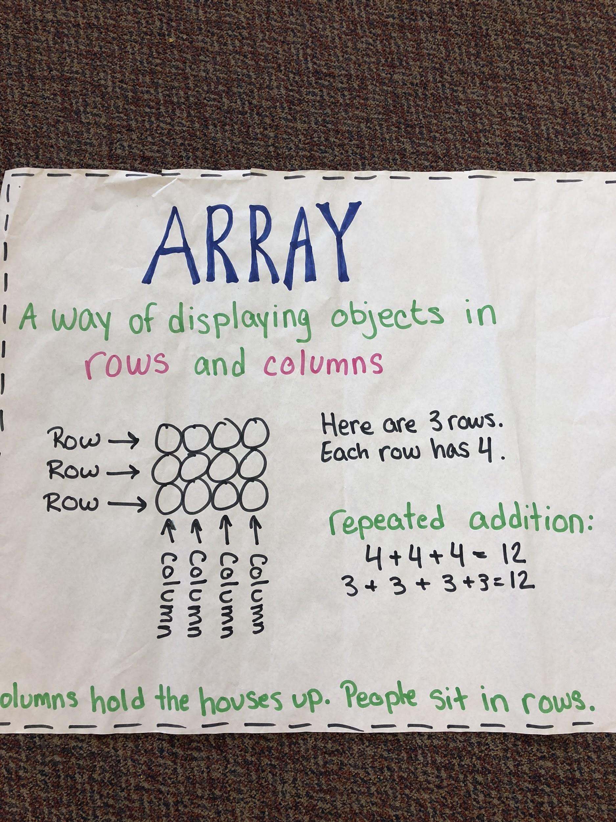

- Ask students to use their hands to show columns (up and down) and rows (left and right).
- Show students the array below using a projector or document camera. Turn and talk about what you notice about the array.
    - How many rows? How many objects in each row?
    - How many columns? How many objects are in each column?
    - How many total objects are there in the array?
    - What repeated addition equations match the array? Where did you get the numbers to repeat?

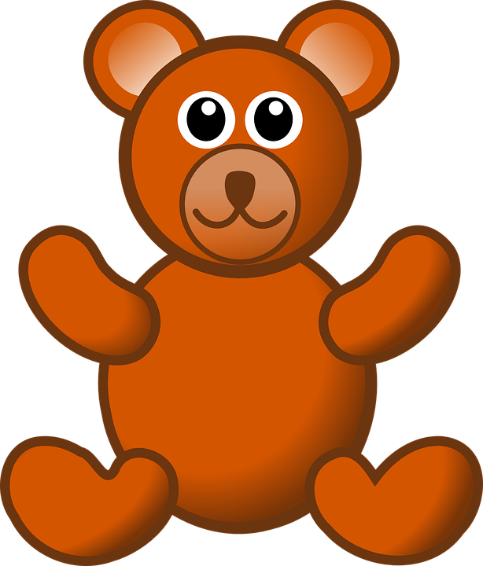

Explore: (10-15 minutes)

- Give each group an error analysis page and pencil.
- The students will work with a partner or in a small group to analyze the error on the page and correct it. Point out that they do not need to draw cars or dragons in their array since that might take a long time.

- The teacher will listen to the discussions of the groups and ask questions to assess understanding:
    - What do you notice about the array?
    - What mistake or error was made?
    - How can you fix the mistake?
    - What do you notice about the rows and columns of your array?
    - What repeated addition equations match your array?
    - Where did you get the addends for your addition equation?

Discuss: (10 minutes)
- Student groups will use the document camera to share their error analysis page. (Pre-select groups to share if several groups had the same analysis page).
- Students will explain the error they noticed and how they corrected the mistake.
- Students will share the repeated addition equations that match their array and explain how they got the equal addends.

Additional Activities (if needed)
- Independent page--Fix Scooter’s Array

Evaluation of Student Understanding
- The students may fix the arrays by adding or crossing out items as well as rearranging the objects they are given to make a new array.
- Make sure students are able to understand that repeated addition equations must match the number of rows and columns in the array.

Formal Evaluation/Exit Ticket:
- Show students the picture below. Students will need to write to explain why this picture is not an array. Give students a sticky note or index card and turn it in to the teacher.

Meeting the Needs of the Range of Learners

Intervention:
- Give students the number of plastic bears or other types of counters to match the number of objects in the picture on the error analysis page.
- Have the students use the counters to create a rectangular array.
- Discuss the number of rows and columns in the array that the student made.
- Identify the repeated addition equation that matches the array that the student made.

Extension:
- Pretend that you are the teacher. Design a lesson or activity to help this student understand the mistake they made so they won’t repeat it in the future.

Possible Misconceptions/Suggestions:
Possible Misconceptions | Suggestions
Students write an equation that has the same total of objects, but doesn’t match the array. | Have the students circle the rows and then write an equation to match what they have circled. Then do the same with the columns.

Error Analysis Page 1

Pugsley made an array with his cars. Then he wrote some equations to show the total number of cars in his array. What mistake did Pugsley make?
3 + 3 + 3 + 1 = 10

3 + 4 + 4 = 10

Show how you corrected Pugsley’s mistake here:

Error Analysis Page 2

Pugsley made an array with his cars. Then he wrote some equations to show the total number of cars in his array. What mistake did Pugsley make?
3 + 2 + 2 + 3 = 10

4 + 2 + 4 = 10

Show how you corrected Pugsley’s mistake here:

Error Analysis Page 3

Falcor made an array with his toys. Then he wrote some equations to show the total number of toys in his array. What mistake did Falcor make?
2 + 6 = 8

3 + 3 + 2 = 8

Show how you corrected Falcor’s mistake here:

Error Analysis Page 4

Falcor made an array with his toys. Then he wrote some equations to show the total number of toys in his array. What mistake did Falcor make?
2 + 3 + 3 = 8

3 + 2 + 2 + 1 = 8

Show how you corrected Falcor’s mistake here:

Additional Activity - Fix Scooter’s Array

Name: _______________________________

Scooter made an array with his cans of cat food. Then he wrote a repeated addition equation to show the total number of cans in his array.

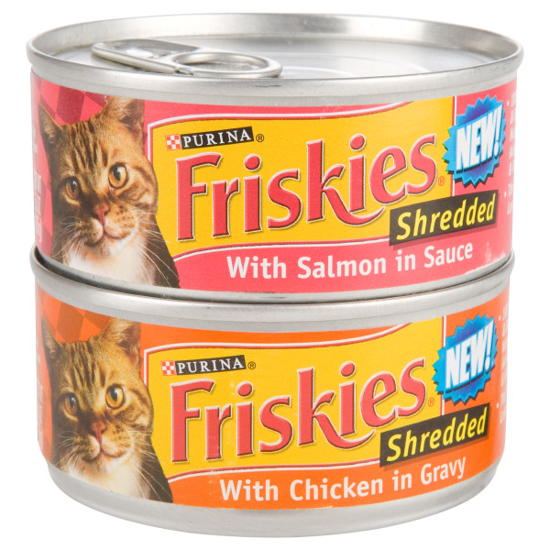
4 + 4 + 2 = 10

What did Scooter do incorrectly? Write and/or draw to show Scooter how to fix his error.

