Our Spring Flower Garden
In this lesson students explore arrays through the context of flats of flowers. Students determine the total number of flowers and write an equation using equal addends. Students calculate the total cost of flats of flowers within 99¢ and represent cost with variations of quarters, dimes, nickels, and pennies.

NC Mathematics Standard(s):
Operations and Algebra
NC.2.OA.4: Use addition to find the total number of objects arranged in rectangular arrays with up to 5 rows and up to 5 columns; write an equation to express the total as a sum of equal addends.

Additional/Supporting Standard:
NC.2.MD.8: Solve word problems involving
- Quarters, dimes, nickels and pennies within 99¢, using the ¢ symbol correctly.
- Whole dollar amounts, using the $ symbol appropriately.

Standards for Mathematical Practice:
- Make sense of problems and persevere in solving them.
- Model with mathematics.
- Look for and make use of structure.
- Look for and express regularity in repeated reasoning.

Student Outcomes:
- I can find the total number of objects in an array.
- I can write an equation using equal addends to find the total number of objects.
- I can find the total cost and represent it using quarters, dimes, nickels, and pennies.

Math Language:
What words or phrases do I expect students to talk about during this lesson?
row, column, array, addend, equal, add, cost, total, sum, coins, quarters, dimes, nickels, pennies,

Materials:
- Images of flower flats
- Flower Flat Cards
- Student record sheet

Advance Preparation:
- Flower Flat Cards copied and cut out.
- Student Record Sheet copied

Launch: How Are Plants Packaged? (5 minutes)

Ask students if they have ever bought plants from a garden center. If so, were those flowers in a “flat”? Show students the images from the “What Is a Flat?” sheet. Turn and talk to your partner about the following question: What do you notice about how the flats are organized? Students should notice that the flats are arranged in rows and columns. Explain that in math we call these rows and columns arrays.

Launch: Introduce the Problem
The School Beautification Team has asked your class to plant a small flower garden. Nan’s Nursery has offered the school a major discount on the flowers to be used in the garden. Your group will be given a flat of flowers to plant. How many flowers will your group be planting? How much will the flat cost? How can you show the cost in different ways using quarters, nickels, dimes, and pennies?

Explore: Calculating the Cost (15-20)
- Student pairs will be given a “Flower Flat Card” and a “Student Record Sheet” (See below). Once students have received their cards, they will begin solving the problem. As students work, monitor and observe how students are organizing and solving the problem.

Possible Prompts:
- Explain how you calculated the total number of flowers.
- What do these numbers in your equation represent?
- How can you represent this array/flat of flowers with another equation?
- What does this number represent in your equation?
- What is your next step?
- Can you explain how you calculated the cost of the flowers?
- Can you find another combination of coins to represent the total cost of your flowers?

- Select student work to share as you monitor student progress. Look for students who individually added the price of each flower and the student who totaled the rows or columns to add equal addends to get the total cost. Also look at the strategies students used to calculate the total cost (number line, base ten, expanded form).

Teacher Note: All flower flats costs are below $1.00, except the flat of pansies which totals a dollar.

Discuss:
- Allow preselected students to share their work. Discuss the similarities and differences in student strategies.
Possible Prompts:
- What do these numbers is your equation represent?
- How can you represent this array/flat of flowers with another equation?
- Why can the marigold flat only be represented by one equation?
- What does this number represent in your equation?
- Can you explain the strategy you used to calculate the cost of the flowers?
- How is your strategy similar to ________’s strategy?
- Which strategy is more efficient? Why do you think so?
- Can you find another combination of coins to represent the total cost of your flowers?

Evaluation of Student Understanding
Informal Evaluation: Observe and note how students solve the problem to guide future instruction. How are students making sense of the task? Are they using mathematical vocabulary as they solve and discuss the problem? How are they applying number operation strategies? Are students using repeated addition of row or column values? Are students grouping numbers in arrays by tens and ones?

Formal Evaluation/Exit Ticket: Assign students a different flat of flowers and have them complete the task independently using the Student Record Sheet.

Meeting the Needs of the Range of Learners
Intervention: Students may have difficulty calculating the total cost of the flat/array of flowers, particularly if they are trying to add each individual plant price. Have students write the plant cost in the box. Guide them to total the rows or column

Extension: Design your own flat to package flowers and calculate the cost of your flat of flowers if every flower cost 50₵ (or allow the student to choose the cost). How could you represent the cost of your flowers with bills and coins?

Possible Misconceptions/Suggestions:
Possible Misconceptions | Suggestions
- Students may not understand that an array can be represented by two equations, repeated addition of the row amount or of the column amount. | - Cover the array and reveal a row at a time. Have students write the total number of objects at the end of the row so that they see one equation can be written using rows. Repeat with the columns. Add to prove that the sum is the same.

Possible Solutions:
Pansy Flat:  Equations: 4 + 4 + 4 + 4 + 4 = 20 or 5 + 5 + 5 + 5 = 20  Total Cost: $1.00 (Solution strategies will vary.)  Coin Combinations: Combinations are many, but should total to $1.00. | Petunia Flat:  Equations: 3 + 3 + 3 + 3 = 12 or 4 + 4 + 4 = 12  Total Cost: 96¢ (Solution strategies will vary.)  Coin Combinations: Combinations are many, but should total to 96¢.
Marigold Flat:  Equations: 3 + 3 + 3 =9  Total Cost: 99¢ (Solution strategies will vary.)  Coin Combinations: Combinations are many, but should total to 99¢. | Aster Flat:  Equations: 2 + 2 + 2 + 2 + 2 = 10 or 5 + 5 = 10  Total Cost: 70¢ (Solution strategies will vary.)  Coin Combinations: Combinations are many, but should total to 70¢.

What Is a Flat?
How Are Plants Packaged?
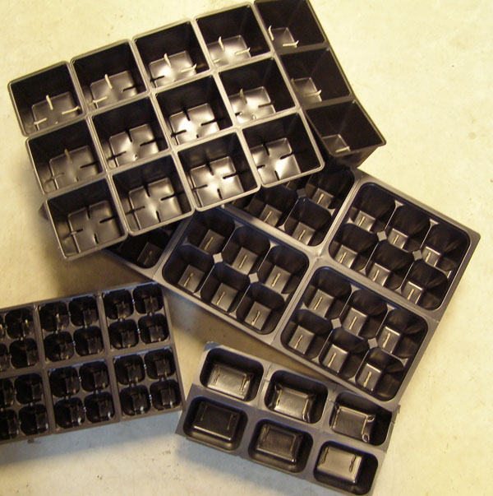

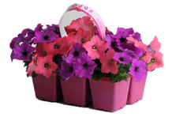 | 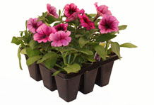
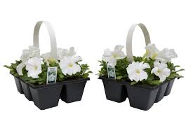 | 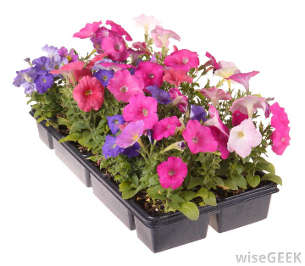

Flower Flat Cards

Pansies = 4 cents per plant
Marigolds = 11 cents per plant

Pansies = 5 cents per plant

Name________________________________
Petunias = 8 cents per plant

Asters = 7 cents per plant

Student Record Sheet
Sketch Your Flat | Equation to Show Total Number of Flowers
Find the total cost of your flat of flowers.

Show the total cost of your plants using quarters, dimes, nickels, and pennies? Can you show it in than one way?

