What Do You Think?

In this lesson, students will write a survey question, collect data, and explore ways to display data leading to a discussion of the purpose of bar graphs. The second portion of this lesson supports the students’ use of a bar graph. This lesson may take more than one day.

NC Mathematics Standard(s):
Represent and interpret data
NC.2.MD.10 - Organize, represent, and interpret data with up to four categories.
• Draw a picture graph and a bar graph with a single-unit scale to represent a data set.
• Solve simple put-together, take-apart, and compare problems using information presented in a picture and a bar graph.

Standards for Mathematical Practice:
- Makes sense of problems and persevere in solving them.
- Reason abstractly and quantitatively.
4. Model with mathematics.
7. Look for and make use of structure.
8. Look for and express regularity in repeated reasoning

Student Outcomes:
- I can collect data and organize the information using a bar graph and picture graph.
- I can answer questions about the data by reading what the bar graph shows.

Math Language:
What words or phrases do I expect students to talk about during this lesson?
- data
- table
- bar graph
- picture graph
- poll or survey
- categories/options

Materials:
- lined notebook paper or graph paper
- rulers

Advance Preparation:
- print or have ready for display the examples of bar graphs and picture graphs
- print copies of the student handouts

Launch 1: Data (10 minutes)
As a cinema owner, I want to know what movies kids like. This helps me know what kind of movies to show in the summer. I did research to find the most popular kids movies for 2017. I have listed the movies in a table to make it easier to collect data (Show students the attached table, “These were the best kid movies in 2017 Which one is your favorite?
How many of these movies have you seen?
- Who else do you think would be interested in this data? (Possible response: Movie makers who want to know what kind of movies kids like so that they can make more.)
- What would we do if we wanted to know our class’s favorite movie from this list of movies? Have students vote for their favorite movie from the list.
- Why do you think I provided categories/options to find out the class’s favorite movie? (Providing options helps students remember what movies came out in that year, it also helps keep the number of categories or options to a manageable amount. Future survey designs could have an “other” category.)

Have the students tell you their favorite movie from the list. Write their initials in the column.

Introduce Task:
What is something that you want to know about your classmates? Create a survey question and categories, collect data, and design a graph to display the data.

Explore 1: (25-30 minutes)
- Allow students time to brainstorm a question, create categories, and fill in the Survey Question and Data Collection sheet.
- Students will then survey their classmates. Students can put their initials beside their choice on the classmates’ tables.
- Challenge students to create a way to display their data using the data in their table.

Possible Questions and Considerations:
- Now that you have collected the data, how can you display this data so that your friends can “read” it?
- How can you display this data so that your friends can tell how much more one choice was selected than another?
- The display of their data needs to be open ended...allow students to create their own display. It is fine if they do not make a bar graph at this point.)

Teacher Note:
As students work and discuss, observe what they are saying and doing and make notes for who you want to share during the discussion. Toward the end of the Explore section, sequence the ideas and examples you will share to highlight the use of bar graphs or picture graphs to display data.

Discuss 1: (20-30 minutes)
As students finish their displays, allow them time to show each other how they displayed their survey results.
- As a group, discuss the graphs you have chosen to share.
- Prompt students to make connections between displays and to begin to recognize what makes displays effective. The teacher can create an anchor chart, “How to Display Data” as students share their observations.
- Refer back to the favorite movie question. “How can we display the favorite movie data to make it clear which movie had the highest number of votes?”
- Show how to make a bar graph using the movie data.
  - Display the data about movie choice on a bar graph.
- Discuss the purpose of bar graphs and the different parts needed to make one. You can refer back to examples of bar graphs.

Launch 2:
- Remind students about the information they collected about their survey question.
- Review what they learned the previous day about a bar graph and how it displays data.
- Discuss horizontal and vertical bar graphs. You may want to show the movie data both ways.

Explore 2:
- Have students go back and display their survey data in a bar graph.

Here are some examples of guiding questions you can ask students while they are working:
- Is there another way for you to display your data in a bar graph?
- Why did you choose a horizontal/vertical bar graph for your graph?
- Why is a bar graph better to display your data than a picture graph?
- What does this bar represent? How do you know?
- What is the title of your graph?

Discuss 2:
- Have students pair up and share the results of their question with their partner using the bar graph they created.
- Choose someone’s graph and display it on the board. Ask the following questions:
  - How many students were polled?
  - Which choice was the favorite?
  - Which choice was the least favorite?
  - How many more students like (choose one of the higher choices) than (one of the lower choices)?
- After creating the graph, write 2-3 observations about your data.

Additional Activities:
- How could we make a bar graph of your data that runs horizontally/vertically? Allow students to experiment with drawing the data from their vertical bar graph onto a horizontal bar graph.

Evaluation of Student Understanding
Informal Evaluation: observations while students are collecting and displaying their data

Formal Evaluation/Exit Ticket: Their finished bar graph.

Additional Activities
- How could we make a bar graph of your data that runs horizontally? Allow students to experiment with drawing the data from their vertical bar graph onto a horizontal bar graph.
- Students can take their data and make a pictograph.

Meeting the Needs of the Range of Learners
Intervention: Some students made need a blank table to create their survey question on and a blank bar graph once they get to the stage of making their own graph.

Extension: Some students may create a bar graph the first time they display their data. Students who do this may use the same data to display their data differently, vertical or horizontal bar graph, picture graph, or they may want to create a different survey question and survey their classmates.

Possible Misconceptions/Suggestions:
Possible Misconceptions | Suggestions
- students may not know how to label their categories and how to show the numbers  - students may need help lining up the rows for the bar graph | - display the movie bar graph for students to reference and prompt them to label each section  - show students how they can use a ruler to measure each row and to draw a straight line

These were the best kid movies in 2017. Which one is your favorite?
Category | Data Collection
Top 5 movies according to ranker.com.

Survey Question and Data Collection
Name: _________________
Question: __________________________________________________
___________________________________________________________
Category | Data Collection

Graphs you can use for examples:

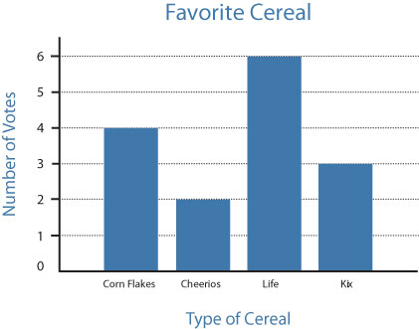
http://www.readingrockets.org/article/creating-bar-graphs

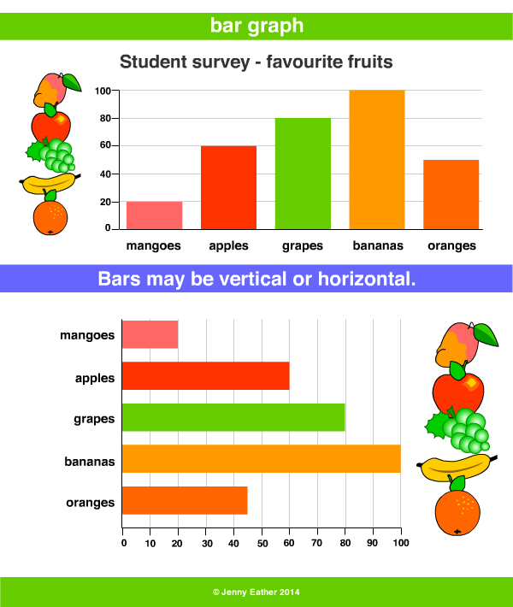
http://www.amathsdictionaryforkids.com/qr/b/barGraph.html

