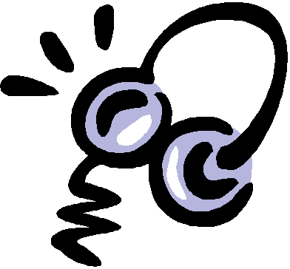
Listen to Reading
Standard(s):
R1.1.2
This Photo by Unknown Author is licensed under CC BY-SA-NC

Book Title: _________________________________

List 3 things you learned about elections from the story:
- _________________________________________________________________________________________________________________________________
___________________________________________

- _____________________________________________________________________________________________________________________________
___________________________________________

- ________________________________________________________________________________________________________________________________________________________________________
Listen to Reading
Standard(s):
R1.1.2, RI..1.4
This Photo by Unknown Author is licensed under CC BY-SA-NC

Book Title: _________________________________

Main Topic (full sentence please!):
______________________________________________________________________________________________
Key Details:

- _________________________________________________________________________________________________________________________________
___________________________________________

- ________________________________________________________________________________________________________________________________________________________________________

List 3 NEW words you learned and their meanings:

Word | Meaning | Picture
_______________________

_______________________

_______________________

_______________________
_______________________

_______________________

_______________________

_______________________
_______________________

_______________________

_______________________

_______________________

