Name: ____________________________ Date: _____________

3rd Grade Artifact MD.5/ MD.7

Directions: Read the following questions carefully and show your work in order to accuately find your answer.
- Amily is laying concrete blocks to create a backyard patio. What is the area of the backyard patio Amily created?
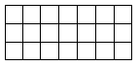

Answer: ________________
MD.5
2. Jack counted the boxes on a chess board. There are 64 boxes each having an area of 1 square inch. What is the total area of Jack’s chess board?

- 1 square inch
- 8 square inch
- 64 square inch
- 65 square inch
MD.5
3. Farrah has 8 square units. If she formed a rectangle with all 8 of her square units, which arrangement of rows and columns below could Farrah have used?

- 4 rows and 2 columns
- 3 rows and 5 columns
- 2 rows and 6 columns
- 1 row and 7 columns
MD.5
4. Each square represents an area of 1 square unit. What is the area of the shaded portion of the figure?
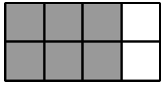

Answer: ________________
MD.5
5. The model shows the area of the parking lot at Seawell Street Elementary.
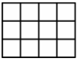
Which expression correctly demonstrates a method for finding the area of the parking lot?
- 3 x 3 x 3
- 3 + 3 + 3 + 3
- 4 + 4 + 4 + 4
- 4 x 4 x 4 x 4
MD.7
6. Jill is buying an area rug for her living room. She needs the area rug to cover exactly 70 square feet. Which area rug should Jill purchase?
- 6 feet by 12 feet
- 7 feet by 10 feet
- 9 feet by 6 feet
- 10 feet by 8 feet
MD.7
7. Cam wants to find the area of three rectangular sections of sidewalk in front of his apartment. He draws this diagram to represent the dimensions of the three sections.
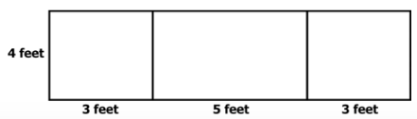

What is the total area of the three sections of sidewalk? _____________________
MD.7
8. Which equation could be used to find the area of the figure shown?
- 3 + 3 + 7 + 7 = 20
- (3 x 3) + (3 x 4) = 21
- 3 + 7 = 10
- 3 x 3 = 9
MD.7

