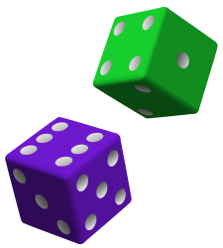
Roll a Rectangle
Materials:
2 different colored dice per pair of students

Directions:
1. Choose two dice—different colors. Choose one color to represent the rows and the other color to represent the columns.
2. Player 1 rolls the two dice and draws the rectangle—with rows and columns.
3. Player 2 rolls and draws the rectangle—with rows and columns.
4. Compare the two rectangles. Determine which rectangle has been partitioned into the most regions.
5. Record the rectangle as the sum of equal addends.
Example
Player 1 rolls 3 rows, 2 columns and records:

The rectangle is 2 + 2 + 2. It is 6 regions.

Player 2 rolls 3 rows, 3 columns and records:

The rectangle is 3 + 3 + 3. It is 9 regions.

Player 2 wins.

