The Number Line – A Visual Representation
Multiplication and Division

In this lesson, students explore how to represent multiplication and division situations on a number line.

NC Mathematics Standard(s):
Represent and solve problems involving multiplication and division.
NC.3.OA.3 Represent, interpret, and solve one-step problems involving multiplication and division.
- Solve multiplication word problems with factors up to and including 10. Represent the problem using arrays, pictures, and/or equations with a symbol for the unknown number to represent the problem.
- Solve division word problems with a divisor and quotient up to and including 10. Represent the problem using arrays, pictures, repeated subtraction and/or equations with a symbol for the unknown number to represent the problem.

Standards for Mathematical Practice:
- Make sense of problems and persevere in solving them.
- Reason abstractly and quantitatively.
- Construct viable arguments and critique the reasoning of others.
- Model with mathematics.
- Use appropriately tools strategically.
- Attend to precision.
- Look for and make use of structure.
- Look for and express regularity in repeated reasoning.

Student Outcomes:
        - I can jump by equal groups to solve multiplication problems.
        - I can skip count backwards on a number line to take out equal groups as a way to find solutions to division problems.
        - I can sometimes solve problems by picturing the empty number line in my head.
        - I can learn from other students as they share different strategies on a number line.

Materials:
      - Pencils, colored pencils
      - Handouts
      - Rulers for drawing number lines

Advance Preparation:
        - Students have had experiences using rulers and tape measures to measure distances from zero.
        - Students have used the “Open or Empty” number line to solve addition and subtraction problems in grade 2.

Teacher Notes:
      - The empty or open number line is a visual representation and allows students to record and share their thinking strategies during the process of mental computation. These are number lines with no numbers or markers.
      - After lots of experiences using the open number line, the number line will become a model for student to think about strategies using mental math.
      - Students are free to choose the type of jumps they will use. One of the interesting things about mental calculations is that we do not all think the same way.
      - The empty number line allows students to see the variety of ways that the same question or problem can be solved.
      - The number line can be a helpful tool to represent repeated addition and build understanding of multiplication. By studying patterns and relationships in multiplication facts and relating multiplication and division, students build a foundation for fluency with multiplication and division facts.
      - It is important that students “see” the strategy and then explore more than one way of finding the result. Working with partners and sharing strategies in teams or whole class supports student understanding. Students should be encouraged to share different strategies and discuss which strategy is the most efficient.
      - Use of the empty number line also increases students’ confidence in their ability to use numbers flexibly which leads to further development in their understanding of number sense.

Questions to Pose:
Before:
        - How can we represent multiplication on the number line?
        - How would you explain 4 x 6 to a friend? How would use explain 12 ÷ 3? During:
        - What do you know about using a number line to solve problems?
After:
        - Can you describe a strategy you might use to solve a problem on a number line?
        - What strategies might you use on a number line for finding the product of 3 x 4?
        - How might you use multiplication on a number line to show division?

Possible Misconceptions/Suggestions:

Possible Misconceptions | Suggestions
Students may not see equal groups for multiplication and division. | Use a cube or an object to allow students to physically jump on a number line for multiplication and division. Students may use a meter tape or a meter stick for making jumps.  Encourage students to make up their own problems.

Various handouts included for your convenience.

Exploring Number Lines for Multiplication and Division

- Write the multiplication equation that matches the jumps on the number line below.

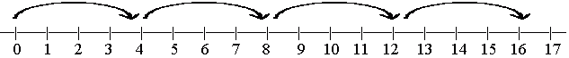

- Write an equation that matches the jumps for division on the number line above. (Hint: Begin at 16 and jump backwards by 4. How many hops?)

- Write the multiplication equation that matches the jumps on the number line below.

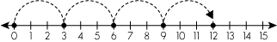

- Write an equation that matches the jumps for division on the number line above.

- What multiplication equation is represented on the number line above?

- What division equation is represented on the number line above?

- How does the number line below show division? Explain to a partner and the class.
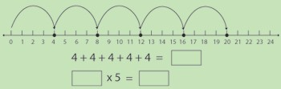

- How does the repeated addition of 4s help you understand multiplication?

- Record the multiplication equation represented on the number line above.

- Record the division equation represented on the number line above.

- Do solving multiplication problems help you to understand division? Explain:

- Complete the equations below.

4 x 6 = ? ÷ 4 = 6 ? ÷ 6 =

- Math Frogs always jump by their favorite number. A +4 Math Frog only jumps by 4s. If a (+ 4) Math Frog starts at 0 and hops 7 times, where will the frog land?

Show the frog’s jumps on a number line. Below is the beginning of a number line.

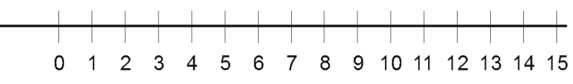

- If a Math Frog starts at 0 and lands on 20, what distance(s) might this frog hop by?

Select one way and show the frog’s jumps on a number line.

- If a +3 Math Frog starts at 3 and lands on 15, and then takes 4 more hops, where will the Math Frog land?

How do you know? Show the frog’s jumps on a number line.

- Write one or more “Math Frog” problems.

Select a problem. Draw a number line and show the Math Frog hops.

Using your problem, write an equation for multiplication.

Using your problem, write an equation for division.

