Kindergarten Family Letter
Cluster 2: Understanding the Relationship between Numbers and Quantities
PART 2

Dear Families,

During the next several weeks, your child continues to work on number sense. At the beginning of this cluster, your child was introduced to counting, writing numbers, and understanding number relationships. They continue to build on these skills throughout the remainder of this cluster. Your child builds on those skills when they identify “how many” objects are in a group, or set. To become effective counters, students develop strategies for tracking the objects counted in a variety of ways. When counting a group, they may point and count each object starting from the left and moving to the right to determine total number in a group. They may move objects from one area on the table and count. This allows them to track objects already counted. When objects are on paper, and can’t be moved, other strategies may be used. These include crossing out as they count, circling the first object they counted (so they know where they started), etc. We practice these skills and strategies throughout this unit. We sort and classify objects including shapes.

Your Partner in Learning,

_________________________

Kindergartners Count to Answer the Question, “How Many?”

- Your child counts to find the amount in a group which may be arranged in a variety of ways:

A Straight Line  (1-10 objects) | More Than One Line  (1-10 objects) | A Circle  (1-10 objects) | Scattered  (1-5 objects)

- When given a number 1-10, your child counts out a group to match the number.
5

“1, 2, 3, 4, 5”

- When given a number such as 10, your child says the number that comes next in the counting sequence. For example, if given 3, they are able to say 4.
3
“4”

Kindergartners Count to Answer the Question, “How Many?”
(Continued from page 1)

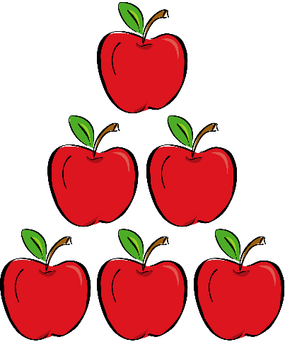
How can parents help?

- Place a group of objects in a line, multiple lines, circle or scattered arrangement. Ask, “How many objects are in this group?” Encourage your child to touch (or move) one and only one object at a time while counting.
- Give your child a group of objects to count. Then, place one more object in the group. Ask, “How many now?” Eventually, your child will move away from recounting the entire group toward simply saying the next number.
- Watch the video: How Many? by English Sing Sing
- Sing the song: Counting Fruits by English Sing Sing

Kindergartners Sort and Count Objects and Shapes

In order to see ways numbers are connected to our world and other areas of math, this cluster has a second focus: Sorting and Counting Objects and Shapes. Kindergartners sort objects by size (examples: tall vs. short, heavy vs. light) and other attributes (example: soft vs. hard). They also sort shapes by their attributes (examples: number of sides, size, or color). After sorting, your child counts to find the amount in each group.
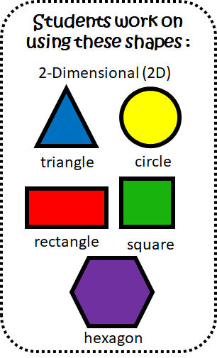

How can parents help?
- Have your child help with household chores. Sort and count things such as socks in the laundry, things on the table for dinner, coins in your pocket, toys in the living room or playroom. All these objects may be sorted and counted. Make sure you have your child not only sort objects, but also tell you how they sorted them.
- Play: Starfall Shape Sort (3 levels)
- Watch: Sesame Street: Sorting Shapes
- Read: Shapes that Roll by Karen Berman Nagel

