NC.3.OA.3
Counting Goldfish
Domain | Operations and Algebraic Thinking
Cluster | Represent and solve problems involving multiplication and division.
Standard(s) | NC.3.OA.3 Represent, interpret, and solve one-step problems involving multiplication and division.  - Solve multiplication word problems with factors up to and including 10. Represent the problem using arrays, pictures, and/or equations with a symbol for the unknown number to represent the problem.  - Solve division word problems with a divisor and quotient up to and including 10. Represent the problem using arrays, pictures, repeated subtraction and/or equations with a symbol for the unknown number to represent the problem.
Materials | Paper, pencils, counters or square tiles  Optional: White boards and dry-erase markers
Task | 5 teachers have fish tanks in their classroom. Each teacher receives an equal number of tropical fish to put in his/her fish tank. Each teacher also receives 6 goldfish.  If there are between 34 and 56 fish in the school, how many tropical fish could there be? Use your counters or square tiles to model the problem. Find at least 3 possible answers and write an equation for each solution.  Write a sentence to explain how you solved the task.

Rubric
Level I  Not Yet | - Level II  - Progressing | Level III  Meets Expectation
- Incorrect answer and work are given. | - Finds the correct answer, but there may be inaccuracies or incomplete justification of solution OR  - Uses partially correct work but does not have a correct solution. | - Accurately finds the answers: There could be as few as 1 or as many as 5 tropical fish. AND  - Writes correct equation for each part of the task  AND  - The sentence clearly and accurately describes student’s strategies.

Standards for Mathematical Practice
1. Makes sense and perseveres in solving problems.
2. Reasons abstractly and quantitatively.
3. Constructs viable arguments and critiques the reasoning of others.
4. Models with mathematics.
5. Uses appropriate tools strategically.
6. Attends to precision.
7. Looks for and makes use of structure.
8. Looks for and expresses regularity in repeated reasoning.

Counting Goldfish

Use your counters or square tiles to model the problem. Find at least 3 possible answers and write an equation for each solution. Write a sentence to explain how you solved the task.

5 teachers have fish tanks in their classroom. Each teacher receives an equal number of tropical fish to put in his/her fish tank. Each teacher also receives 6 goldfish.

If there are between 34 and 56 fish in the school, how many tropical fish could there be?

Scoring Examples

Not Yet: The student answer is incorrect and the work does not lead to a correct answer. The student’s work shows evidence of beginning to make sense of the context (5x6). The work that follows reveals confusion with the operation being used in this problem.

Progressing: The student was able to come up one correct solution. The student was not able to find 2 other possible answers. The student showed a picture as a strategy that clearly communicated thinking.

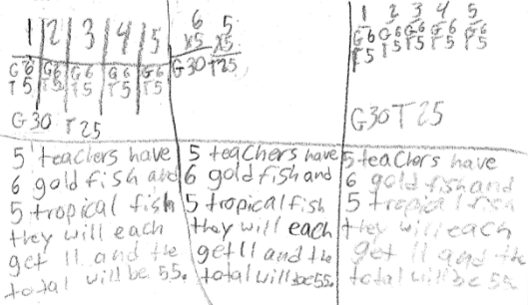

Meets Expectations: The student was able to accurately find two possible answers and was able to support the answers with equations and a written explanation that was clear.

