Multiplication and Division Anchor Chart Examples

- Teachers and students work together to generate anchor charts on specific mathematical concepts.
- These anchor charts are then displayed in the classroom for students to refer to throughout lessons.
- Parents can also benefit from these anchor charts, as they are snapshots of vital information their child is learning.
- Teachers can include photos of anchor charts in newsletters, emails, and any other communications they have with parents.
- Anchor charts are not posters, created by teachers and then posted in the classroom for reference. They are co-created and represent learning shared among the class.
- Below, there are pictures of anchor chart examples. These are not comprehensive for the content in these standards. They are included for teachers get an idea of how some anchor charts for this content may look.

The first two anchor charts focus on vocabulary for multiplication:
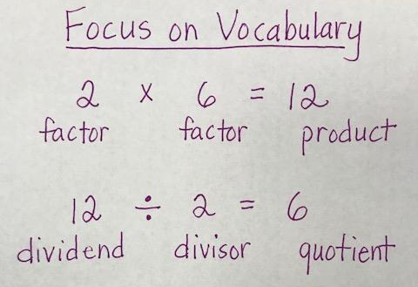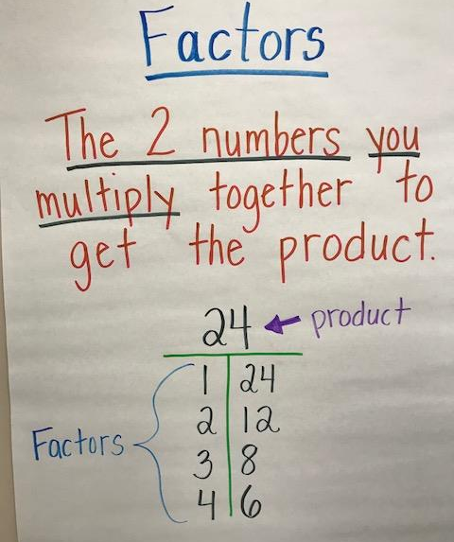
Cluster 1 builds on second grade work when students worked with equal groups to build a foundation for multiplication (skip counting with 2, 5 and 10 and repeated addition). During this cluster, students are formally introduced to the meaning of multiplication and the symbolic notation for multiplication. The emphasis is on context and story problems (not merely equations); therefore 3.OA.1 and 3.OA.2 are addressed through story problems. This anchor chart may be developed as students participate in classroom routines such as counting around the room.

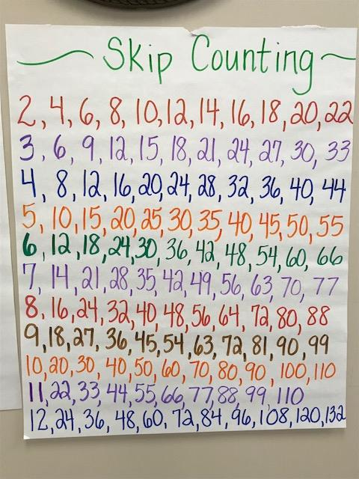

Illustrate and explain strategies including arrays, repeated addition, decomposing a factor, and applying the commutative and associative properties.

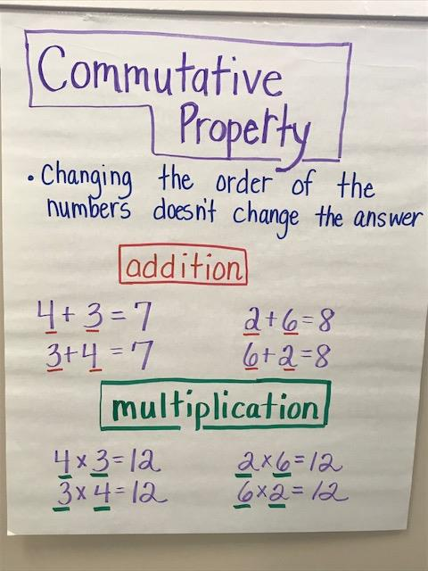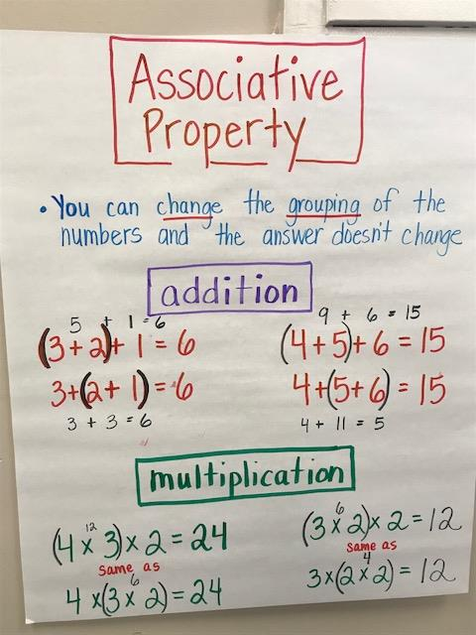

- The anchor charts below are introductory multiplication and division anchor charts and division anchor charts.
- Illustrate and explain strategies including arrays, repeated addition, decomposing a factor, and applying the commutative and associative properties.
- Solve multiplication word problems with factors up to and including 10. Represent the problem using arrays, pictures, and/or equations with a symbol for the unknown number to represent the problem.
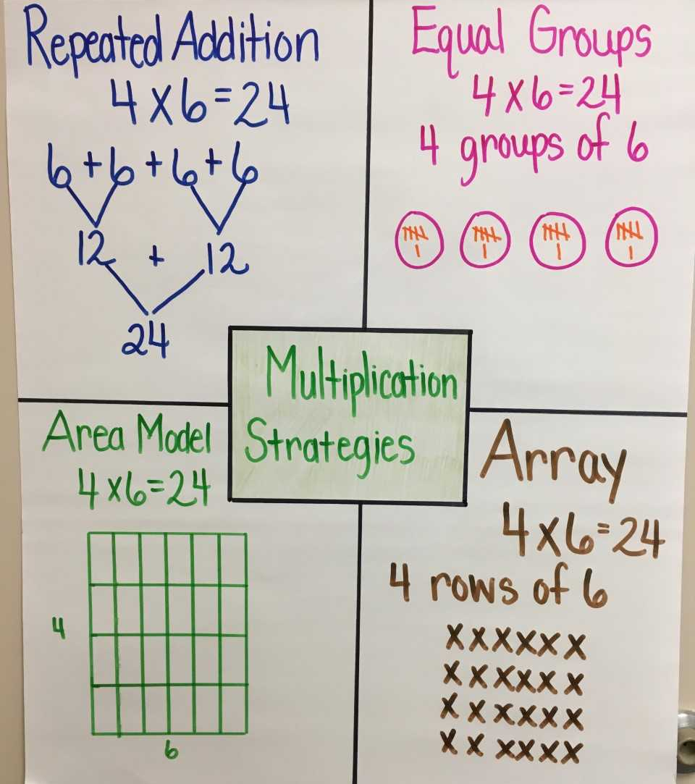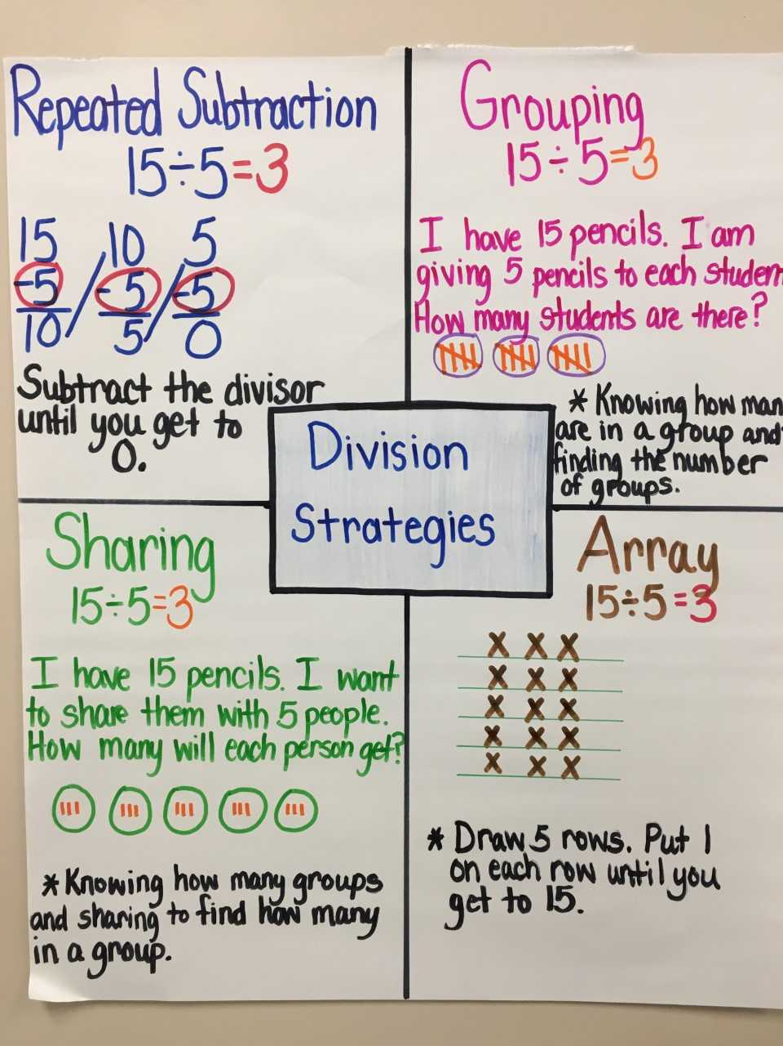

NC.3.OA.3 Represent, interpret, and solve one-step problems involving multiplication and division.
- Solve multiplication word problems with factors up to and including 10. Represent the problem using arrays, pictures, and/or equations with a symbol for the unknown number to represent the problem.
- Solve division word problems with a divisor and quotient up to and including 10. Represent the problem using arrays, pictures, and repeated subtraction.

