Third Grade Cluster 4 CFA Items Assessment
Teacher Guide
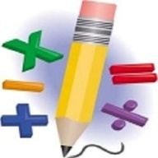

This assessment assesses students’ ability to:
- Use equations to represent mathematical situations
- Recognize contexts that involve multiplication and division
- Connect multiplication and division situations to multiplication expressions and equations
- Use multiplication and division within 100 to solve word problems in situations involving equal groups, arrays, and measurement quantities
- Solve problems in which you need to find the number of things in a group
- Use and represent properties of operations for multiplication
- Use the relationship between multiplication and division to solve division problems

Common Core Standards:
This assessment addresses each of the following Common Core Standards
Data Driven Instruction:
This assessment is one data point and should be used with data gathered from multiple sources to make an informed decision about student misconceptions and mastery.

3rd Grade Cluster 4 CFA Items – Scoring Guide

Question | Standard | Answer
1 | NC.3.OA.3 | C
2 | NC 3.OA.3 | B
3 | NC 3.OA.3 | D
4 | NC 3.OA.1 | C
5 | NC 3.OA.3 | B
6 | NC 3.OA.3 | D
7 | NC 3.OA.3 | C
8 | NC 3.OA.1 | B
9 | NC 3.OA.2 | C
10 | NC 3.OA.3 | B
11 | NC 3.OA.3 | D
12 | NC 3.OA.2 | A
13 | NC 3.OA.1 | B
14 | NC 3.OA.2 | D
15 | NC 3.OA.3 | B
16 | NC 3.OA.6 | B
17 | NC 3.OA.8 | C
18 | NC 3.OA.8 | C
19 | NC 3.OA.8 | B
22 | NC 3.OA.9 | D
23 | NC 3.OA.9 | B

Student Name: ________________________ Date: _________

3rd Grade Cluster 4 CFA Items

Directions:

Solve each problem and show your work.
_______________________________________________________________________________________________________________________________________________________________________________________________________________________________________________________________
- Ivan displayed a collection of Hot Wheels on a shelf.

- He made 6 rows.
- He put 8 cars in each row.

How many cars does Ivan have in his collection?

A 14 B 42
C 48 D 64

- Adela has 56 dolls. She stores them on 8 shelves. If she puts the same number on each shelf, how many dolls will be on one shelf?

A 6 B 7
C 8 D 9

- Tyshawn is hosting a cookout at his house this weekend.

- He bought 4 packs of hotdogs.
- Each pack contains 8 hotdogs.

How many hotdogs did Tyshawn buy for the cookout?

A 2 B 12
C 16 D 32

- Archie has 9 model cars at home. Every car has 4 wheels. Which expression best represents how Archie would determine how many wheels he has?

A 9 + 4 B 9 - 4
C 9 x 4 D 9 ÷ 4

- The music teacher was getting the stage ready for a performance.

- She set up 6 rows of chairs.
- Each row had 7 chairs.

How many chairs did the music teacher have on the stage?

A 13 B 42
C 54 D 56

- Nathan collected 12 lightning bugs and put them into jars. He put an equal number in each of the 3 jars. Which equation below can be used to represent how the bugs were placed in jars?

A 12 – 3 = 9 B 12 x 3 = 36
C 12 + 3 = 15 D 12 ÷ 3 = 4
- Betty started babysitting to earn money this summer.

- She makes $7 every day.
- She has worked 5 days.

How much money has Betty earned?

A $2 B $12
C $35 D $49

Student Name: ____________________

Calculator Active: You may use a calculator on this part of the test.

- Michael has a collection of trading cards that he put in a book. There are 10 pages in his book. Each page holds 6 cards. Which expression can be used to find the total number of trading cards Michael has?

A 10 + 6 B 10 x 6
C 10 ÷ 6 D 10 - 6

- Which problem could be solved using the expression 36 ÷ 4?

A Tina had 36 pieces of gum. She gave 4 pieces to a friend. How many pieces of gum does Tina have left?
B Tina had 36 pieces of gum. She bought 4 more pieces. How many pieces does Tina have now?
C Tina had 36 pieces of gum. She gave all of her gum to 4 friends. If she gave each friend the same number of pieces, how many pieces did she give each friend?
D Tina had 4 friends. She gave each of them 36 pieces of gum. How many pieces of gum did Tina give away?

- Ms. Harrison wants to rearrange the desks into rows.

- There are 28 desks in the classroom.
- She wants 4 rows of desks.

How many desks will Ms. Harrison put in each row?

A 6 B 7
C 24 D 32

- Amanda planted a flower garden.

- She planted 8 rows of flowers.
- Each row had 4 flowers.

Which equation below represents Amanda’s flower garden?

A 8 ÷ 4 = 2 B 8 – 4 = 4
C 8 + 4 = 12 D 8 x 4 = 32

- Four girls have 20 bracelets to share equally. How many bracelets will each girl get?

A 5 B 16
C 24 D 80

- Which problem could be solved using the expression 8 x 4?

A Rylan has a pack with 8 pieces of gum. She gets 4 more pieces. How many pieces of gum does Rylan have now?
B Rylan has 8 pages of pictures in her journal. Each page has 4 pictures. How many pictures are in Rylan's album?
C Rylan has 8 cookies. She wants to share them equally between 3 friends and herself. How many cookies will Rylan and each of her friends get?
D Rylan has to read 8 chapter books this month. She has read 4 books so far, how many books does Rylan have left to read?

- Which of the following problems could be solved using the expression 12 ÷ 4?

A 12 children were on the playground on Sunday. There were 4 more students on the playground on Saturday than on Sunday. How many students were on the playground on Saturday?
B 12 families went to a piano recital. Each family had 4 people. How many people were at the recital?
C 12 cookies were in the cookie jar. Someone ate 4 cookies. How many cookies are left in the cookie jar?
D There were 12 model cars on a book shelf. There were an equal number of cars on each of the 4 shelves. How many cars were on each shelf?

- Sonya has stickers to share with her Girl Scout troop.

- Sonya has 72 stickers.
- There are 8 girls in her troop.

How many stickers will each girl get?

A 6 B 9
C 64 D 576

16. Jafari has 30 toy cars. He wants to give the toy cars to 6 of his friends. S is the number of toy cars that Jafari will give to each friend, Which expression can Jafari use to figure out how many toy cars he should give to each friend?

A 30 x 6 = S B S x 6 = 30
C 30 - 6 = S D S + 6 = 30

17. Third grade will need 172 juice boxes for an end-of-year celebration.

- Parents have donated 9 packages of juice boxes.
- Each package has 6 juice boxes.

If J is the number of juice boxes still needed, which equation could be used to find how many juice boxes are still needed?

A 9 x 6 x J = 172 B J x 6 + 9 = 172
C J + 6 x 9 = 172 D 9 x 6 – J = 172

18. Tyler wants to buy a Star Wars Lego set that costs $116. He is earning money to buy the Lego set by walking dogs for his neighbors.

- Each time Tyler walks a dog he earns $5.
- He has walked 9 dogs so far.

How much more money does Tyler need to buy the Lego set?

A $45 B $61
C $71 D $101

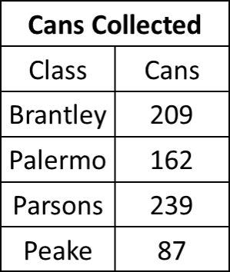
19. Four classes collected cans for the can food drive. Estimate how many cans were donated by the four classes. Round to the nearest hundred.

A 600 B 700
C 800 D 900

20. John created the following pattern for his friends:

14, 29, 44, 59, ____, 89

What is one way that his friends could find the missing number?

A Add 59 and 89 B Add 15 to 89
C Subtract 59 from 89 D Subtract 15 from 89

21. Use this multiplication chart to decide which statement below is true.

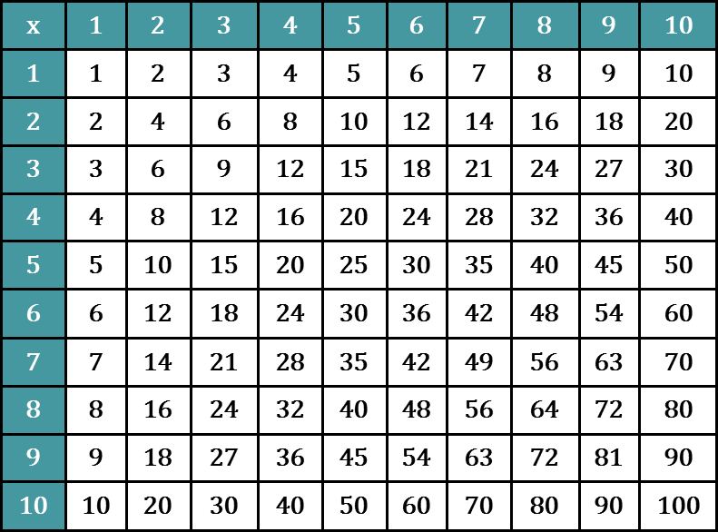

A All of the multiples of 3 are even.
B All of the multiples of 2 are even.
C Multiples of 4 can be odd or even.
D Multiples of 7 cannot have a 0 in the ones place.

