Composing Shapes: Mrs. Winkle’s Classroom

In this lesson students explore how new shapes can be formed by composing other shapes.

NC Mathematics Standard(s):
Geometry
Reason with shapes and their attributes
NC.G.1 Reason with two-dimensional shapes and their attributes.
• Investigate, describe, and reason about composing triangles and quadrilaterals and decomposing quadrilaterals.
• Recognize and draw examples and non-examples of types of quadrilaterals including rhombuses, rectangles, squares, parallelograms, and trapezoids.

Standards for Mathematical Practice:
3. Construct viable arguments and critique the reasoning of others.
- Students compose and decompose shapes. Students use attributes to make an argument for how they know what kind of new shape that they have created.
6. Attend to precision.
- Students must attend to precision as they consider the attributes of shapes being used compose or decompose and how that impacts the side length of the new shape or shapes formed. Students must also label their work and use informal mathematical language to describe the shapes formed by composing and decomposing.
7. Look for and make sense of structure.
- Students may notice that certain attributes are needed in order to make a specific kind of shape (ie Student might notice that they need triangles with one square corner (right angle) to make a square or rectangle).

Student Outcomes:
- I can compose shapes to form a new shape.
- I can describe the attributes of shapes using informal mathematical language.

Math Language:
What words or phrases do I expect students to talk about during this lesson?
Triangle, quadrilateral, hexagon, pentagon, square, rectangle, rhombus, trapezoid, parallelogram, square corners, length, sides, corners (angles), opposite sides

Materials:
- Shape Set on Cardstock (Attached or use Power Polygons (At least 2 of each shape)
- Composing and Decomposing shapes

Advance Preparation:
- Print student copies of task.
- Make sure sets of shapes are available (1 set for each pair).

Launch:
- Introduce the task:
Mrs. Winkle and her 3rd grade class moved to a new classroom with desks that are different shapes. And even stranger, all the desks were sitting by themselves. Mrs. Winkle said, “This desk arrangement will never work. My students learn by working with partners!” Immediately, her students began pushing desks together to make partners. The funny thing is that they realized the shapes of their desks changed when they combined with a partner. Everyone was all abuzz talking about the different shapes that their new arrangements made.

Explore
2. Give students the set of shapes. Ask student to work with their partner to begin exploring the shapes and ways that the class might have put them together. Share that the one rule that Mrs. Winkle made is that the two sides that are put together must be the same length. Give students about 5 minutes to explore ways that the desks might be put together.

Pose the following questions as students explore during this part:
- Pointing to a specific combination, which two shapes did you combine for this pair?
- What attributes did you use to identify that shape?
- What new shape was formed?
- What attributes did you use to identify the new shape?

(Note that you may want to refer to an anchor chart with mathematical language used to describe shapes created earlier in the unit or develop one in a brief discussion here. Discuss attributes such as number of sides, number of corners (angles), length of sides, how many sides are the same length, will the opposite sides ever meet or cross, what kinds of corners are in the shape: square corners, smaller than square corners, or bigger than square corners.)

3. Tell students that Mrs. Winkle decided to ask her student to make specific shapes when putting their desks together. Give students the student sheet “Rearranging Desks in Mrs. Winkles 3rd Grade Class.” Tell students that their challenge today is to figure out how Mrs. Winkles students can make the combinations she describes. Tell students that they will need to record the attributes to prove that they have the right shapes. (Note that shapes can be reused for the different combinations).

Continue to pose the questions listed above. Most students will not have enough time to find all of the combinations, so you might consider asking students to star a few that you want to discuss. Then students can do those first.
Discuss:
4. What are some ways that you found to combine the shapes to follow the directions given by Mrs. Winkle? (Refer to specific questions). What attributes did you use to prove you were using the right shapes? What attributes did you use to prove that you formed the right shape? Is there more than one way to make some of the shapes?

Evaluation of Student Understanding
Informal Evaluation:
Use questions such as the ones suggested in the explore to informally evaluate student understanding of the following concepts:
- Two different shape can be put together to make a new shape.
- Attributes such as number of sides, side length, number of sides with the same length, whether or not opposite sides will meet or cross, number of corners (angles), and presence of square corners can be used to identify shapes.

Formal Evaluation/Exit Ticket:

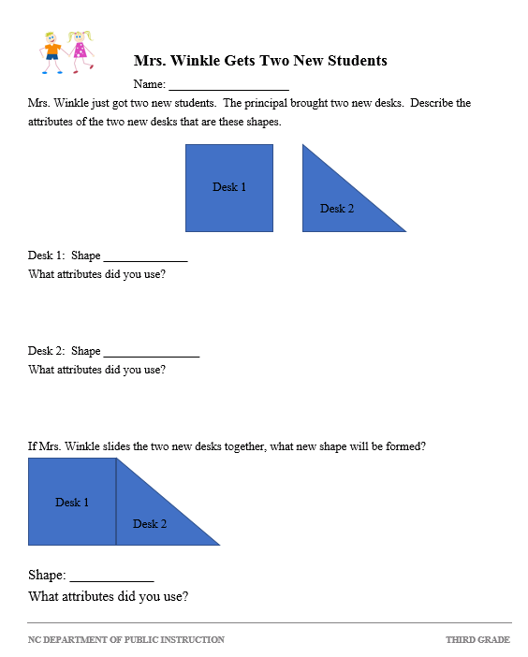
Meeting the Needs of the Range of Learners
Intervention:
If all of the shapes at once make it difficult for a student to get started, students may need to be provided 2 shapes at first. Give the two shapes one at time to discuss the attributes of each of the shapes individually. Then have the student explore different ways that those two shapes can and cannot be put together to make a new shape. Then have students move to a larger mix of shapes.

For students who have difficulty with describing attributes, be sure that they have access to an anchor chart with pictures and phrases to describe specific attributes.

Extension:
Part A: Ask students to imagine that Mrs. Winkle wants the class to work in groups of 3 or in groups of 4. How can the shapes be put together to make new shapes? Describe the attributes of the original shapes and the new shape.
Part B: What if Mrs.Winkle changed her rule for partner desks? What kind of shapes might be made if the two sides do not have to be the same length?

Possible Misconceptions/Suggestions:
Possible Misconceptions | Suggestions
Students may have difficulty seeing the shape formed by the new shape. | Have students trace the new shape that is formed around the outside. They should not draw the line where the two smaller shapes touch. Then remove the smaller shapes, so that the students can see only one shape.
Students may have difficulty generating attributes for shapes formed. | Provide a list of questions for the shapes to be answered with a complete sentence:  1. How many sides does the shape have? _________________________________________  2. How many corners (angles) does the shape have?  3. How many square corners does the shape have?  4. How many sides are the same length?  5. If there are opposite sides, would those sides every meet or cross if they were extended?  _________________________________________
Name: ________________________

Rearranging Desks in Mrs. Winkle’s Third Grade Class

Mrs. Winkle and her 3rd grade class moved to a new classroom with desks that were different shapes. And even stranger, all the desks were sitting by themselves! Mrs. Winkle said, “This desk arrangement will never work. My students learn by working with partners!” Immediately her students began pushing desks together to make partners. The funny thing is that they realized the shapes of their desks changed when they combined with a partner. Everyone was all abuzz talking about the different shapes that their new arrangements made. Mrs. Winkle made one special rule: When you put two desks together, the sides you put together must be the same length.

Mrs. Winkle asked her students to figure out how to put two desks together in some specials ways. Use the shapes to show how Mrs. Winkle’s class might have made these partners. Record the attributes for each shape to show how you know you made the correct shape.

Show How You Can Make This Shape: | First Shape  Name & Attributes | Second Shape  Name & Attributes | New Shape  Name & Attributes
Use two triangles to make a square:
Use a rhombus and a triangle to make a trapezoid

Show How You Can Make This Shape: | First Shape  Name & Attributes | Second Shape  Name & Attributes | New Shape  Name & Attributes
Use two squares to make a rectangle.
Use a rectangle and a trapezoid to make a pentagon.
Use two triangles to make a rectangle.

Use a trapezoid and a triangle to make a triangle.

Show How You Can Make This Shape: | First Shape  Name & Attributes | Second Shape  Name & Attributes | New Shape  Name & Attributes
Use two rhombuses to make a rectangle
Use two triangles to make a rhombus.
Use a triangle and a rectangle to make a trapezoid
Use two triangles to make a parallelogram.
Use two triangles to make another triangle.

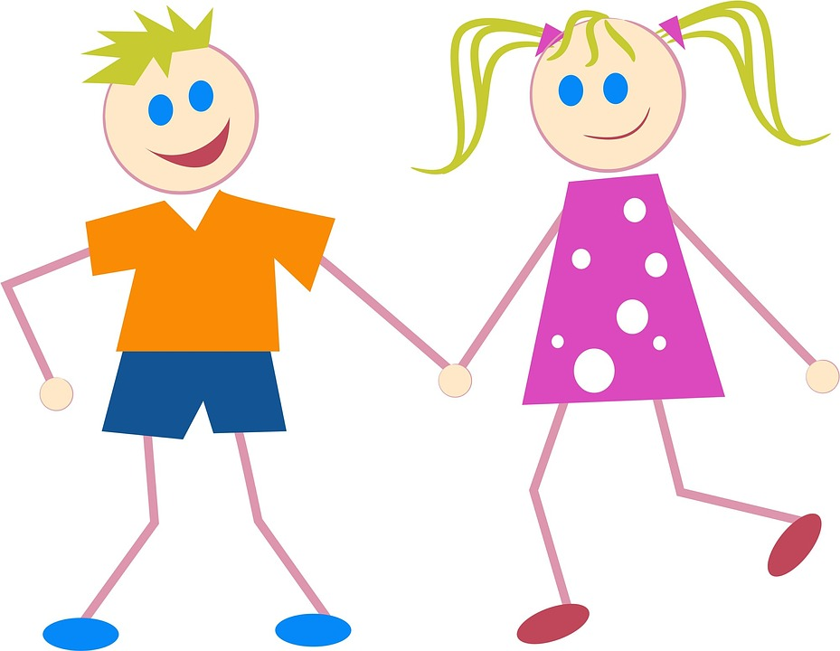

Mrs. Winkle Gets Two New Students
Name: ____________________
Mrs. Winkle just got two new students. The principal brought two new desks. Describe the attributes of the two new desks that are these shapes.
Desk 2
Desk 1

Desk 1: Shape ______________
What attributes did you use?

Desk 2: Shape ________________
What attributes did you use?

If Mrs. Winkle slides the two new desks together, what new shape will be formed?
Desk 2
Desk 1

Shape: ____________
What attributes did you use?
Desk Shape Set (or Use Power Polygons) Each pair needs 2 copies of each shape.
A
D
G
C
K
I
J
B
L
F
M

