Creating and Sorting Triangles

In this lesson, students explore various triangles by sorting them based on attributes such as having equal lengths and square corners (right angles).

NC Mathematics Standards:
Geometry: Reason with shapes and their attributes.
NC.3.G.1 Reason with two-dimensional shapes and their attributes.
● Investigate, describe, and reason about composing triangles and quadrilaterals and decomposing quadrilaterals.
● Recognize and draw examples and non-examples of types of quadrilaterals including rhombuses, rectangles, squares, parallelograms, and trapezoids.

Standards for Mathematical Practice:
3. Construct viable arguments and critique the reasoning of others.
6. Attend to precision.

Student Outcomes:
- I can sort triangles by attributes.
- I can communicate with precision about the attributes of triangles as well as how shapes are similar and different from each other.

Math Language:
- Corner (angle), triangle, side, square corner (right angle)

Materials:
- Geoboard and bands
- Copy of Launching Activity Sheet to display or copies for students
- Copy of Creating Triangles on the Geoboard Activity sheet
- Triangle Sort cards
- Ruler
- Square tiles

Advance Preparation:
- Gather materials.

Launch:
- Defining Triangles (8-10 minutes)
Display Defining Triangles sheet for students to see or make copies.

Students work in pairs or groups of 3 to determine which shapes are triangles and which ones are not. Students should be able to reason about why the shape is or is not a triangle.

Remind students that triangles are polygons and ask students to talk about characteristics of polygons: closed shapes with straight sides, whose sides have no gaps or overlaps.

Introduce the task. Tell students that today we are going to spend time creating different types of triangles.

Explore:
- Explore Part 1: Creating Triangles on the Geoboard (10-12 minutes)

Students need a copy of the Creating Triangles on the Geoboard, a geoboard, and bands to make shapes on the Geoboard. Students use Geoboards to make 2 examples of each of the following triangles below. They then draw a picture of the shapes below in the dot grid and label them. Students should have 10 pictures: 2 per type of triangle.

- 1 square corner and no equal side lengths D- no square corners and 3 equal side lengths
- 1 square corner and 2 equal side lengths E- no square corners and 2 equal side lengths
- No square corners and no equal side lengths

Table 1. Questions to ask as students explore.
Observation | Questions to Ask
Students struggle to create triangles that meet the specific side lengths in the tasks. | - “How can you use the pegs on the geoboard to help you determine the lengths of the sides of the triangle?”  - “Which side lengths look like they may be the same? How can you check?”  - “How can you use a ruler to examine the side lengths of the shape?”
Students make the misconception that the distance between two diagonal pegs is the same as two pegs that are side by side or on top of one another. Note: diagonal pegs are farther apart than pegs that are side by side or on top of one another. | - “How can you use your ruler to examine the side lengths of the shape?”
Students struggle to create triangles that meet the specific numbers of square corners (right angles). | - “Which shapes look like they may have square corners?”  - “How can you check to see if a shape has a square corner?”  - “How can this plastic square tile help you determine if the shape has a square corner?”

Explore Part 2: Sorting Quadrilaterals (10-12 minutes).
Pair students up, provide them with the triangle cards (attached below). Allow students to work in pairs or groups of 3 to sort the cards. Students should be encouraged to sort their cards however they choose. If students get stuck, suggested sorts could be:
- 2 sides of equal length
- 3 sides of equal length
- 1 square (right) corner

Table 2 provides possible questions to pose based on students’ work on the observation.

Table 2. Questions to ask as students explore.
Observation | Questions to Ask
Students cannot identify which sides have equal length. | - “Which side lengths look like they may be the same? How can you check?”  - “How can you use a ruler to examine the side lengths of the shape?”
Students cannot identify which shapes have a square (right) corner. | - “Which shapes look like they may have square corners?”  - “How can you check to see if a shape has a square corner?”  - “How can this plastic square tile help you determine if the shape has a square corner?”

Discuss:
- Discussion of Activities (12-15 minutes)
Note: Teachers may want to do the geoboard activity and discuss it, then do the sorting activity, or do both activities then do the discussion to close the lesson.

Table 3 provides some sample questions and possible sentence frames to support the class discussion.

Table 3. Sample Questions to Facilitate Classroom Discourse about Triangles on the Geoboard
Sample Questions | Possible Responses or Talk Frames
- What strategies did you use to make sure your triangles met the requirements of the side lengths? | - “I saw that they looked about the same.”  - “I used the pegs on the geoboard and found that the side lengths were (the same/different).”
- What strategies did you use to make sure your triangles met the requirements of square corners? | - “If the shape needed a square corner I kept moving the rubber band until I had one.”  - “If the shape needed a square corner the first thing I did was create one on the geoboard by bringing the band straight down and straight to the right.”

Table 4 provides some sample questions and possible sentence frames to support the class discussion.

Table 4. Sample Questions to Facilitate Classroom Discourse about Sorting Triangles
Sample Questions | Possible Responses or Talk Frames
- What strategies did you use to sort and organize your shapes? | - “I sorted them by shapes that 2 or more sides that were equal length.”  - “I sorted them by shapes that had opposite sides that were equal length.”  - “I sorted them by shapes that had a square corner.”
- How did you prove that sides had the same side lengths? | - “I saw that they looked about the same.”  - “I used a ruler and found that the side lengths were (the same/different).”
- How did you prove that sides had square corners (right angles)? | - “I saw that it looked like a square corner.”  - “I used the square tile to check to see if there was a square corner.”

Close the lesson by asking students, “What are ways that you sorted triangles today?”’

Evaluation of Student Understanding:
Informal Evaluation:
- Observe students and ask questions as they are completing the explore task. Pay attention to how students are determining equal side lengths and square corners and using them to create

Formal Evaluation:
- Students’ work during the Explore phase can be used as a formal evaluation.

Meeting the Needs of the Range of Learners:
Interventions:
- For students who struggle with creating triangles on the geoboard begin by having them explore by making triangles with no specific attributes at first, then ask them how to manipulate or change triangles that they have created.
- For students who struggle with sorting the large number of cards, use a smaller set that includes Cards A, B, C, D, and J.

Extensions:
- Students can begin to sort shapes in a double venn diagram with labels that refer to side length and square corners. Students can also draw more examples of triangles and include them in the conversation.

Special Notes:
- The Explore activity and the follow-up activity could be repeated as a center activity in future lessons by having students sort the shapes in various ways.

Launch Activity
Directions:
Label these shapes as: 1) polygons that are not triangles, 2) triangles, or 3) not polygons.

Building Triangles on the Geoboard

Use your geoboard to make 2 examples of each of the following triangles.
Then draw a picture of the shapes below in the dot grid and label them. You should have 10 pictures: 2 per type of triangle.

- 1 square corner and no equal side lengths D- no square corners and 3 equal side lengths
- 1 square corner and 2 equal side lengths E- no square corners and 2 equal side lengths
- No square corners and no equal side lengths

Triangle Sort Cards

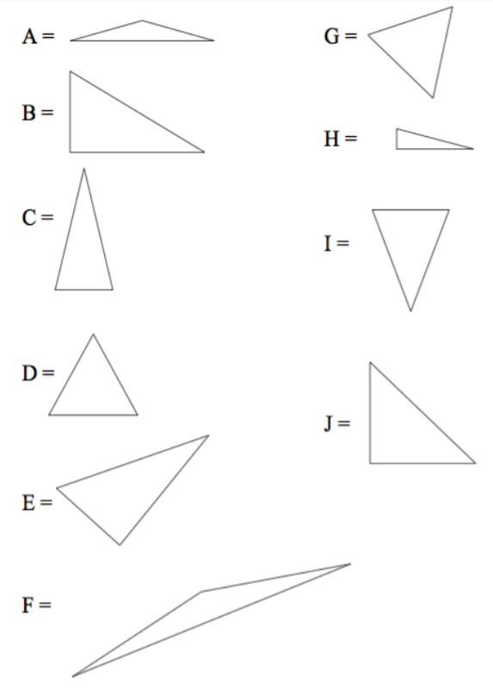

Used with permission from Virginia Dept. of Education, http://www.doe.virginia.gov/testing/solsearch/sol/math/5/mess_5-12ab.pdf

