Family Letter
2nd Grade Addition and Subtraction Concepts

Dear Parents,

During the week of <date> we will be starting a new math unit focused on Addition and Subtraction. The purpose of this letter is to give you some background information about our new unit.

In this unit, your child will:
- Practice efficient math strategies to add and subtract within 20, using mental strategies
- Explore odd and even numbers
- Solve addition and subtraction story problems

This unit will build on the concepts from first grade when students solved addition and subtraction problems within 20. We will be working with numbers within 100.

Strategies that students will learn
You will begin to see several strategies for addition and subtraction. I’ve shared several models below to give you a good understanding of what your child will be doing in math.

Decomposing Numbers: Your child may refer to this as breaking apart numbers into tens and ones to solve this equation. After breaking apart the numbers, your child can add 30+80= 110 and 1+4= 5 and then 110+5=115.
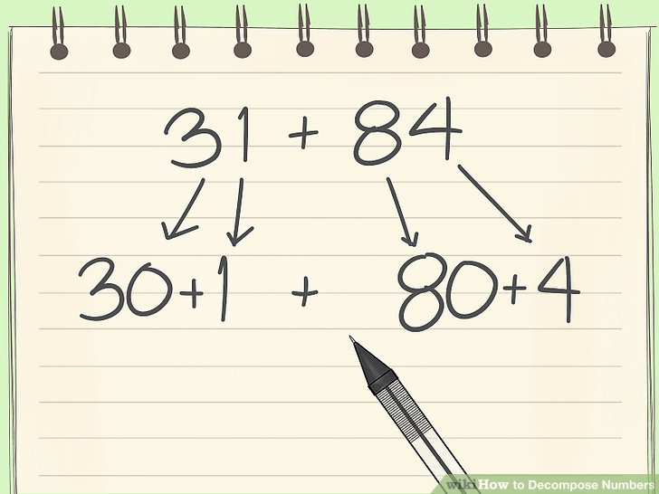

Number Line: The open number line means that students can start at any number. This student started at 45 and jumped three tens on the number line to represent 30 and two jumps to represent 2.
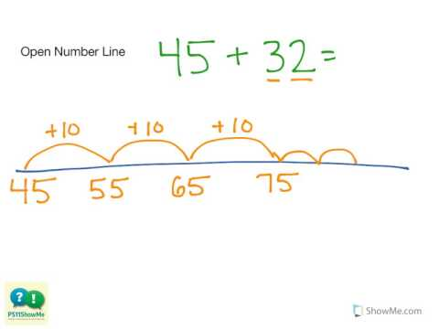

Thank you for serving as partners in your child’s success as a mathematician!
<signature>

