The intended purpose of this document is to provide teachers with a tool to determine student understanding and suggest instructional moves that may help guide a student forward in their learning. It is not an exhaustive list of strategies.

Comparing Two-Digit Numbers

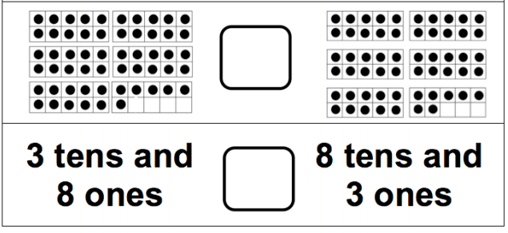
Use one of the 3 symbols to make each statement true. ( symbols are < = > )
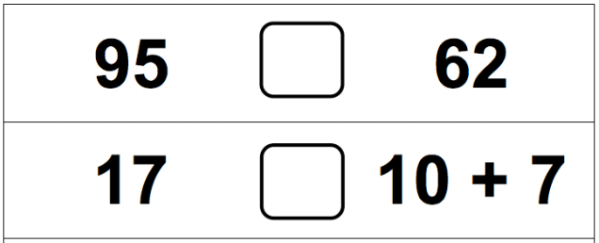

NUMBERS AND OPERATIONS IN BASE TEN
Understand place value.
NC.1.NBT.3 Compare two two-digit numbers based on the value of the tens and ones digits, recording the results of comparisons with the symbols >, =, and <.
Not Yet Proficient | - Ask students to compare numbers within 20 (e.g., 12 and 15).  - Provide tasks similar to the one above with numbers less than 20.  - Instruct student on comparing numbers while writing the words greater than, less than or equal to in order to form a sentence, using numbers less than 10 (Ex. 5 is greater than 3).  - Ask students to build models (cube towers) for the numbers and compare the numbers.
Progressing | - Provide opportunities for students to compare numbers while writing the words and symbols for greater than, less than, or equal to for numbers less than 20 (Ex. 13 is less than 18. 13 < 18).  - Provide ten frame cards or connecting cubes to support students’ exploration of tasks similar to the ones above.
Meets Expectations | - Provide opportunities to deepen understanding of NC.1.NBT.3.  - Begin instruction asking students to identify if two addition or subtraction expressions are >, < or =.  (e.g., 6 + 3 __ 12 - 4)

