The intended purpose of this document is to provide teachers with a tool to determine student understanding and suggest instructional moves that may help guide a student forward in their learning. It is not an exhaustive list of strategies.

Determining Shapes and Their Attributes
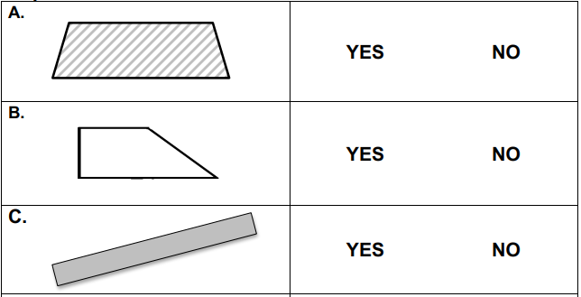
Circle Yes if the shape is a trapezoid. Circle No if it is not a trapezoid. (This could include additional shapes.)

Draw a trapezoid. Describe at least 3 defining attributes of a trapezoid.

GEOMETRY
Reason with shapes and their attributes.
NC.1.G.1 Distinguish between defining and non-defining attributes and create shapes with defining attributes by:
• Building and drawing triangles, rectangles, squares, trapezoids, hexagons, circles.
• Building cubes, rectangular prisms, cones, spheres, and cylinders.

Not Yet Proficient | - Ask the student to orally describe the differences between non-defining and defining attributes.  - Ask student to sort a set of shapes into those that are polygons and those that are not polygons.  - Give students a set of shapes sorted already into polygons and non-polygons and ask them to describe attributes of each set.  - Have students practice drawing and labeling polygons and non-polygons.  Note: Student may copy or trace shapes.
Progressing | - Review defining attributes of shapes (Example: trapezoid)  - A trapezoid has exactly one set of parallel lines, 4 sides, 4 angles, and is a closed figure  - Ask student to sort a set of shapes into two piles (trapezoids and those that are not trapezoids).  Suggested Set: Only quadrilaterals  - Ask student to describe the defining attributes of the trapezoid.  - Provide opportunities for student to practice drawing different representations of a trapezoid. Student may copy or trace trapezoids.
Meets Expectations | - Provide opportunities to deepen understanding of NC.1.G.1.  - Provide opportunities to build composite shapes and describe the attributes of the new shape.  - Provide opportunities to build understanding about the attributes of 3-D shapes.

