Next Steps Document- Kindergarten, Cluster 6
The intended purpose of this document is to provide teachers with a tool to determine student understanding and suggest instructional moves that may help guide a student forward in their learning of a concept or standard. This guide is not an exhaustive list of strategies.
Kindergarten: Cluster 6
Exploring Parts and Wholes with Joining and Separating
NC.K.CC.6 Identify whether the number of objects, within 10, in one group is greater than, less than, or equal to the number of objects in another group, by using matching and counting strategies.

NC.K.OA.1 Represent addition and subtraction, within 10:
● Use a variety of representations such as objects, fingers, mental images, drawings, sounds, acting out situations, verbal explanations, or expressions.
● Demonstrate understanding of addition and subtraction by making connections among representations.

NC.K.OA.2 Solve addition and subtraction word problems, within 10, using objects or drawings to represent the problem, when solving:
● Add to/Take From-Result Unknown
● Put Together/ Take Apart (Result Unknown and Two Addends Unknown)

NC.K.OA.3 Decompose numbers less than or equal to 10 into pairs in more than one way using objects or drawings, and record each decomposition by a drawing or expression.

NC.K.OA.4 For any number from 0 to 10, find the number that makes 10 when added to the given number using objects or drawings, and record the answer with a drawing or expression.

NC.K.OA.6 Recognize and combine groups with totals up to 5 (conceptual subitizing).

Not Yet | Students that are consistently scoring “Not Yet” could have a variety of errors. These errors may include not being able to count 10 objects in a line, array, or circle (K.CC, foundation for K.OA standards). Students at this level may also not be able to represent addition and subtraction situations and use an appropriate strategy to find an answer.
Next Steps:
For students who are not yet able to count a set of 10 objects (foundation for K.OA standards):
- Provide opportunities for students to count sets of objects within 5. Remind them to move counters one at a time as they count. Work with students to ensure they are demonstrating tagging and one-to-one correspondence.
- Provide opportunities for students to count objects by placing counters/cubes on a number path or 10s chart (hundreds board with only numbers 1 to 10. Number paths and 10s charts are good resources since they include each written numeral which helps students to keep track of the number of objects they have.
- Play games that involve students pulling number cards (numbers and pictures) from a stack of cards and counting out that set with objects with the use of a number path or 10s chart. Discuss with students that when we count a set of objects the last number that we say is the total number of objects in that set. “When I counted the group I had 1, 2, 3, and 4. Since the last number I said was 4 that means that I have 4 counters.”

For students who are not yet able to solve addition and subtraction problems (K.OA.1, K.OA.2):
- In small groups or with individual students, use K.OA.1 tasks as a context for counting (K.CC.5). “There are 4 dogs in the park.” Have students represent them on a number path. “How do you know you have 4?” Now 1 more dog comes. Have students represent the new dog on their number path. “How many dogs are there now?” Most students will have to count all the objects from 1 again to find the answer. Work with students on counting strategies as they determine the final answer.
- Focus primarily on addition. Focus on low numbers and situation in which only 1 is added. Based on research, having students learn about addition through word problems and situations in context they are likely to have a deeper understanding than tasks such as “4 joined with 1” or “4 plus 1.” Tasks that are not in word problems have no context and no meaning for students- avoid posing them until students have had ample time to solve word problems that involve addition and subtraction situations.

For students who are not yet able to decompose numbers within 5 (K.OA.3, K.OA.4):
- Provide activities in which students naturally divide a quantity into 2 groups. The examples below, On the Plate and Red or Yellow, allow students to see the entire quantity decomposed. The last example, Snap It, requires students to determine the missing part (K.OA.4) which is a more challenging concept.
  - On the Plate: Students drop a set number of counters onto a paper plate that has a line drawn down the middle of it. Students count the number of counters on each side of the plate then record it on a recording sheet or their math journal. On the Plate and similar activities are an appropriate starting point for students who are not yet able to determine the missing part of a number (K.OA.4).
On the Plate |  |  | Red or Yellow
Left side | Right side |  | Red | Yellow
7 | 1 |  | 2 | 6
5 | 3 |  | 4 | 4
8 | 0 |  | 0 | 8
  - Red or Yellow: Students lightly drop a group of counters onto their paper. They count the red and yellow counters and record them on a table that is similar to the one above.
  - Snap It: Students start with a set number of multi-link cubes connected (e.g., 10 cubes). Students put it behind their back and snap it into 2 smaller pieces. They look at one part, and try to determine determine how many cubes are in the piece they cannot see. Snap it is more difficult since students find the missing part (K.OA.4).

Progressing | Students who are “Progressing” are able to count a group of 10 objects in a line, array, or circle and use their counting skills to explore the other standards in their cluster. Students at this level are working on comparing numbers (K.CC.6, K.CC.7), counting on from a given number (K.CC.2) and working on finding the missing part when a number is decomposed (K.OA.4). Students at this level are also working on determining whether word problems are addition or subtraction and using various ways to represent those situations (K.OA.1, K.OA.2).
Next Steps:

For students who are progressing in solving addition and subtraction problems (K.OA.1, K.OA.2):
- In small groups or with individual students, use K.OA.1 tasks as a context for counting (K.CC.5). “There are 4 dogs in the park.” Have students represent them on a number path. “How do you know you have 4?” Now 1 more dog comes. Have students represent the new dog on their number path. “How many dogs are there now?” Most students will have to count all the objects from 1 again to find the answer. Work with students on counting strategies as they determine the final answer.
- Focus primarily on addition. Focus on low numbers and situation in which only 1 is added. Based on research, having students learn about addition through word problems and situations in context they are likely to have a deeper understanding than tasks such as “4 joined with 1” or “4 plus 1.” Tasks that are not in word problems have no context and no meaning for students- avoid posing them until students have had ample time to solve word problems that involve addition and subtraction situations.
- Lessons: One More Animal, One Less Dog, Ducks on the Pond
- Instructional and Assessment Task: Representing and Solving Problems

For students who who are progressing to decompose numbers within 5 (K.OA.3, K.OA.4):
- Provide activities in which students naturally divide a quantity into 2 groups. The examples below, On the Plate and Red or Yellow, allow students to see the entire quantity decomposed. The last example, Snap It, requires students to determine the missing part (K.OA.4) which is a more challenging concept.
  - On the Plate: Students drop a set number of counters onto a paper plate that has a line drawn down the middle of it. Students count the number of counters on each side of the plate then record it on a recording sheet or their math journal. On the Plate and similar activities are an appropriate starting point for students who are not yet able to determine the missing part of a number (K.OA.4).
On the Plate |  |  | Red or Yellow
Left side | Right side |  | Red | Yellow
7 | 1 |  | 2 | 6
5 | 3 |  | 4 | 4
8 | 0 |  | 0 | 8
  - Red or Yellow: Students lightly drop a group of counters onto their paper. They count the red and yellow counters and record them on a table that is similar to the one above.
  - Snap It: Students start with a set number of multi-link cubes connected (e.g., 10 cubes). Students put it behind their back and snap it into 2 smaller pieces. They look at one part, and try to determine determine how many cubes are in the piece they cannot see. Snap it is more difficult since students find the missing part (K.OA.4).
- Lesson: Coin Drop
- Provide additional practice using Tools4NCTeachers Center Ideas.

For students who are progressing on standards related to comparing numbers (K.CC.6):
- Provide experiences for comparing two quantities using counters. Students can compare numbers by lining up counters where each set has a match. For example, if comparing four black cubes and three white cubes students may line them up and determine there are more more black cubes since there is one extra after matching them up.

- Build and compare: Students draw a number card and build that quantity with counters/cubes. Students draw a 2nd number card and also build that quantity. Students determine which quantity is larger and explain how they know.
- Find one larger, find one smaller: Students draw a number card and build that quantity with counters/cubes. Students then write a number that is smaller than that number and also write a number that is larger than that number. Once students have been introduced to strategies for comparing two quantities, provide additional practice using Tools4NCTeachers Center Ideas.

For students who are progressing on conceptual subitizing (K.OA.6):
- Provide experiences for students to view up to 5 objects on dot cards, images of objects in ten frames, and various arrangements of objects. Have students explain how they see groups of objects within the image that they are viewing.
- Break It Up: Give students five tiles and have them make a picture of the five tiles. Then have students make 2 groups out of the counters and write the quantity in each group. In the picture below students have made a picture with 4 tiles and broke it into 2 groups with 2 objects in each.

- Lesson: Partner Quick Flash

Meets Expectation | Students that are consistently scoring “Meets Expectation” in this cluster are able to consistently demonstrate their understanding of concepts in this cluster.
Next Steps:
For students who have demonstrated proficiency in addition and subtraction word problems (K.OA.1, K.OA.2):
- Provide opportunities for students to solve addition and subtraction word problems within 15. Provide them with number paths, number lines, or double ten frames, and concrete objects (counters, cubes) to support their work.

For students who have demonstrated proficiency decomposing numbers (K.OA.3) and finding missing parts of a number (K.OA.4) within 10:
- Provide more opportunities for students to solve missing parts activities (K.OA.4) for numbers within 10. Work with students on a variety of strategies including counting on and counting back to develop their understanding of combinations for addition and subtraction.

For students who have demonstrated proficiency comparing numbers:
- Spend more time on other Standards in Cluster 7 and/or K.OA.1 and K.OA.2

Five Frame

Ten Frame

Double Ten Frame

Primary Number Cards (Adapted from Investigations, TERC)

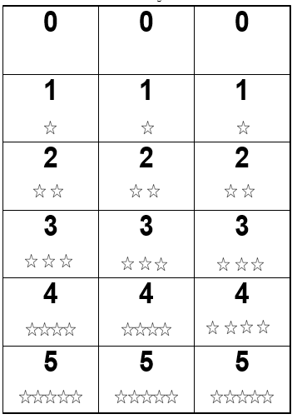

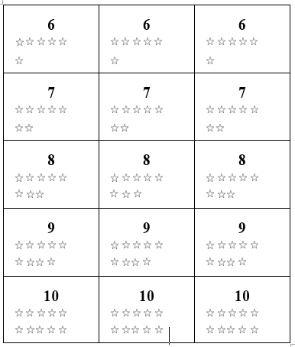

Number Path to 10 (Tens Chart)

1 | 2 | 3 | 4 | 5 | 6 | 7 | 8 | 9 | 10

Number Line

0 |  | 1 |  | 2 |  | 3 |  | 4 |  | 5 |  | 6 |  | 7 |  | 8 |  | 9 |  | 10

