Next Steps Document- Kindergarten, Cluster 7
The intended purpose of this document is to provide teachers with a tool to determine student understanding and suggest instructional moves that may help guide a student forward in their learning of a concept or standard. This guide is not an exhaustive list of strategies.
Kindergarten: Cluster 7
Foundations of Place Value
NC.K.NBT.1 Compose and decompose numbers from 11 to 19 into ten ones and some further ones by:
● Using objects or drawings
● Recording each composition or decomposition by a drawing OR expression
● Understanding that these numbers are composed of ten ones and one, two, three, four, five, six, seven, eight, or nine ones.

NC.K.OA.3 Decompose numbers less than or equal to 10 into pairs in more than one way using objects or drawings, and record each decomposition by a drawing or expression.

NC.K.OA.4 For any number from 0 to 10, find the number that makes 10 when added to the given number using objects or drawings, and record the answer with a drawing or expression.

NC.K.OA.5 Demonstrate fluency with addition and subtraction within 5.
Not Yet | Students that are consistently scoring “Not Yet” could have a variety of errors. These errors may include not being able to decompose numbers within 5 or a lack of fluency with addition or subtraction with numbers larger than 2.
Next Steps:
For students who cannot count a set of 19 objects (foundational for K.NBT.1):
- Provide opportunities for students to count objects. Remind them to move counters one at a time as they count. Work with students to ensure that they are demonstrating tagging and one-to-one correspondence.
- Provide opportunities for students to count objects by placing counters/cubes on a number path or 20s chart (hundreds board with only numbers 1 to 20. Number paths and 20s chart are good resources since they include each written numeral which helps students to keep track of the number of objects they have.

For students who cannot decompose numbers within 5 (K.OA.3, K.OA.4):
- Snap It: Students start with a set number of multi-link cubes connected (e.g., 5 cubes). Students put it behind their back and snap it into 2 smaller pieces. One piece they look at. They then determine how many cubes are in the part they cannot see.

- On the Plate: Students drop a set number of counters onto a paper plate that has a line drawn down the middle of it. Students count the number of counters on each side of the plate then record it on a recording sheet or their math journal.
Left side | Right side
4 | 1
2 | 3

Progressing | Students that are consistently scoring “Progressing” may demonstrate confusion with consistently decomposing teen numbers. They may also struggle consistently demonstrating how to decompose numbers within 10.
For students who can count a set of 19 objects but are unable to decompose a teen number accurately into a group of 10 and leftovers (K.NBT.1):
- Provide opportunities for students to build teen numbers with counters/cubes and a double ten frame. Discuss with them that a completely filled in ten frame is always a group of ten and the ten frame not filled in includes leftovers or ones. For example, a double ten frame with a completely filled in ten frame and 6 counters in the other ten frame would be a group of 10 and 6 ones which could be written as “10 joined with 6” or 16.
- Build it, Change it: Teen Numbers. Students need teen number cards with the numbers 10-19 written on them. Students draw a card and build that number with cubes/counters on the double ten frame. Students then draw another card and change the number of cubes/counters by removing or adding more cubes/counters.
- Lessons: Building Teen Numbers, On and Off the Ten Frame, Ring Around the Tens
- Instructional and Assessment Tasks: Counting Apples
- Tools4NCTeachers Math Centers

For students who cannot decompose numbers within 10 (K.OA.3, K.OA.4):
- Snap It: Students start with a set number of multi-link cubes connected (e.g., 9 cubes). Students put it behind their back and snap it into 2 smaller pieces. One piece they look at. They then try to determine how many cubes are in the piece that they cannot see.
- On the Plate: Students drop a set number of counters onto a paper plate that has a line drawn down the middle of it. Students count the number of counters on each side of the plate then record it on a recording sheet or their math journal.
Left side | Right side
8 | 1
3 | 6
4 | 5
- Lessons: Addie’s Tower
- Instructional and Assessment Tasks for Making Ten (middle column)

For students who are progressing with developing fluency with addition and subtraction within 5 (K.OA.5):
- Provide opportunities for students to play games to practice fluency within 5 for both addition and subtraction. Examples:
  - Roll two dice and determine the sum (or difference) of the numbers generated. Because students should only be working within 5, dice can be custom made by drawing dots on blank number cubes found at a teacher store or craft store.
  - Flip two number cards and determine the sum (or difference) of the numbers.
- For students who are struggling with subtraction work with students on counting on from the number they are subtracting until they reach their start number. 4 minus 1 can be thought of as “1 before 4” which is 3. Or by counting on from 1 until they reach 4, “2, 3, 4” so the answer is 3.
- Lesson: Race to 5
- Instructional and Assessment Tasks (middle column)

Meets Expectation | Students that are consistently scoring “Meets Expectation” in this cluster are able to proficiently meet all standards in this cluster.
Next Steps:

For students who have demonstrated proficiency related to K.NBT.1:
- Spend time on other standards. Students will receive more opportunities with teen numbers as they get into first grade. Do not do place value work beyond 19 in Kindergarten.

For students who have demonstrated proficiency decomposing numbers (K.OA.3) and finding missing parts of a number (K.OA.4) within 10:
- Provide more opportunities for students to solve missing parts activities (K.OA.4) for numbers within 10. Work with students on a variety of strategies including counting on and counting back to develop their understanding of combinations for addition and subtraction.

For students who have demonstrated proficiency in addition and subtraction word problems (K.OA.1, K.OA.2):
- Provide opportunities for students to solve addition and subtraction word problems within 15. Provide them with number paths, number lines, or double ten frames, and concrete objects (counters, cubes) to support their work.

For students who have demonstrated fluency with addition and subtraction within 5 (K.OA.5):
- Pose fluency games with number cards and dice that involve addition within 10. This is a focus in first grade so there is no need to rush students and force automatic recall or memorization of facts.

Teen Number Cards

10 | 11 | 12
13 | 14 | 15
16 | 17 | 18
19 | 10 | 11
12 | 13 | 14
15 | 16 | 17
18 | 19 | 15

Double Ten Frame

Primary Number Cards (Adapted from Investigations, TERC)

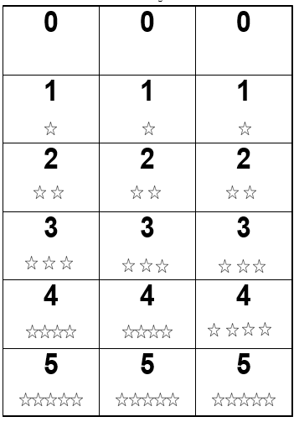

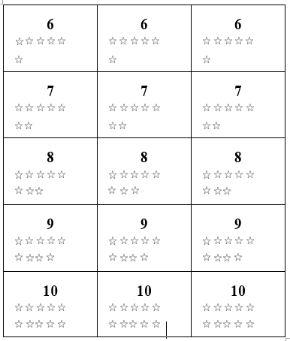

Number Path to 10 (Tens Chart)

1 | 2 | 3 | 4 | 5 | 6 | 7 | 8 | 9 | 10

Number Line

0 |  | 1 |  | 2 |  | 3 |  | 4 |  | 5 |  | 6 |  | 7 |  | 8 |  | 9 |  | 10

