Kindergarten Family Letter
Exploring Parts and Wholes with Joining and Separating

Dear Family,
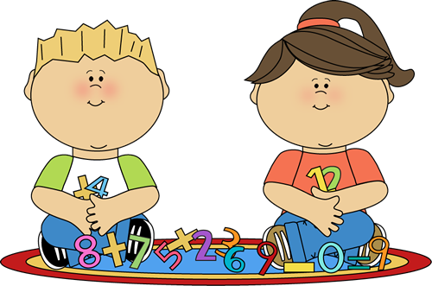
In the last cluster, students worked to develop an understanding that numbers can be decomposed or broken down in different parts. In this cluster, students explore the connection between part-part-whole relationships and solve addition and subtraction word problems.

In this cluster, your child:
- Uses objects and drawings to represent addition and subtraction word problems within 10.
- Solves a variety of problem types.
- Records answers to word problems using drawings, words or expressions. (Students are not expected to use the math symbols +, – , = until 1st grade)

Your Partner in Learning,
_________________________

What types of problems do Kindergartners solve?
Add To and Take From Word Problems: These are simple addition and subtraction problems that have action, so in each problem there is something real-world happening that lets the child know whether something is being added to a set or taken away from a set. Problems may easily be acted out using people, objects, or drawings. Example problems:
- Four children were playing on the swing set. Three more children came to join the fun. How many children are on the swing set now? (This is an Add to problem with the action as three students joining in to play.)
- 9 frogs were on a log. 3 hopped away. How many frogs are left on the log? (This is a take from problem with the action as frogs hopping away.)

Put Together/Take Apart Word Problems with the Total Unknown: These problems have no action. They focus on parts within a collection. The word problem tells the amounts in each part, and students add to find the total amount. Example problem:
Five red apples and four green apples are on the table. How many apples are on the table?
(In the problem above, the 5 red apples are one part and the 4 green apples are the other part. There is no action in the problem that tells the students to add them. They need to put them together to find out how many apples there are on the table.)
Put Together/Take Apart Word Problems with Both Parts Unknown: With these word problems, students are given the total amount, but they do not know the amount in each part. These problems have multiple solutions. Example problem:
There are 5 pigs on the farm. The pigs could either play in the mud, or rest in the grass. How many pigs could be playing in the mud, and how many could be resting in the grass?
(In this problem, there could be 4 pigs playing in the mud & 1 pig resting in the grass, or 3 pigs playing in the mud & 2 pigs resting on the grass, or many other possible solutions.)

How can parents help their child solve word problems?

- Help understand the word problems. Read the word problem aloud to your child. Ask:
  - What do we know from reading the problem?
  - What are we trying to find out?

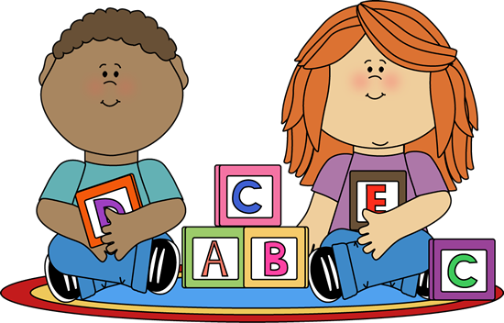
- Encourage your child to use strategies that make sense…to them. Kindergartners represent problems by acting them out, using objects, drawing pictures, or writing numbers. It is helpful to have a variety of materials available so your child may select a way to represent the problem. Materials may include dry noodles, paperclips, building blocks, and cereal. Also keep paper, crayons, and a pencil on hand; children may use these to create their drawings, record numbers, or write words to show their thinking.

- It’s OK to let your child struggle. Don’t be too quick to rescue your child if they’re having a hard time solving a problem.
  - Ask: What do you already know?
  - Help identify missing information needed to solve the problem.
  - Ask: How can you use objects/drawings to show what’s happening in this problem?
  - Avoid doing the work for your child. They CAN do it if they keep trying!

Why isn’t my child expected to write equations or number sentences yet?

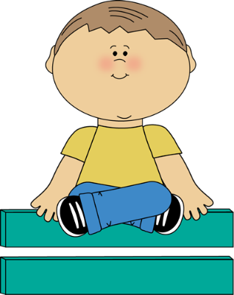
Before children start to record their thinking using symbols like +, – and =, they need to develop a strong understanding of the concepts of addition, subtraction, and equal. Students must also understand how to use specific vocabulary to describe these concepts. For example, before students record their thinking with symbols, they should be able to say statements such as: 3 and 2 has the same value as 5. When your child is ready to start recording their thinking with symbols, he/she will be encouraged to do so in school. However, starting too early can prove to be confusing to children. According to the North Carolina Standard Course of Study, students are not required to write equations until first grade.

