NC.3.G.1
Sally’s Shape Sort
Domain | Geometry
Cluster | Reason with shapes and their attributes.
Standard(s) | NC.3.G.1 Reason with two-dimensional shapes and their attributes.  • Investigate, describe, and reason about composing triangles and quadrilaterals and decomposing quadrilaterals.  • Recognize and draw examples and non-examples of types of quadrilaterals including rhombuses, rectangles, squares, parallelograms, and trapezoids.
Materials | Sally’s Shape Sort handout, pencils
Task | Part 1:  - Provide students with copy of Sally’s Shape Sort handout.  - Read: Sally sorted some shapes into groups.  What rule(s) did Sally use to sort the shapes? Explain your reasoning using precise vocabulary.  Part 2:  - Read: Draw two more shapes for each of Sally’s boxes.

Rubric
Level I  Not Yet | Level II  Progressing | Level III  Meets Expectations
- Student is unable to identify how shapes are sorted.  - Student has little to no explanation to justify reasoning.  - Student is unable to generate additional shapes for each box. | Student does 3-5 of the following:  - Student recognizes that Group A contains trapezoids.  - Student recognizes that Group B contains parallelograms.  - Student justifies reasoning using some precise vocabulary.  - Two additional trapezoids are placed in Group A.  - Two additional parallelograms are placed in Group B.  - Two additional non-examples of trapezoids and parallelograms are placed in the bottom box. | - Student recognizes that Group A contains trapezoids and Group B contains parallelograms.  - Student clearly justifies reasoning using precise vocabulary.  - Student places two additional of trapezoids in Group A, two parallelograms in Group B, and two non-examples of trapezoids and parallelograms in the bottom box.

Standards for Mathematical Practice
1. Makes sense and perseveres in solving problems.
2. Reasons abstractly and quantitatively.
3. Constructs viable arguments and critiques the reasoning of others.
4. Models with mathematics.
5. Uses appropriate tools strategically.
6. Attends to precision.
7. Looks for and makes use of structure.
8. Looks for and expresses regularity in repeated reasoning.

Sally’s Shape Sort

Sally sorted some shapes into groups.

Group A Group B

Shapes that Don’t Belong in Either Group

What rule did Sally use to sort the shapes?
Explain your reasoning using precise vocabulary.

Draw two more shapes for each of Sally’s boxes.

Scoring Examples

Not Yet: These students received a Level 1 (Not Yet) because they attempted to use some precise vocabulary, but they did not accurately identify how the shapes were sorted. They attempted to add more shapes to the boxes, but the work is inaccurate and incomplete.

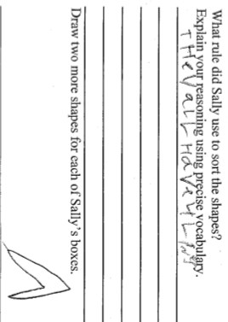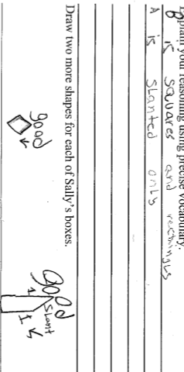
Progressing: This student received a Level II (Progressing) because she accurately identified Group A as trapezoids, but did not accurately identify Group B as parallelograms. She did not provide any further explanation or reasoning using precise vocabulary as to why the shapes are trapezoids and “rectangles.” She added accurate examples of other shapes that would belong in each group, however only added one shape in “Shapes that Don’t Belong in Either Group”.
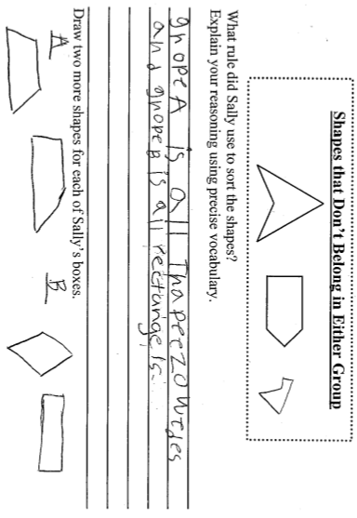
Meets Expectations: This student received a Level III (Meets Expectations) because he accurately identified Group A as trapezoids and Group B as parallelograms, provided justification using precise vocabulary, and accurately added two more shapes to each group. He clearly demonstrates understanding of the attributes of trapezoids and parallelograms.

