Area, Perimeter, and Geometry
Family Math Night
Cluster 5 and 6

Area, Perimeter, and Geometry
Family Math Night

- Overview (Page 3)
  - Summary
  - Target Audience
  - Focus Area

- Preparation Packet (Pages 4-5)
  - Preparation Checklist
  - Advertisement Flier or Letter

- Event Packet (Pages 6-12)
  - Sign-In Sheet
  - Agenda and Materials Checklist
  - NC.3.G.1 Center- Geo-Matchup (Pages 8-10)
  - NC.3.MD.7-8 Center- Cut a Rug (Page 11)
  - Parent Evaluation

Overview
Summary: Area, Perimeter, and Geometry Family Math Night is an opportunity for parents to collaborate with their children using 3rd grade math objectives to solve real world problems. Parents interact with the child’s teacher and other school staff, as well as receive resources to use at home with their child. This parent night focuses on cluster 5 and cluster 6. Prior to beginning, parents will receive the cluster 5 and 6 parent letters from www.Tools4NCTeachers.com.

Target Audience: Third Grade Parents

Focus:
Cluster 5
NC.3.G.1 Reason with two-dimensional shapes and their attributes.
- Investigate, describe, and reason about composing triangles and quadrilaterals and decomposing quadrilaterals.
- Recognize and draw examples and non-examples of types of quadrilaterals including rhombuses, rectangles, squares, parallelograms, and trapezoids.
Cluster 6
NC.3.MD.5 Find the area of a rectangle with whole-number side lengths by tiling without gaps or overlaps and counting unit squares.

NC.3.MD.7 Relate area to the operations of multiplication and addition.
● Find the area of a rectangle with whole-number side lengths by tiling it, and show that the area is the same as would be found by multiplying the side lengths.

● Multiply side lengths to find area of rectangles with whole-number side lengths in the context of problem solving, and represent whole-number products as rectangular areas in mathematical reasoning.

● Use tiles and/or arrays to illustrate and explain that the area of a rectangle can be found by partitioning it into two smaller rectangles, and that the area of the larger rectangle is the sum of the two smaller rectangles.

NC.3.MD.8 Solve problems involving perimeters of polygons, including finding the perimeter given the side lengths, and finding an unknown side length.

Preparation Checklist
- If parents do not already have them, print cluster 5 and 6 parent letters from www.Tools4NCTeachers.com.
- Send out invitations or flyers a few weeks prior to the event to the parents.
- Advertise on email, phone messages, or the marquee at school.
- Prepare and print a sign-in sheet.
- Print the directions for each center and gather necessary materials.
- Print and send a reminder before the day before event.
- Write list of the centers on the board as well as where in the classroom each center is located.
- Consider displaying recent student work on current cluster 5 and cluster 6 for parents to see.
- For the Geo-Match Up, the teacher should print the game board and cut out the cards for the game.

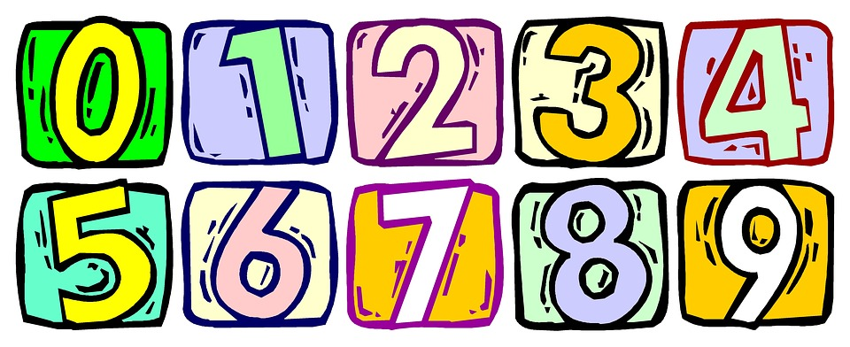
Join Us for a Family Math Night

When: (Insert Date & Time Here)
Where: (Address Here)
Come out and learn third grade math strategies while having a great time with your child. There will be special fun activities for you to learn with your child. We look forward to seeing you at this exciting educational event!

Join Us for A Family Math Night

When: (Insert Date & Time Here)
Where: (Address Here)

Come out and learn third grade math strategies while having a great time with your child. There will be special fun activities for you to learn with your child. We look forward to seeing you at this exciting educational event!
Area, Perimeter, and Geometry
Family Math Night Sign-In
Family Member(s) | Student Name
Area, Perimeter, and Geometry Family Math Night Agenda

As students and families drop in, hand out the parent letters for clusters 5 and 6 provide explanations for the centers listed on the board.

Throughout the time of the event, students will participate in the centers with their families in order to foster area, perimeter, and geometry understanding of cluster 5 and 6 standards. Below are the centers along with the list of required materials.

  - NC.3.G.1 Center- Geo-Matchup
Materials: A set of Geo-Match Up cards per player
  - NC.3.MD.7-8 Center- Cut a Rug (from NCDPI)
Materials: pair of dice, recording sheet, centimeter grid paper

NC.3.G.1 Center
Geo-MatchUp Directions

Materials needed:

- A set of Geo-Matchup cards per player

1. Each player has a set of cards.
2. Players match up their cards.
3. Players compare their answers and agree or disagree.
4. Players defend and prove their answers until all players agree.

Variation/Extension: Play as a memory game. First player turns over two cards. If they match, the player takes the cards and plays again. If not, the player turns the cards back over and play passes to the next player. Players can create additional cards.

NC.3.G.1 Center- Geo-Matchup
Geo-MatchUp Gameboard
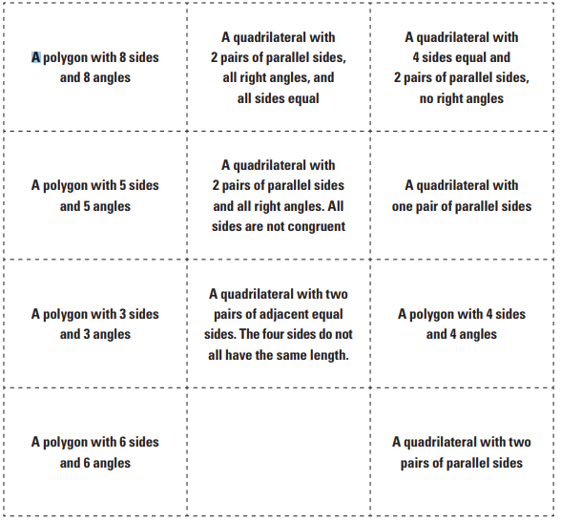

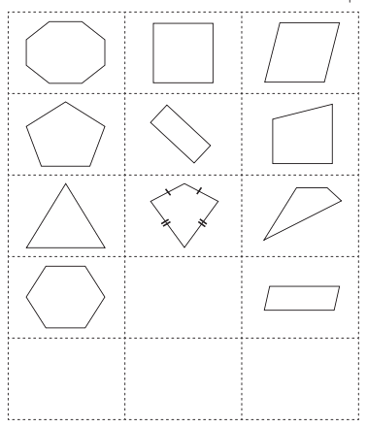
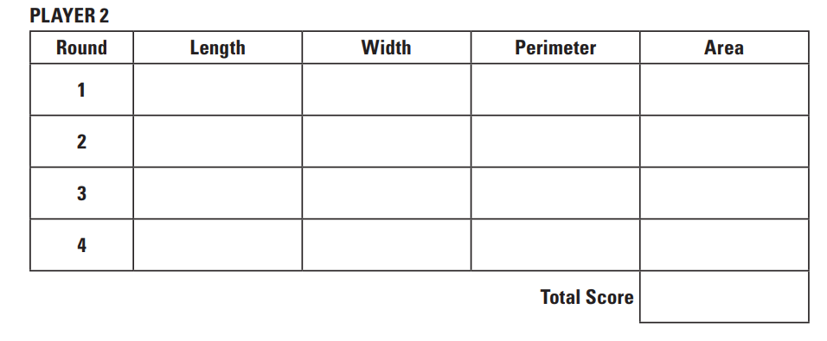
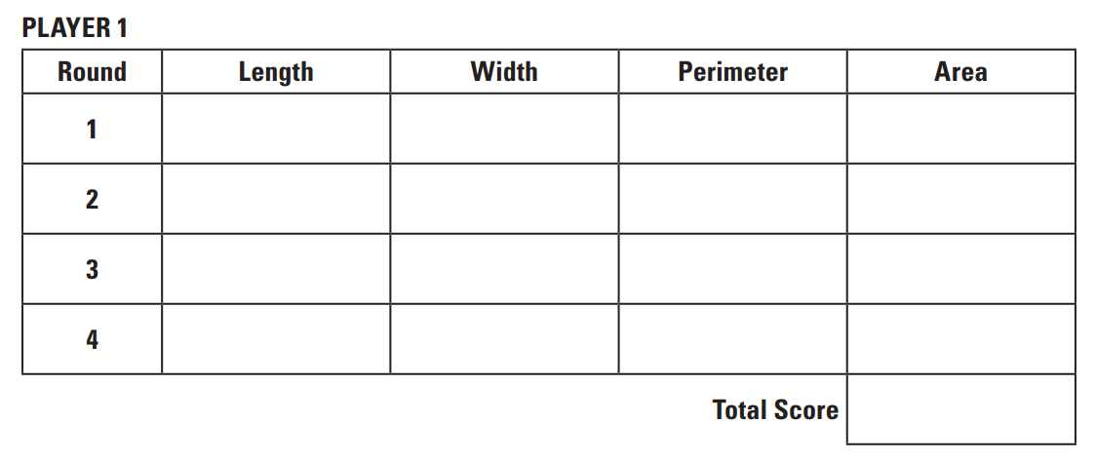
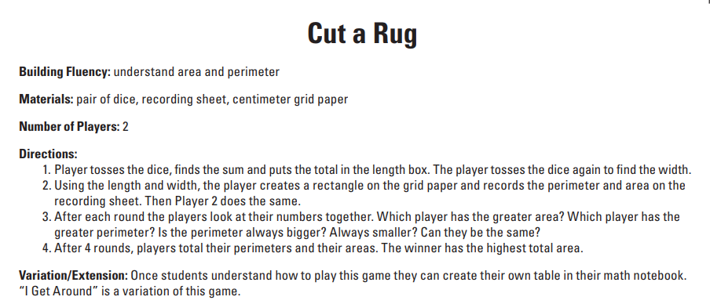
Area, Perimeter, & Geometry Family Math Night Parent Evaluation
Thank you for attending our area, perimeter, and geometry Family Math Night. We value your feedback.
- What was your favorite part of Family Math Night?

- What would you change about our Family Math Night?

- What did you learn from Family Math Night?

- Additional Comments:

Area, Perimeter, & Geometry Family Math Night Parent Evaluation
Thank you for attending our area, perimeter, and geometry Family Math Night. We value your feedback.
- What was your favorite part of Family Math Night?

2. What would you change about our Family Math Night?

3. What did you learn from Family Math Night?

4. Additional Comments:

