Third Grade CMS Cluster 5 Assessment
.Teacher Guide
This assessment assesses students’ ability to:
- Identify shapes by their attributes. Categorize (group) shapes using their attributes.
- Identify and categorize triangles, quadrilaterals, pentagons, and hexagons.
- Use opposite sides, parallel, congruent, vertex, square corner, and angle to describe attributes of shapes (especially quadrilaterals).
- Identify and categorize parallelograms, rectangles, rhombuses, squares, and trapezoids.
- Identify attributes shared by shapes in two different groups. Identify the larger category to which both shapes belong.
- Classify parallelograms, rectangles, rhombuses, squares, and trapezoids as quadrilaterals.
- Classify rectangles, rhombuses, and squares as parallelograms.
- Compare similarities and differences among quadrilaterals.

Common Core Standards:
This assessment addresses each of the following Common Core Standards
Standard | Questions
3.G.1 | 1-12

Data Driven Instruction:
This assessment is one data point and should be used with data gathered from multiple sources to make an informed decision about each student’s misconceptions and mastery.

3rd Grade Assessment – Scoring Guide
Question | Standard | Answer
1 | NC.3.G.1 | C
2 | NC.3.G.1 | A
3 | NC.3.G.1 | B
4 | NC.3.G.1 | C
5 | NC.3.G.1 | B
6 | NC.3.G.1 | D
7 | NC.3.G.1 | D
8 | NC.3.G.1 | B
9 | NC.3.G.1 | A
10 | NC.3.G.1 | B
11 | NC.3.G.1 | Rubric
12 | NC.3.G.1 | Rubric

Rubric Scoring Guide:
Question 11 (4 points):
Student receives 1 point for each of the following bullets:
- Student identifies the first shape as a rhombus
- Student identifies the second shape as a rectangle
- Student gives 2 attributes that the shapes have in common (ie 4 sides, opposite sides that never meet)
- Student gives 2 attributes that the shapes do not have in common (ie rectangle has square corners, rhombus has equal sides)

*Consider giving half credit on each of these items. For example if student uses a less specific name such “quadrilateral” or “parallelogram” for the rhombus, give half credit because the shape does fit in that category, it’s just not the most specific name. Also for the last two questions, students may receive half credit if they only give 1 attribute instead of 2.

Question 12 (4 points):
Student receives 1 point for each of the following bullets:
- Student identifies shape as a parallelogram
- Student identifies shape as a rectangle
- Student identifies shape as a quadrilateral
- Student identifies shape as a polygon

Student Name: ______________________ Date: ______________
3rd Grade Assessment
Directions:
Calculator Active: # 1 – 12
You may use a calculator for this test.
______________________________________________________________
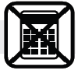
1. Anna drew a pentagon. Her pentagon had some square corners. Which shape might be the one Anna drew?
A | B  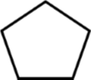 | C | D

2. Ms. King asked her students to draw a quadrilateral with exactly two pairs of opposite sides that will never meet. Which shape might her students draw?
A | B  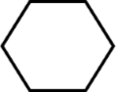 | C  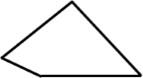 | D

3. Which shape is a rhombus?
A | B | C | D  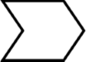

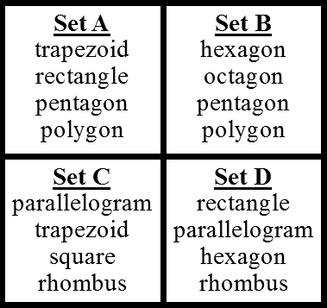
4. Which of the following sets contains only quadrilaterals?

A Set A
B Set B
C Set C
D Set D

5. Which of the following has sides that are not equal?
A B C D
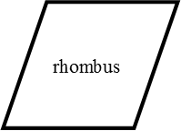
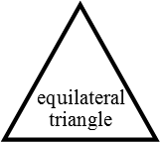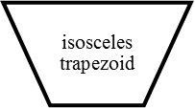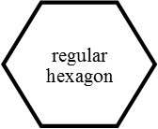

6. Logan drew a hexagon with unequal sides. Which of the following could be the hexagon that he drew?
A | B  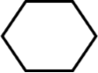 | C | D  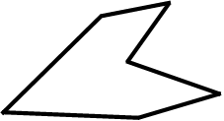

7. Dimitri drew the following shapes on his page:
What title could he use to describe all of the shapes?
A trapezoids B rectangles
C parallelograms D quadrilaterals
8. Susan was told to draw a polygon with at least one square corner. Which shape could Susan draw?
A B

C D
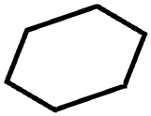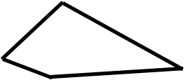
9. Andrew sorted the following shapes using a rule. What name could Andrew give to all the shapes that fit his rule?
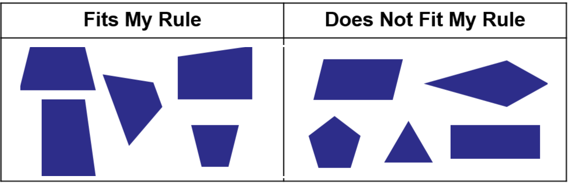
A trapezoids B parallelograms
C pentagons D triangles

10. Look at the two figures below. Which of the following describes an attribute that the two figures have in common?
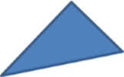

A Both figures have one pair of opposite sides that will never meet or cross.
B Both figures have at least one square corner.
C Both figures have equal sides.
D Both figures have exactly three sides.
11. Look at the two shapes below. Name the shapes below with their most specific name and answer the questions below.

Name: ____________________ Name: ______________________
What are two attributes that the shapes have in common?
__________________________________________________________________________________________________________________________________

What are two attributes that are different on the two shapes?
__________________________________________________________________________________________________________________________________

12. Circle all the names that can be used for this shape:

Trapezoid Square Parallelogram

Rectangle Hexagon

Quadrilateral Polygon Rhombus

