Making Sense of the Order of Operations

In this lesson, students will explore the order of operations conceptually by connecting expressions to context and modeling multi-operation expressions.

NC Mathematics Standard(s):
Operations and Algebraic Thinking
NC.5.OA.2 Write, explain, and evaluate numerical expressions involving the four operations to solve up to two-step problems. Include expressions involving:
- Parentheses, using the order of operations
- Commutative, associative and distributive properties

Mathematical Goals:
- Connect the rules for Order of Operations to story contexts
- Understand how the properties of multiplication are connected to Order of Operations
- Understand the relations between the different operations
- Create models to represent the expressions they are connecting to contexts

Standards for Mathematical Practice:
- SMP 2 Reason abstractly and quantitatively
  - Students can make sense of the quantities in an expression and connect the quantities to a given context.
- SMP 7 Look for and make use of structure
  - Students are aware of and can make use of the properties of multiplication. They recognize that the order in which we add and multiply numbers will impact the result.

Student Outcomes:
- I understand how to use grouping symbols to arrive at a given result
- I can connect the order in which I add, subtract, multiply or divide to a given situation.
- I understand that when there is not a context given, numbers are added, subtracted, multiplied and divided in a certain order.
- I understand that a context and expressions are connected.

Math Language:
What words or phrases do I expect students to talk about during this lesson?
Students will use vocabulary from third and fourth grade such as: addends, sum, difference ,factors, products, and quotient. New vocabulary words that are conceptualized and then used in this lesson are: order of operations, parentheses, contextualize and decontextualize

Materials:
- Task & Exit Card
- Matching Game Cards
- Square Tiles or Centimeter Grid Paper

Advance Preparation:
- Copy Task & Exit Card
- Copy grid paper or prepare square tiles for students to use individually or with a partner.

Directions:
Activity 1: De-contextualizing Story Problems Part 1 (5 minutes)

ENGAGE/ LAUNCH:
Build Upon Prior Knowledge
- Display the following story problem.
  - A family of four went to the movies last night. If each ticket cost $8.00, how much money did the family spend at the movies?
- Have students solve the problem individually, and then share their results with their partners.
- Choose several students to share their methods for solving the problem and record the methods.
- Have students work in partner groups to create an expression that would represent the context of the story problem.
- Remind students that expressions and equations can be contextualized by creating a situation to match the numbers and operations, and story problems can be decontextualized by creating an expression to represent the context.
Activity 2: De-contextualizing Story Problems Part 2 (10 minutes)

EXPLORE:
Introduce the Task
- Display the second story problem.
  - A family of four went to the movies last night. Each ticket cost $8.00, and one of the kids got a candy bar for $4.00. How much money did the family spend at the movies?
- Have students work in partner groups to create an expression that would represent the context of the story problem.
- Choose several students to share their methods for solving the problem and record the methods.
- Discuss the use of parentheses to help organize the steps involved in solving the problem.
- Ask students to use their Square Tiles or Grid Paper to model the expression, and again record the models as students share.
Possible Representation:

$8.00 | $8.00 | $8.00 | $8.00
Multiply 4 groups of $8.00
and then add

$4.00

Activity 3: De-contextualizing Story Problems Part 3 (15 minutes)

EXPLORE:
Introduce the Task
- Display the third story problem.
  - A family of four went to the movies last night. Each ticket cost $8.00, they each got candy bars for $4.00 a piece and they also bought one large popcorn to share for $10.00. How much money did the family spend at the movies?
- Have students work in partner groups to create an expression that would represent the context of the story problem.
- Choose several students to share their methods for solving the problem and record the methods.
- Ask students to use their Square Tiles or Grid Paper to model the expression, and again record the models as students share.
- Focus on the use of parentheses to help illustrate which steps should be solved first.

Informal Evaluation/ Formative Assessment
- Pose questions such as:
  - How did/can you use the distributive property to solve the problem?
  - How does creating a model help you visualize the order of operations we are performing in these problems?
  - Are parentheses necessary when writing expressions for multi-step story problems?

EXPLAIN OUR LEARNING/ WHOLE GROUP DISCUSSION:

- The main ideas to come up in this discussion are:
  - Single expressions can be created to represent contexts with the use of parentheses and multiple operations.
  - Multi-operation expressions can be represented with models. For example:

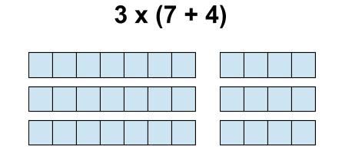

- Pose questions such as: What does the 3 represent? What does the 7 and the 4 represent?
- Ask students to create a story context for the representation above.
- Discuss the following expressions: 3 x 7 + 3 x 4. Why would we not add the 7 and 3? Use the representation to explain the order of operations for the expression 3 x 7 + 3 x 4.

Activity 3: Contextualizing Story Problems Part 3 (15 minutes)

EXPLORE:
Introduce the Task
- Pass out Matching Game cards to each group of partners.
- Ask partners to match the Context Cards with their corresponding Expression Cards.
- Come back together as a group and discuss matches (there will be one extra expression, and 2 expressions / contexts are interchangeable).
- Pose questions such as: How did you know which expressions to match with each context? Why do we have two different Expression Cards for the ____ and the ____ Context Cards? Which expression didn’t match any of the contexts?
- Have partners work together to create a context for the extra expression. Share with the class.

Formal Evaluation/Exit Ticket:

Exit Card:

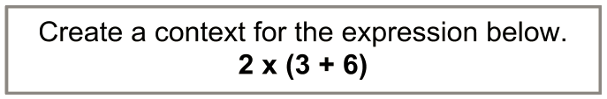

Meeting the Needs of the Range of Learners
Intervention:
- Students may need to practice modeling several single-operation expressions before having them model multi-operation expressions. Remind students of the relationships between repeated addition and multiplication, and repeated subtraction and division. You may want to encourage the use of color when modeling the expressions to differentiate the different operations of the expressions.

Extension: The extension task will ask

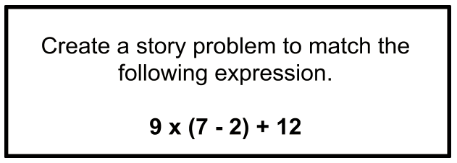

Possible Misconceptions/Suggestions:
Possible Misconceptions | Suggestions
Students may already have memorized the mnemonic for order of operations and may have a hard time “letting go” of that prior knowledge. | Suggest that at first you avoid mentioning the term “order of operations” until students have had time to conceptually explore the concept. Introduce the term “order of operations” once students understand that contexts can be decontextualized and expressions/equations can be contextualized.
Students may assume that there is only one way to solve a multi-operation expression. | Provide students with examples of the distributive property being used to solve multi-operation expressions.

Name: ________________________

Decontextualizing Story Problems Part 1

A family of four went to the movies last night. If each ticket cost $8.00, how much money did the family spend at the movies?

Decontextualizing Story Problems Part 2
A family of four went to the movies last night. Each ticket cost $8.00, and one of the kids got a candy bar for $4.00. How much money did the family spend at the movies?

Decontextualizing Story Problems Part 3
A family of four went to the movies last night. Each ticket cost $8.00, they each got candy bars for $4.00 a piece and they also bought one large popcorn to share for $10.00. How much money did the family spend at the movies?

Matching Game Cards

(3 + 4) x 12 | Twelve friends went to a baseball game. They each bought a foam finger for $4.00 and a drink for $3.00. How much money did they spend at the game altogether?
3 + (4 x 12) | Four people shared a box of mini chocolates. If each person ate 12 chocolates and there were still 3 left in the box, how many mini chocolates came in the box?
12 ÷ 4 - 3 | A dozen cookies were baked for 4 friends to share evenly. Each friend was to get a plate of cookies, but the baker’s dog ate 3 cookies from each plate before any of the friends got to eat one. How many cookies were left for the baker’s friends?
12 x 3 + 12 x 4 | 12 students competed in an athletics showdown. At the beginning of the competition they ran 3 laps around the field. At the end of the competition they ran 4 laps. How many total laps were ran?
12 - (4 + 3)

Name: _________________________________
Making Sense of Order of Operations Exit Ticket

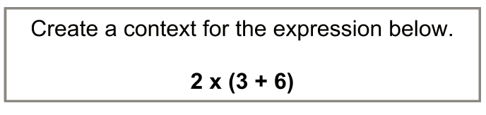

Name: _________________________________
Making Sense of Order of Operations Extension Task

