Nautical Fractions

In this lesson, students will use nautical flags to apply their understanding of addition and subtraction of fractions with unlike denominators within context.

NC Mathematics Standard(s):
Numbers and Operations: Fractions
5. NF. 1 Add and subtract fractions, including mixed numbers, with unlike denominators using related fractions: halves, fourths, and eighths; thirds; sixths; and twelfths; fifths; tenths; and hundredths.
- Use benchmark fractions and number sense of fractions to estimate mentally and assess the reasonableness of answers.
- Solve one- and two-step word problems in context using area and length models to develop the algorithm. Represent the word problem in an equation.

Standards for Mathematical Practice:
Standard for Math Practice 7 Look for and Make Use of Structure
- Students will use prior knowledge of fractions from 4th grade and apply what they know in order to determine equivalent fractions to help students find the sums of fractions.
- Students will notice and use the structure of non-unit fractions as being composed of like unit fractions.
Standard for Math Practice 6 Attend to Precision.
- Students will accurately add fractions using equivalent fractions.

Student Outcomes:

I can use area and linear models to represent equivalent fractions. Students will work to create models to show equivalent fractions and be able to explain/see equivalent fractions.
- I can create like units with an area or linear model to add fractions with unlike denominators. Students will work together to create models to show how to add fractions with unlike denominators.

Math Language:
What words or phrases do I expect students to talk about during this lesson?
Students should be using words or phrases such as: area model, whole, like units, unit fraction, unlike denominator, simplify, common denominator, sum, difference, equivalent fractions, mixed numbers

Materials:
- Paper
- Pencil
- Nautical Flag Chart
- Nautical Fractions recording sheet
Advance Preparation:
- Display the Nautical Flag Chart
- Copy Nautical Flag recording sheet (1 per student)

Launch:
Say: There are many different ways to communicate around the world. Some are verbal like the English language. Others are visual like sign language or math symbolic notation. Sailors use colorful flags to communicate messages. Today we’re going to use our understanding of adding and subtracting fractions using nautical flags.
Say: (Display nautical flag chart.) Take a few moments to look at the chart of nautical flags. What do you notice? What do you wonder?

Explore:

      - Nautical Fractions Part 1: (20 minutes)
- Pass out the Nautical Fractions recording sheet.
- Read through the Task together.
- Jenna wanted to create some of the nautical flags. She had a whole sheet of red paper, a whole sheet of white paper, and a whole sheet of yellow paper. She decided to create the “Oscar” and “Foxtrot” flags. Will Jenna have enough paper to create those two flags? Explain your thinking using models, pictures, and words.
- Give students ample time to grapple with this problem. As students work in groups, walk around monitoring student progress. Strategically choose and sequence 2-3 groups/students to share their solution paths with the whole group. Be strategic about what you are choosing to display - make sure to choose groups that are different and not necessarily correct.

Possible response/model:

I can see that $\frac{4}{8}$ of the “Foxtrot” flag is red and $\frac{4}{8}$ of the flag is white.
I can see that $\frac{1}{2}$ of the “Oscar” flag is red and $\frac{1}{2}$ is yellow.
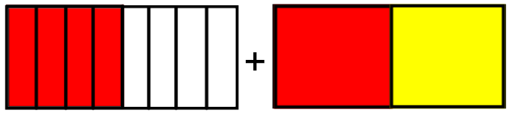
I can see that $\frac{4}{8}$ is equivalent to $\frac{1}{2}$. $\frac{1}{2}+\frac{1}{2}=$ 1 whole. Jenna has enough red paper to create the two flags. I can also see that $\frac{4}{8}$ or $\frac{1}{2}$ of the “Foxtrot” flag is white, and $\frac{1}{2}$ of the “Oscar” flag is yellow. So, she would also have enough white and yellow paper.

Discuss:
      - Nautical Fractions Part 1: (20 minutes)
- Choose three groups/students to model what they found during this exploration. Be strategic about what you are choosing to display - make sure to choose groups that are different and not necessarily correct.
* Have students come back together and discuss how as a group this equation could be represented.

Questions to consider:
- Why did you choose to represent this fraction equation the way that you did?
- Explain your how your representation helps you combine the two fractions.
- Show me where the two fractions are in your representation.
- What do you notice about the models that are on the board?
- Is there something that is the same or different between the representations?
- What connections can we make between adding fractions with like denominators like we did in the launch and the representations you created?

Explore:

- Nautical Fractions Part 2: (10 minutes)
- Have students refer to Part 2 of the Nautical Fractions recording sheet.
- Read through the second portion of the Task together.
  - Which flag combinations would require more than one sheet of blue paper to create? Less than one sheet of blue paper? Exactly one sheet of blue paper? Be ready to explain your thinking. (Answers will vary.)
- Give students ample time to grapple with this problem. As students work in groups, walk around monitoring student progress. Strategically choose and sequence 2-3 groups/students to share their solution paths with the whole group. Be strategic about what you are choosing to display - make sure to choose groups that are different and not necessarily correct.

4. Discuss:
      - Nautical Fractions Part 2: (10 minutes)
- Choose three groups/students to model what they found during this exploration. Be strategic about what you are choosing to display - make sure to choose groups that are different and not necessarily correct.
* Have students come back together and discuss how as a group this equation could be represented.

Questions to consider:
- What do you notice about the models that are on the board?
- Is there something that is the same or different between the representations?
- Are there any flag you specially avoided using? Why?
- Explain the difference between the “Tango” flag and the “3” flag.
- As you were looking for flags that would add to equal exactly 1 sheet of blue paper, what did you notice about the fractions you chose to put together?
- Are there three flags that could be combined to equal exactly 1 sheet of blue paper? Red paper? Etc.?

Evaluation of Student Understanding
Informal Evaluation: The discussion questions posed in the lesson will provide the teacher with enough information as to whether students understand the concepts or not.

Formal Evaluation/Exit Ticket: Have students reflect on questions they may still have; what is something that they learned; and something they could use to help others.

Meeting the Needs of the Range of Learners
Intervention: You may need to return to 4th grade standards and review equivalent fractions; and adding like denominators. Additional work with area models with fractions with unlike denominators to develop visual models for those fractions.

Extension: Ask the students to create a flag challenges that involves adding fractions with unlike denominators. Students will connect the context to the area models.

Possible Misconceptions/Suggestions:
Possible Misconceptions | Suggestions
Students use a common denominator that is larger than the first common multiple. | Have students create a chart of the multiples of that denominator
Students may not clearly model their fractions, therefore their model is not accurate. | Use rulers and marked paper. Ask students to double check that the problem they are working on matches what they are drawing. Ask questions that help them connect the parts of the problem to the representations.
Students may multiply the denominators which may not be the smallest number they could have used thus making it harder for them to simplify. | Students will create a chart of multiples of the denominators.

Nautical Fractions
Part 1

Jenna wanted to create some of the nautical flags. She had a whole sheet of red paper, a whole sheet of white paper, and a whole sheet of yellow paper. She decided to create the “Oscar” and “Foxtrot” flags. Will Jenna have enough paper to create those two flags? Explain your thinking using models, pictures, and words.

Nautical Fractions
Part 2

Which flag combinations would require more than one sheet of blue paper to create? Less than one sheet of blue paper? Exactly one sheet of blue paper? Be ready to explain your thinking.

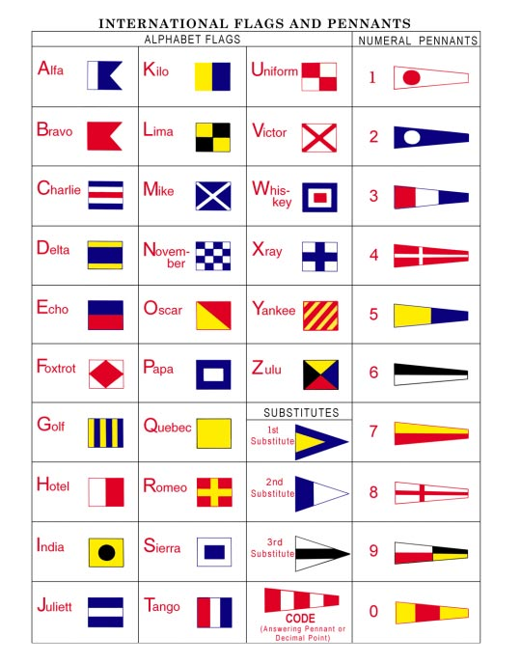
File:ICS-flags.png - Wikimedia Commons
Wikimedia Commons
File:ICS-flags.png

