**5th Grade Cluster 5:**

**Using Models to Add and Subtract Decimals and Fractions**

*Additional Resources*

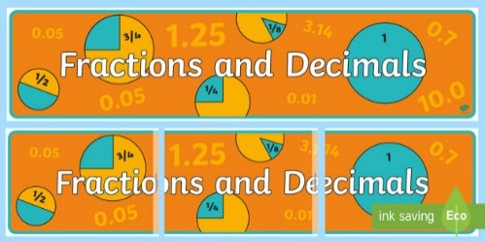

**Professional Reading for Teachers**

**Visit the** [**National Council of Teachers of Mathematics**](https://www.nctm.org/) **for the following article:**

* 5 Indicators of Decimal Understandings
* Understanding Fraction Computation

**Additional Professional Reading**

* [Are These Equivalent to 9.52?](https://www.illustrativemathematics.org/content-standards/tasks/1813)
* [Comparing Decimals on the Number Line](https://www.illustrativemathematics.org/content-standards/tasks/1802)
* [Finding Common Denominators to Add](https://www.illustrativemathematics.org/content-standards/tasks/848)

**Literature Connections**

* *The Wishing Club* by Donna Jo Napoli
* *Piece=Part=Portion* by Scott Gifford
* [Video reading of *Piece=Part=Portion* by Scott Gifford](https://www.youtube.com/watch?v=6kVHBZhzVMU)

**Interactive Activities**

* [Place Value of Decimals](http://www.aaamath.com/B/dec51cx2.htm)
* [Decimals Jeopardy](http://www.math-play.com/Decimals-Jeopardy/decimals-jeopardy-game_html5.html)
* [Fraction Four](http://www.shodor.org/interactivate/activities/FractionFour/)
* [Adding Fractions](http://nlvm.usu.edu/en/nav/frames_asid_106_g_2_t_1.html?from=category_g_2_t_1.html)