Fifth Grade Cluster 5 Assessment - Fractions

This assessment assesses students’ ability to:
- Add and subtract fractions with unlike denominators.
- Find the common denominator of two or more fractions.
- Solve word problems involving addition and subtraction of fractions or mixed numbers with unlike denominators.
- Using visual fraction models and equations to represent the problems involving addition or subtraction of fractions.
- Estimate sums and differences using benchmark fractions.
- Use estimate to determine if actual answer is reasonable.

NCSCOS 2017 Standards:
This assessment addresses each of the following NCSCOS 2017 Standards:

Standard | Questions
NC.5.NF.1 | 1, 2, 3, 4, 5, 6, 7, 8, 9, 10, 11, 12

5 Math Cluster 5 Assessment Scoring Guide
Question | Standard | Answer
1 | NC.5.NF.1 | B
2 | NC.5.NF.1 | D
3 | NC.5.NF.1 | C
4 | NC.5.NF.1 | D
5 | NC.5.NF.1 | A
6 | NC.5.NF.1 | A
7 | NC.5.NF.1 | B
8 | NC.5.NF.1 | A
9 | NC.5.NF.1 | A
10 | NC.5.NF.1 | 11/10 or 1 1/10
11 | NC.5.NF.1 | 54/5 or 10 4/5
12 | NC.5.NF.1 | Rubric (4 pts)

Rubric Scoring:
Question 12 (4 points):
Student receives 1 point for including each of the following bullets in their response:
- Student identifies an equivalent fraction for 3/10 and 2/5.
- Student identifies equivalent fractions with a common denominator so that the two trays can be combined (ie 3/10 and 4/10).
- Student creates models to show that the new fractions are equivalent to 3/10 and 4/10.
- Student states that Ms. Patterson has 7/10 (or a fraction equivalent) tray of brownies left over.

Student Name: ________________________ Date: _________

5th Grade Cluster 5 Assessment - Fractions

1. The models shown are shaded to represent two mixed numbers.
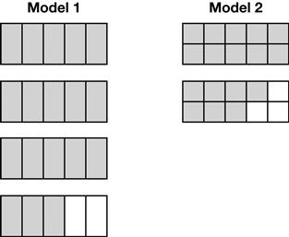

What is the sum of these two mixed numbers?

A 5 $\frac{3}{5}$ B 5 $\frac{3}{10}$

C 4 $\frac{2}{3}$ D 4 $\frac{3}{10}$

2. Macy washed her dirty clothes over the weekend. She used 1$\frac{1}{3}$ scoops of detergent for her white load and $\frac{9}{12}$ of a scoop of detergent for her color load. How much more laundry detergent did she use in the white load?

A $\frac{1}{12}$ of a scoop B $\frac{2}{12}$ of a scoop

C $\frac{5}{12}$ of a scoop D $\frac{7}{12}$ of a scoop

3. How far apart are the two points on this number line?
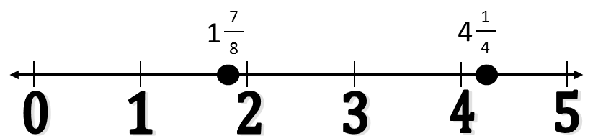

A $2\frac{1}{2}$ B $2\frac{2}{8}$

C $2\frac{3}{8}$ D $2\frac{2}{12}$

4. Maggie carried 3 bags of groceries in from the grocery store.

- The first bag weighed 4$\frac{5}{12}$ pounds.
- The second bag weighed 2$\frac{1}{6}$ pounds
- The third bag weighed 1$\frac{2}{3}$ pounds.

She carried the first bag in her left hand. She carried the second and third bag in her right hand. How much more weight did she carry with her left hand than her right hand?

A 8$\frac{5}{12}$ pounds B 3$\frac{5}{6}$ pounds

C 1$\frac{3}{12}$ pounds D $\frac{7}{12}$ pound

5. Busola had 6 cups of flour. She used 4$\frac{2}{3}$ cups of flour to make cookies. How many cups of flour does Busola have left?
A 1$\frac{1}{3}$ cups B 2$\frac{1}{3}$ cups

C 2$\frac{2}{3}$ cups D 10$\frac{2}{3}$ cups

6. The cafeteria served pizza for lunch to three fifth grade classes. The cafeteria made 18 pizzas to be shared by the three classes.
- Ms. Hill’s class ate 5 $\frac{1}{2}$ pizzas.
- Mr. Jones’ class ate 7 $\frac{3}{4}$ pizzas.

How much pizza was left for Ms. Barnette’s class?
A 4 $\frac{3}{4}$ B 5 $\frac{3}{4}$

C 12 $\frac{3}{4}$ D 13 $\frac{1}{4}$

Plants | Amount Grown
Plant A | 3$\frac{5}{6}$ inches
Plant B | 2$\frac{1}{10}$ inches
Plant C | 4$\frac{3}{12}$ inches

7. Josie has three plants. She is keeping track of how much the plants grow. The table below shows how many inches the plants have grown.

About how many inches have the three plants grown altogether?

A 9 inches B 10 inches
C 11 inches D 12 inches

8. Javion drank $\frac{7}{8}$ quart of juice in two days. He drank $\frac{1}{4}$ quart of juice yesterday. How much did he drink today?

A $\frac{5}{8}$ quart B $\frac{6}{8}$ quart

C 1$\frac{1}{4}$ quarts D 1$\frac{1}{8}$ quarts

9. Sonya was 40 $\frac{3}{8}$ inches tall in kindergarten. She is 60 $\frac{7}{12}$ inches tall in fifth grade. About how many inches taller is Sonya in fifth grade than she was in kindergarten?

A 20 inches B 22 inches

C 101 inches D 102 inches

10. The models are shaded to represent two fractions.

What is the sum of these two shaded fractions?

Answer:

11. What is the value of this expression?

$$14-3\frac{1}{5}$$

Answer:

12. Ms. Patterson made two trays of brownies for a class celebration. After the party, both trays had some brownies left over.

- $\frac{3}{10}$ of the first tray of brownies was left over.

- $\frac{2}{5}$ of the second tray of brownies was left over.

Ms. Patterson decided to combine the two trays of brownies. Explain how she can use equivalent fractions to figure out how much of a tray of brownies she has left. Create fraction models to show the equivalent fractions used to combine the two trays of brownies are the same amount as $\frac{3}{10}$ and $\frac{2}{5}$. How much of a tray does Ms. Patterson have left?

