Name: ______________________________ Date: ___________ Number: _____
Cluster 6: Area of a Rectangle (MD.5)

- Amily is laying concrete blocks to create a backyard patio. What is the area of the backyard patio Amily created?
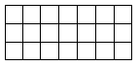

Answer: ________________

2. Jack counted the boxes on a chess board. There are 64 boxes each having an area of 1 square centimeter. What is the total area of Jack’s chess board?

- 1 square centimeter
- 8 square centimeters
- 64 square centimeters
- 65 square centimeters
3. Farrah has 8 square units. Which arrangement of rows and columns can Farrah use to form a rectangle with all 8 square units?

- 4 rows and 2 columns
- 3 rows and 5 columns
- 2 rows and 6 columns
- 1 row and 7 columns
4. Each square represents an area of 1 square unit. What is the area of the shaded portion of the figure?
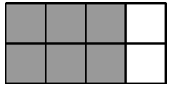

Answer: ________________

