Dear Family,
During the next three units, we will be starting new math concepts focusing on fractions and decimals.
This topic is often one that gives parents hives as they begin trying to help their child at home.
In reality, the standards your child is responsible for are easily obtained because of the conceptual approach used in the classroom. During these units, encourage your child to share these fraction and decimal strategies with you.

Let’s start by knowing what the fractions standards are.
The standards call for students to:
- Use models to understand equivalent fractions.
- Use different strategies to compare fractions with different numerators and
denominators while understanding the size of the whole matters.
- Decompose fractions into smaller fractions using equations and models.
- Add and subtract fractions and mixed numbers with like denominators.
- Solve word problems involving addition and subtraction of fractions.
- Use models to multiply a whole number by a fraction and solve word problems using these models.
- Understand how decimals and fractions are related (1/10=0.1) and make comparisons using this understanding.

Let’s see this in action:
Strategies | Examples
Students will use models to determine equivalent fractions.  By using a variety of models, students begin to see the relationship between numerators and denominators in equivalent fractions. | 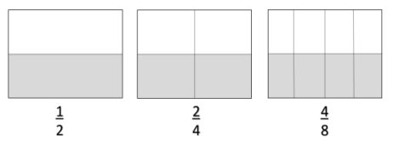  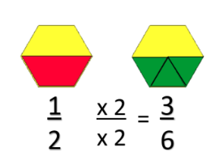  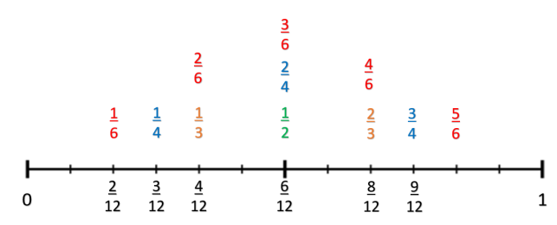
Students will use models to show how decimals and fractions are related. | 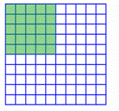  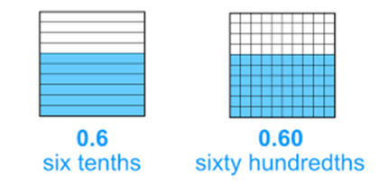  $$.25 = \frac{25}{100} \frac{25}{100}=\frac{1}{4}$$
Students reason about the size of fractions and decimals, using models in order to compare them.  Which is greater, .24 or .3? | Which is larger, 2/3 or 7/8?  “When comparing 2/3 and 7/8, I can think about how in both fractions, the numerator is one piece away from the denominator. 2/3 is 1/3 away from a whole. 7/8 is 1/8 away from a whole. In my model, I can see that even though both fractions only need one piece to make a whole, it is the size of the missing pieces that helps me to know which fraction is larger. 1/3 is larger than 1/8, so it is further away from a whole.”  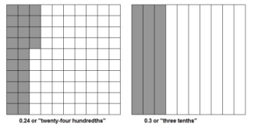  .24 < .3
Students will use benchmark numbers of 0, ½, and 1 to compare numbers. | Which is larger, 3/4 or 2/6?  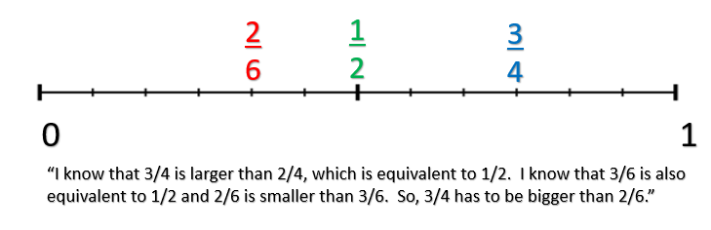
Students will compare fractions using common numerators and common denominators. | Compare 2/6 and 2/4.  “In this situation, both numerators are 2, so I have to think of the size of the pieces. Sixths are smaller than fourths. Since I have the same number of pieces, I know that two of the fourths will take up more space in my whole than two of the sixths.” | Compare 3/5 and 4/5.  “In this situation, both denominators are 5, so I know the pieces are the same size. To find the bigger fraction, all I have to do is figure out which numerator is larger, because the numerator tells me how many of each piece I have. So, 4/5 is bigger than 3/5.”
By decomposing larger fractions into smaller fractions, students develop flexibility in their thinking in order to add and subtract. | 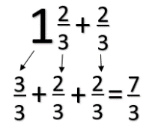
Important Vocabulary:
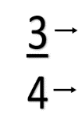
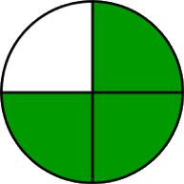
Numerator- The top number in a fraction that represents how many parts of a whole are being considered.
Denominator- The bottom number in a fraction that tells the total number of parts in the whole.
Equivalent- Fractions that have the same value.

Common Student Misconceptions:
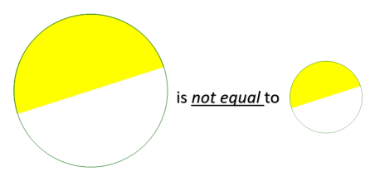
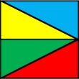 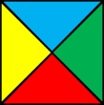 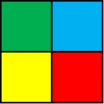 Students often think that the equal-sized pieces must look the same. When given models like these, students do not think the fractional parts are equivalent, when, in fact, they are.

Students often do not consider the size of the whole when dealing with fractions. All halves are not equivalent! The size of the whole determines the size of the fraction.

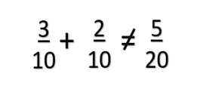
When adding fractions, students will add both the numerators and the denominators, forgetting that the denominator only indicates the size of the pieces, not the number of pieces that need to be added.

