My Cookies!
In this lesson, students compare sets and make equal sets. The lesson should be facilitated at the beginning of a unit on comparing sets once students have been exposed to comparison vocabulary (more, less, greater, fewer).

Lesson may be repeated with amounts closer in range, making it trickier to compare (i.e., 8 & 10).

NOTE: This lesson has two cycles of Launch-Explore-Discuss, which may be done over 1-2 days.

NC Mathematics Standard:
Compare numbers.
NC.K.CC.6 Identify whether the number of objects, within 10, in one group is greater than, less than, or equal to the number of objects in another group, by using matching and counting strategies.

Supporting Standard
NC.K.CC.5 Count to answer “How many?” in the following situations:
- Given a number from 1-20, count out that many objects.
- Given up to 20 objects, name the next successive number when an object is added, recognizing the quantity is one more/greater.
- Given 20 objects arranged in a line, a rectangular array, and a circle, identify how many.
- Given 10 objects in a scattered arrangement, identify how many.

Standards for Mathematical Practice:
4. Model with mathematics
5. Use appropriate tools strategically
6. Attend to precision

Student Outcomes:
- I can use matching to compare two sets of objects.
- I can use counting to compare two sets of objects.
- I can make equal sets.

Math Language:
- More/greater, less/fewer, equal/same amount as

Materials:
- projection equipment (document camera or laptop and projector)
- My Cookies! Pictures on page 5
- Manipulatives such as counters, cubes, or cookie-shaped cereal pieces

Advance Preparation:
- Print My Cookies! pictures (on page 5) to display via document camera, or plan to display pictures using laptop and projector. It’s important that pictures are shown one at a time.
- Ensure that all students have access to manipulatives, paper, and crayons.
Launch (PART 1):
- Display My Cookies! Picture #1. Discuss:
  - This is a picture of Jackson and Reagan. They are brother and sister.
  - What do you notice?
  - How do you think Jackson feels in this picture feels? What makes you think that?
  - How do you think Reagan feels in this picture? What makes you think that?
- Display My Cookies! Picture #2. Ask:
  - What do you notice?
- Introduce today’s task. Say: Some of you said Reagan has more cookies than Jackson. Let’s investigate. Go back to your seats, use manipulatives or paper/crayons to see if Reagan has more cookies than Jackson.

Explore (PART 1):
- Allow 3-5 minutes for students to grapple with today’s task alone.

Observation | Questions to Ask
Student does not know how to start the task. | How many cookies does Reagan have? How can you show that?  How many cookies does Jackson have? How can you show that?  How can you decide who has more?
Student represents the sets, but does not know how to compare them. | How can you organize the sets to easily decide who has more?  How can you use counting to decide who has more?
Student compares by lining up the sets and using matching. | How did lining up the sets help you decide who has more?  What part of Reagan’s set shows that she has more?  How can you record your work using numbers?  Can you record a drawing to match your work?
Student counts to compare the sets. | How do you know that your answer is correct?  How can you record your work? (using pictures, words, numbers)

- As students work, select a few to share their thinking during the “Discuss” section of the lesson. Determine a sequence in which students will share (e.g., strategies that are related and can be compared).

Discuss (PART 1):
- Bring students together to share their thinking. Remind students of the task.
- Have pre-selected students share.
  - As students share, draw attention to representations used (e.g., objects, drawings, numbers, spoken words). Make connections between the representations.
  - Emphasize vocabulary: more/greater, less/fewer.
  - The goal for Part 1 of the lesson is for students to use matching and counting to compare quantities. Draw attention to these strategies, and make connections between them. For example: Piers lined up the sets of cookies next to each other. Morgan counted each set to know who had more. What is the same about their thinking? What is different?
- Close Part 1 of the lesson. Say: As we solved today’s task, we compared two sets of objects. We didn’t just look and guess which has more. We used math to prove our thinking. Today and every day, you can count or line up/match the sets to find who has more and less.
Launch (PART 2):
- Revisit My Cookies! Picture #2. Discuss:
  - How many cookies does Reagan have? Jackson? How many are on the table?
  - Do you think this is fair? Discuss with a partner.
  - Are both sets equal? What does the word equal mean? (same amount as)
- Introduce today’s task. Say: There are eight cookies on the table, but Jackson and Reagan do not have equal amounts. Today’s task is to find a way for them to share the eight cookies so they will both have equal amounts. You may use your manipulatives, crayons, and paper.

Explore (PART 2):
- Allow 5 minutes for students to grapple with today’s task independently.

Observation | Questions to Ask
Student does not know how to start the task. | How many total cookies do we have? (8)  How can you use manipulatives to show this?  How can we share these between Jackson and Reagan?
Student represents the original sets, but does not know how to share them. | How many total cookies do we have? (8)  Right now, which set has more?  How can we move the cookies around so that both sets are equal?
Student represents the original sets, then moves one cookie at a time until both sets match / both sets are equal. | How many cookies does each child get?  How can you check to see if both sets are equal?  How can you record your work using a picture or numbers?
Student counts out 8 cookies, then gives each child one cookie at a time until there are no cookies left. | How many cookies does each child get?  How can you line up the sets to make sure they are equal?  Example of lining up/matching:  How can you record your work using a picture or numbers?

- As students work, select a few to share their solution strategies during the “Discuss” section of the lesson. Determine a sequence in which students will share (e.g., strategies that are related and can be compared).

Discuss (PART 2):
- Bring students together to share solution strategies. Remind students of the task.
- Have pre-selected students share.
  - As students share, draw attention to the representations used (e.g., objects, drawings, numbers, spoken words).
  - Emphasize vocabulary: more, less, equal, same amount as.
  - The goal for Part 2 of the lesson is to find ways to make equal sets, and to use strategies to ensure the sets are equal (e.g., lining up/matching objects from the sets or counting each set). Be sure to highlight these strategies, and model as needed.
- Close Part 2 of the lesson. Say: We solved today’s task by finding equal sets. This means we wanted both groups to have the same amount. Then, we checked to make sure both sets were equal. Today and every day, you can see if sets are equal (have the same amount) by lining up the sets / matching them or by counting.
Evaluation of Student Understanding:
Informal Evaluation:
- When shown two sets of objects, students will be able to determine the quantity in each set and compare them using vocabulary such as: more, less, greater, equal, or same amount as.

Meeting the Needs of the Range of Learners:
Interventions:
- Start students with sets that have smaller quantities.
- Strategically partner struggling students with proficient students.
Extensions:
- Practice comparing sets in stations. Use vocabulary from anchor chart.
- Compare the quantity of each color block within each set.
- Use sets of objects with larger quantities in arrangements such as a circle, line or an array.
- Add a third set of objects for comparison.

Additional Information: This lesson may be repeated using students. When repeating, use amounts that are closer in range and more difficult to compare (e.g., 9 and 10).

My Cookies! Pictures

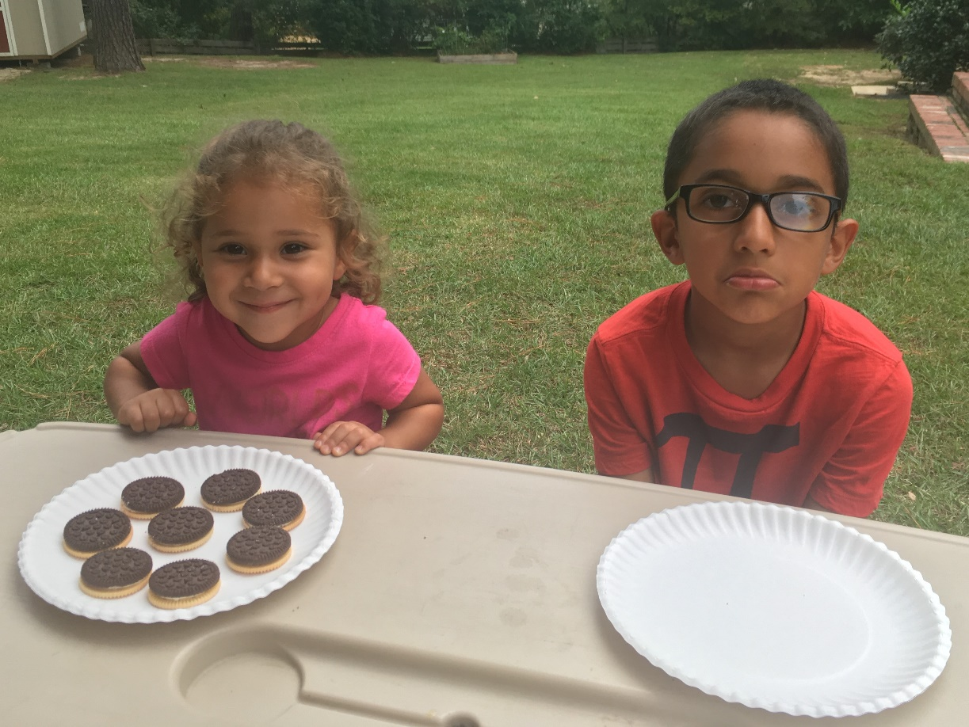
1

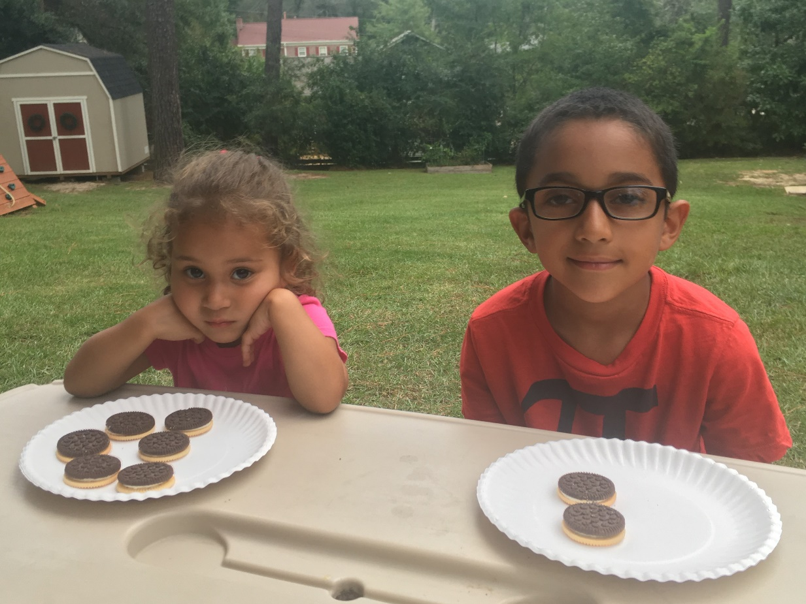
2

