Name _______________________________ NC.4.NF.2 CFA (Cluster 5)

- Ryan, Tony, Lonnie, and Ethan were each running a mile. Ryan ran $\frac{6}{8}$ of a mile before stopping for water. Tony ran $\frac{1}{3}$ of a mile before stopping for water. Lonnie ran $\frac{1}{2}$ a mile before stopping for water, and Ethan ran $\frac{4}{6}$ of a mile before stopping. Who ran the farthest before stopping?
- Tony
- Lonnie
- Ethan
- Ryan

- The two fraction models are each shaded to represent fractions.

Which number sentence correctly compares the fraction model?
- $\frac{3}{6}$ < $\frac{8}{12}$
- $\frac{3}{6 }$ > $\frac{8}{12}$
- $\frac{3}{6}$ = $\frac{8}{12}$
- $\frac{3}{6}$ > $\frac{4}{12}$
- Will and Jayden are both reading the same book for their reading class. Will has read more of the book than Jayden. Jayden has read $\frac{5}{10}$ of the book. Which fraction of the book could Will have read?

- $\frac{6}{12}$
- $\frac{3}{6}$
- $\frac{3}{4}$
- $\frac{4}{10}$

- What fraction goes into the box to make the following statement true?
□ < $\frac{1}{2}$
a. $\frac{5}{8}$
b. $\frac{7}{10}$
c. $\frac{3}{4}$
d. $\frac{1}{4}$

- Kevin walked $\frac{2}{10}$ of a mile to school. Lori walked $\frac{2}{4}$ of a mile to school. Which statement is true comparing Kevin and Lori’s walks to school?

- Kevin and Lori walked an equal distance to school.
- Kevin walked a shorter distance to school than Lori.
- Kevin walked a farther distance to school than Lori.
- Lori walked to school more often than Kevin.
- Which symbol makes the equation true?
$\frac{5}{6}$ □ $\frac{7}{8}$

- <
- =
- >
- ^

- The pictures below shows the amount of pizza Tammy and Ben ate for dinner.
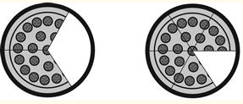
Which statement correctly compares the amount of pizza Tammy and Ben ate?

- $\frac{1}{3}$ < $\frac{1}{6}$
- $\frac{2}{3}$ = $\frac{5 }{6}$
- $\frac{1}{3}$ > $\frac{1}{6}$
- $\frac{2}{3}$ < $\frac{5}{6}$

- What number sentence is true based on the number lines below?

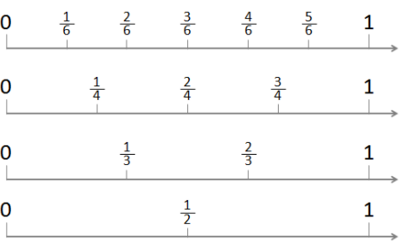

- $\frac{3}{4}$ = $\frac{4}{6}$
- $\frac{2}{4}$ = $\frac{3}{6}$
- $\frac{1}{4}$ = $\frac{2}{6}$
- $\frac{2}{3}$ = $\frac{5}{6}$
- Samantha has 3 pieces of ribbon to make new hair bows. The ribbon is described below.
- A pink piece of ribbon that is $\frac{3}{4}$ of a meter long.
- A yellow piece of ribbon that is $\frac{6}{8}$ of a meter long.
- A purple piece of ribbon that is $\frac{4}{12}$ of a meter long.
Which number sentence correctly compares the lengths of 2 of these pieces of ribbon?
- $\frac{3}{4}$ < $\frac{6}{8}$
- $\frac{4}{12}$ > $\frac{6}{8}$
- $\frac{3}{4}$ > $\frac{6}{8}$
- $\frac{4}{12}$ < $\frac{6}{8}$
- Noah read for $\frac{1}{2}$ an hour. Lily read for $\frac{5}{6}$ of an hour. Jose read for $\frac{3}{4}$ of an hour and Callie read $\frac{2}{3}$ of an hour. Which statement is true about two of these readers?

- Lily read for a greater amount time than Callie.
- Noah and Jose read for an equal amount of time.
- Callie and Lily read for an equal amount of time.
- Jose read for less time than Noah.

ANSWER KEY NF.4.2 (CLUSTER 5)
- D
- A
- C
- D
- B
- A
- C
- B
- D
- A

