Two Sets, Whose Sets?
Prior to this lesson students should have had experiences comparing sets of objects.

The goal of this lesson is to bridge standards CC.6 and MD.2 by comparing sets using measurement concepts and vocabulary.

NC Mathematics Standards:
Compare Numbers
NC.K.CC.6: Identify whether the number of objects, within 10, in one group is greater than, less than, or equal to the number of objects in another group, by using matching and counting strategies.

Supporting Standards:
NC.K.CC.4: Understand the relationship between numbers and quantities.
- When counting objects, say the number names in the standard order, pairing each object with one and only one number name and each number name with one and only one object (one-to-one correspondence)
- Recognize that the last number named tells the number of objects counted regardless of their arrangement (cardinality).
- State the number of objects in a group, of up to 5 objects, without counting the objects (perceptual subitizing).
NC.K.CC.5: Count to answer "How many?' in the following situations:
- Given a number from 1-20, count out that many objects.
- Given up to 20 objects, name the next successive number when an object is added, recognizing the quantity is one more/greater.
- Given 20 objects arranged in a line, a rectangular array, and a circle, identify how many.
- Given 10 objects in a scattered arrangement, identify how many.
NC.K.MD.2: Directly compare two objects with a measurable attribute in common, to see which object has "more of/less of" the attribute and describe the difference.

Standards for Mathematical Practice:
4. Model with mathematics
5. Use appropriate tools strategically
6. Attend to precision
7. Look for and make use of structure

Student Outcomes:
- I can decide if the quantity of objects in one group is greater than, less than, or equal to the quantity of objects in another group (for numbers 0-10).
- I can count to identify a quantity of objects arranged in an array and circle.

Math Language:
Teacher language: array, efficient, compare

Student language: greater than, less than, more, equal, compare, sets, quantity
Materials:
- projection equipment (document camera or laptop and projector)
- table sets of blocks or cubes (20 per pair of students)
- pre-made anchor chart on comparing sets (page 4)
- Pictures #1 and #2 (print one large copy to display, and a class set to place in journals)

Advance Preparation:
- Strategically create list of partners for this lesson.
- Print task to display via document camera, or plan to display pictures using projector.
- Print and glue task in student math journals.
- Place blocks on students’ tables.

Launch
- Ask: Have you ever played blocks with a friend? Did you build as a team or alone? Discuss with your partners.
Sample T-chart
- Display Picture #1.
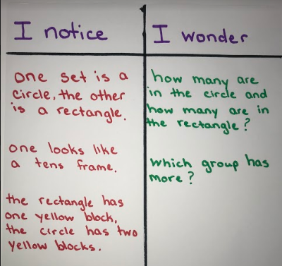
- Have students share with a partner what they notice and wonder. Partners may use sentence starters: I notice ____. I wonder____.
- Select students to share with the class.
- Allow for a wide variety of responses, while purposely selecting students who could wondered who had more/less. It may be helpful for the teacher to make a T-chart of responses (see right).
3. Display Picture #2.
- Focus student thinking on the task: Dianna and Hannah each get a new set of blocks. Hannah has more blocks than Dianna. Which set is Hannah's?
- Say: Discuss the important details of this problem with your shoulder buddy. Make certain that all students make sense of the question the task is asking.
- Say: Today you are going to work with a partner to solve this problem. You may use any of the tools on your table to help you solve the problem. This includes manipulatives, paper, pencils, and the copy of the task in your journal.

Explore
- Allow 7-10 minutes for students to solve the problem with their partner. This exploration time is useful for observing and collecting formative data on students’ current level of understanding. If students are productively grappling, walk around asking questions to elicit thinking (see chart). If the class shows unproductive frustration, pull students back together. Redirect the entire class by asking questions to elicit thinking. The ultimate goal is for the teacher to lead at least one student/pair towards making towers to compare, by asking probing questions like the ones in the chart below. (Ex. How can you use objects (blocks) to check your answer or show your thinking?)

Observation | Questions to Ask
Student does not know how to start the task. | - What we are trying to find out?  - How can you figure out how many blocks each girl has?  - What strategies can you use to count and keep track of the blocks?  - How can we find out which set has more blocks?
Student counts to find the total quantity or counts sets individually, but not for the purpose of comparing. | If student is unable to remember the quantity counted in each set:  - What could you write to help you remember as you count?  If student needs to be refocused on the task at hand.  - What is the question asking use to find?  - How can you use what you have done to decide who has more?
Student counts and attempts to compare, but does not get the correct answer. | - How can you use objects to show how many blocks each girl has?  - What could you do with these blocks to compare them?
Student quickly and correctly completes the task using previously taught strategies. | - What other ways can you represent your thinking?  - How can you use objects to check your answer?  If students compare using numerals...  - How can you prove that your answer is correct?
Student successfully solves the task by making towers to represent the different sets of blocks. | - Why is it important to be careful when building sets to compare?  - How did building a tower help you compare sets?  - How did you know which set has more?

- As students work, select a few to share their shapes during the “Discuss” section of the lesson. Determine sequence in which students will share from the least sophisticated strategy to the most sophisticated strategy.

Discuss:
- Bring students together to share solutions on the carpet.
- Remind students of task and have it displayed on the board.
- Start by having students share their solutions with each other.
- Have pre-selected students to share. This is chance to highlight the math and misconceptions related to today’s goal. The focus for this lesson is to advance students toward more sophisticated problem strategies than they are currently using, such as making towers to compare quantities. When selecting student’s to present they should be ordered by the strategy that they chose, ranging from least sophisticated to most sophisticated.
- As each student shares, direct attention to the strategy used and how efficient it was.
- Ask questions to elicit thinking, drawing attention to more efficient strategies for comparing
- Encourage students to repeat strategies they heard classmates share. This promotes active listening, and encourages students to attend to other’s strategies.

Examples of Problem Solving Methods
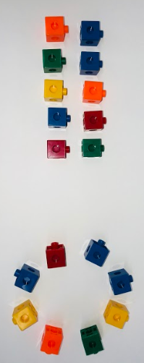 | I used cubes to make the circle and rectangle. Then I counted them. I know that the rectangle has more because 10 is more than 8.
 | I counted the blocks on the picture and drew the same number of blocks. I know that 10 is more than 8 because I looked at the number line.
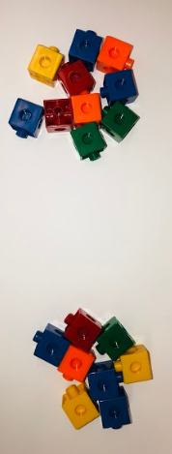 | I made sets that were the same as the ones in the picture. Then, I put each set on a ten frame. I know that 10 is more than 8 because I put them on a tens frame and one tens frame was full and the other was not.
 | I used my cubes to build a tower for each girls set of blocks. I know that the first set has more because the tower is taller than the other one.

- Tell students the answer to the task by saying: The array/first set that looks like a tens frame has more than the set that looks like a circle. That means that the first set is Hannah’s and the second set is Dianna’s.
- Highlight a strategy for comparing sets:
- As we solved today’s task, we saw classmates solve it in a variety of ways. Some students created each set and count, then use a number line or a tens frame to determine which set has more. Others used cubes to build towers to directly compare the two sets by seeing which tower is taller or shorter. These are strategies we can use today and every day to solve problems.
- Display the pre-made anchor chart on comparing sets as pictured below. This could added to an anchor chart that has previously been started when teaching other comparison strategies. Discuss the anchor chart with students.
- Say: Comparing in math means finding ways things or quantities are the same and different. One strategy you can use is building towers to compare sets. When you build towers, you can easily see the differences or similarities by seeing which tower is taller and which tower is shorter. The tower that is taller has more than the tower that is shorter. Sometimes the towers may even be the same size. This means that the quantities are equal.
- Introduce other words for comparing while showing examples (e.g., longer, greater, less)

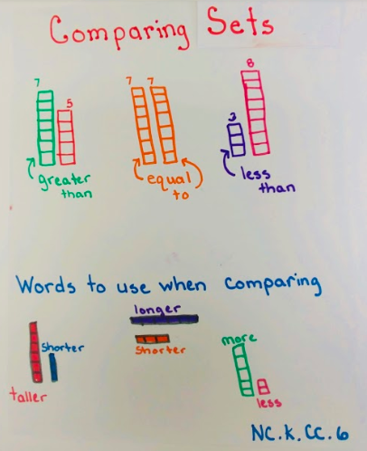

Evaluation of Student Understanding:
Informal Evaluation:
- When shown two sets of objects, students will be able to determine the quantity in each set and compare them using measurement vocabulary such as: more, less, greater, equal, taller, shorter, longer, etc.

Meeting the Needs of the Range of Learners:
Interventions:
- Start students with sets that have smaller quantities.
- Strategically partner struggling students with proficient students.
Extensions:
- Practice comparing sets in stations. Use vocabulary from anchor chart.
- Compare the quantity of each color block within each set.
- Use sets of objects with larger quantities in arrangements such as a circle, line or an array.
- Add a third set of objects for comparison.
Extension Sample:
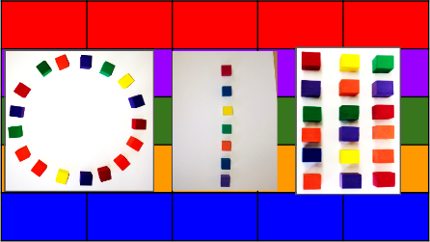

Picture #1
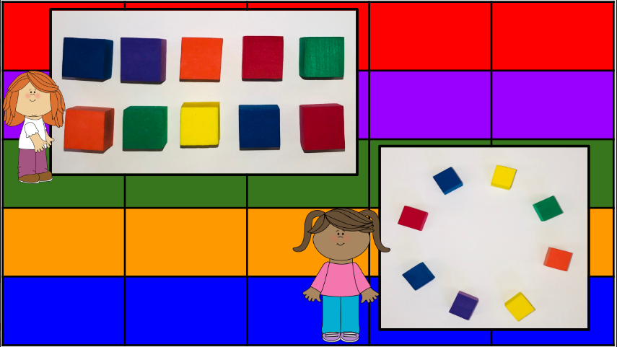

Picture #2
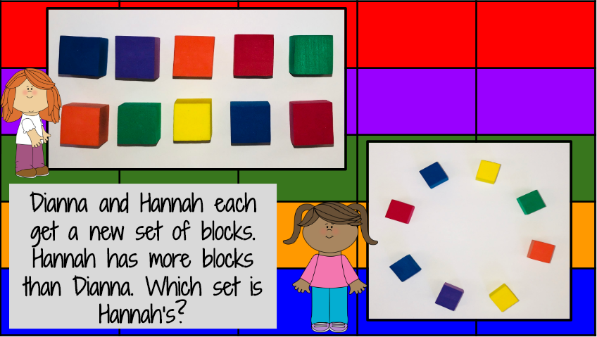

**Can be printed for students or used in math journals.**

