First Grade Properties of Operations Parent Letter

Dear First Grade Family,

During the week of <date> we will be starting a new math unit focused on solving unknown-addend, or missing addend problems. The purpose of this letter is to give you some background information about our new unit.

Focus of the Unit

Your first grader will develop reasoning strategies to solve for missing numbers in equations. In first grade, a box or a picture are symbols used to represent these missing numbers, or unknowns, in equations.
14 = 6 + □ 7 + □ = 15 □ + 3 = 17
First graders apply their understanding by writing and solving equations for situations presented in word problems. These equations represent situations found in the following word problem examples below:
- There are 14 pieces of pizza. Six are pepperoni and the rest are cheese. How many pieces of pizza are cheese?
- Seven kids were swinging on the playground. Some more kids came to swing. Then there were 15 kids swinging. How many kids joined the first seven?
- Some birds were in the yard. Three more birds flew into the yard. Then there were seventeen birds. How many birds were in the yard at first?

Building Off Past Mathematics

Students build on their prior understanding of addition and subtraction situations as well as their fluency of math facts within 10. In kindergarten, students were introduced to the idea of a missing part when they worked on determining how many more to make ten with tasks such as, “Here are six counters. How many more do I need to make ten?” Learning all of the combinations that equal ten is emphasized throughout first grade in order for students to use that understanding to apply the strategy of “making ten” when working with larger numbers.

Strategies that Students Will Learn

Making Ten: 14 = 6 + □  Student A: I know that 6 + 4 makes ten. I need to make 14 which is one ten and four ones. I have ten and I’ll add four more. 4+4 is 8. The missing number is 8. 6+8=14 | Using Known Facts: 14 = 6 + □  Student B: I know that 6+6=12 and 14 is two more than 12 so the missing number is 6+2 or 8
Using a Number Line: 14 = 6 + □  Student C: I started at 6 on my number line and counted up by twos until I reached 14. 14 is 8 more than 6. The missing number is 8.  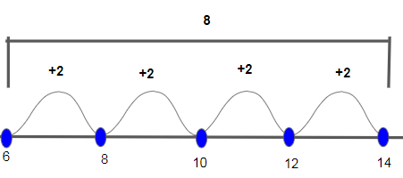 | Change it to a Subtraction Problem:  14 = 6 + □  14 – 6 = □  Student D: I know that six plus something equals 14. 6 is one part of 14. I need to find the missing part. I changed the equation to subtraction. If I take away six from 14, I will know the missing part.  I start by solving 14-4=10, then I find 10-2= 8. I broke up the number 6 into 4 and 2 to make the problem easier. The missing part is 8.

While learning the strategies above, understanding of the commutative and associative properties of addition are also developed. Students are not expected to learn the formal names for these properties in first grade, but they are expected to understand that order does not matter when adding numbers. If a student knows that 6+4=10 we want her to also recognize that she knows 4+6=10 as well (Commutative property of addition). Also, if she needs to add 2+6+4, she can begin by adding the 6 and 4 to make a ten, so 2+6+4=2+10=12 (Associative property of addition).

Ideas for Home Support
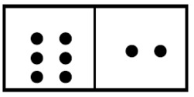
- Domino Number Relationships
  - Choose a domino and write the two addition and subtraction facts that match the domino.
  - 6+2=8 2+6=8 8-6=2 8-2=6
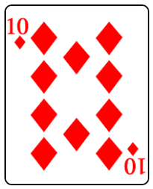
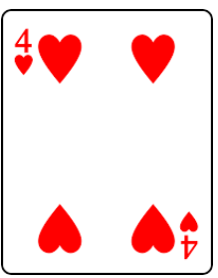
- How Many More to 20?
  - For each turn, players draw and add two playing cards (10+4=14). Then the player determines how many more to make 20 (14+□=20 or 20-14=□). For this turn, the score 6 would be recorded. After ten turns, the winner is the player with the least amount of accumulated points.

Thank you for serving as partners in your child’s success as a mathematician!

<signature>

