Dear Families,

During the <week(s) > of <date> we will be starting a new math unit focused on adding and subtracting using many methods and strategies. The purpose of this letter is to give you some background information about our new unit.

Focus of the Unit
The strategies that students discover and are taught in our 2nd grade class ensure that problems make sense. Learning many ways to think about numbers and their relationships enables our children to use what they know flexibly to solve challenging problems.

Our students will learn to recognize and use patterns including:
- the same digit can have a different value based on where it is placed (7, 70, 700, 7000)
- groups of tens and hundreds can be counted (3 hundreds + 4 hundreds is 7 hundreds)
- changing the order of the numbers they are adding does not change the result
- addition and subtraction are related

Building off Past Mathematics
In kindergarten and first grade, students focused on adding and subtracting within ten and one hundred and learned to count by multiples of ten to one hundred. They learned to organize single objects into groups of ten in kindergarten and groups of one hundred in 1st grade. In 2nd grade, our children use the idea that we can make and break groups of ten, one hundred, and one thousand, add up to four numbers at a time, and add and subtract within one thousand. They also solve addition and subtraction word problems using these numbers.

Strategies Students Will Learn or Continue:

Combinations that Make Tens and Hundreds
Recognizing and using combinations that make tens such as 8 + 2 and 5 +5 or hundreds such as 80 + 20 and 50 + 50 help children understand relationships between numbers and solve problems more easily. For instance, 62 + 48 can be quickly solved by thinking 60 + 40 = 100 and 2 + 8 = 10 more.

Breaking Apart – This strategy becomes even more powerful as students work with larger numbers and add four numbers at a time. Numbers can be broken apart in any way students choose and are often broken down by place value. For instance, 357 is 3 hundreds, 5 tens, and 7 ones or 300 + 50 + 7.

Open Number Line – Students “jump” on a number line to represent adding to or taking away from starting amounts so that they can track and check their thinking. To solve this problem
Miguel is 41 inches tall. His sister, Maria is 78 inches tall. How much taller is Maria than Miguel? There are several ways to solve this on a number line. Here are three possible ways:
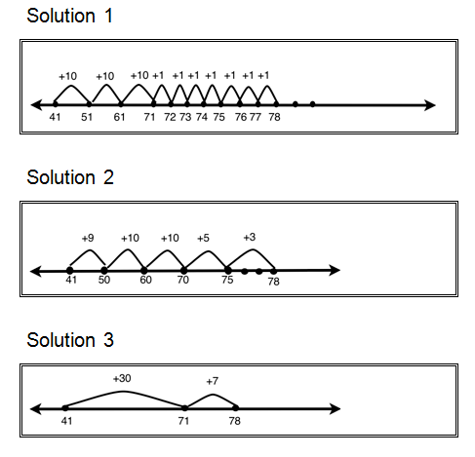

Properties of Addition –
Changing the order of the numbers we add does not change the total or sum. 35 + 27 + 15 + 23 = 35 + 15 + 27 + 23
Changing the grouping of the numbers we add does not change the total or sum. 35 + 27 + 15 + 23 = (5 + 5) + (7 + 3) + (30 + 20 + 10 + 20)
25 + 32 + 75 = 132
A child might rearrange and combine numbers they know go together first. “I know 25 plus 75 is 100 plus 32 more is 132.”
+25
75
+32

75
132
100
A child might do the following. “I broke apart the numbers into tens and ones. I saw that 70 plus 30 is 100 and 20 more is 120. Then I combined the two 5s to make another ten so that I had 130 and the and added the tens first. 20 plus 30 is 50 and then I counted on 7 more tens to 120. Next, I saw that I had two 5s to make another 10 and finally 2 more made 132.”
+10
(5+5)
+2
+30
70
+20

130
132
70
120
100

300 – 134 = 166
A child might use their understanding of place value to break apart 134 like this. “First I took away 100 and then I had 200. I jumped back 30 to 170 and then counted back 4 more to 166.”
-100
-4
-30

166
170
200
300
A child might use their understanding of the relationship between addition and subtraction to count up rather than subtracting. “I decided to add up to 300, so first I added 6 to get to 140 then I jumped 60 to make 200. Then I knew I only needed 100 more.”
+6
+100
+60

300
200
134
140

Ideas for Home Support:
Skip Counting Together
Skip count together with your child by 2s, 5s, 10s, or 100s. For example, the adult starts by saying 10 and the child continues with 20 and so on to count by 10s. Challenge them by starting at different places such as 27, 37, 47, etc. Students count “up” or “down” by a set amount such as 5: 5-10-15 or 95-90-85, 100: 300-400-500 or 800-700-600. Practice with skip counting allows students to recognize and take advantage of patterns with numbers that they can use when adding and subtracting increasingly large numbers.
More or Less
When in the car together, waiting at an appointment, or any other time that you have a few minutes, children enjoy practicing counting up and down one, ten, or one hundred more or less. You can start by skip counting up or down as in, “What is 10 less than 90?” or “What is 100 more than 700?” and then check their understanding of place value with questions such as, “What is 10 more than 397?” or “What is 100 less than 520?” You will be able to tell a lot about what they understand by how challenging the problems they create for you are. These problems can be solved mentally or using visual and written strategies.
Addition and Subtraction Patterns
Ask a series of related questions and have students explain the patterns they notice and how those patterns help them understand addition and subtraction. For instance, “What is 6 - 2?, What is 60 - 20?, What is 600 - 200?, What do you notice about these facts?”

Thank you for serving as partners in your child’s success as a mathematician.

