Second Grade Properties of Operations Parent Letter
Dear Families,

During the week of <date> we will start a new math unit focused on solving story problems with unknowns in all positions. The purpose of this letter is to give you some background information about our new unit.

Focus of the Unit
Your second grader will develop reasoning strategies to solve word problems. Second graders extend their previous work with addition and subtraction word problems in two ways. First, they represent and solve word problems within 100. Second, they represent and solve one and two-step word problems.
Here are some examples of the types of problems they solve:
- There are 29 students on the playground. Some more students joined them. Now there are 47 students on the playground. How many students came? This problem could be represented as 29 + □ = 47 or 47 – 29 = □.
- An example of a two-step word problem is, There are 9 students in the cafeteria. 9 more students come in. After a few minutes, some students leave. There are now 14 students in the cafeteria. How many students left the cafeteria? 9 + 9 - □ = 14

Building Off Past Mathematics
Students build on their prior understanding of addition and subtraction situations as well as their fluency of math facts within 10. In first grade, students were introduced to the idea of a missing part when they worked on determining how many more to make ten, with tasks such as, “Here are six counters. How many more do I need to make ten?” In second grade students extend their knowledge of number facts to 20.

Strategies Students Will Learn:
Throughout the unit, your child will use his/her understanding of the action of addition (putting together/adding to) and subtraction (taking apart/taking from) to choose the operation that makes sense when solving different types of story problems. Rather than focus on key words to develop this understanding, your child will spend ample time:
- acting out problems with classmates
- using objects or counter to model what is happening in story problems
- retelling stories in his/her own words
- drawing pictures to show what is happening
- writing equations that connect to what is happening in story problems
Your child will also become familiar with the meaning of the equal sign and with showing unknowns in various places in equation using symbols.

Ideas for Home Support:
Skillful problem solvers think about a plan before jumping into a solution and do not give up if they get stuck. Help your child make sense of problems and persevere in solving them by asking the following questions while they are working:

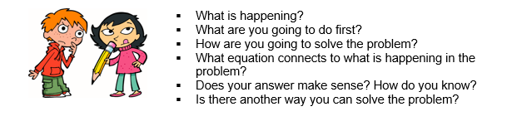

Thank you for serving as partners in your child’s success as a mathematician!

<signatur>

