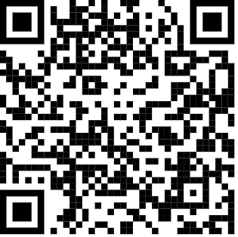
Forces and Motion Playlist
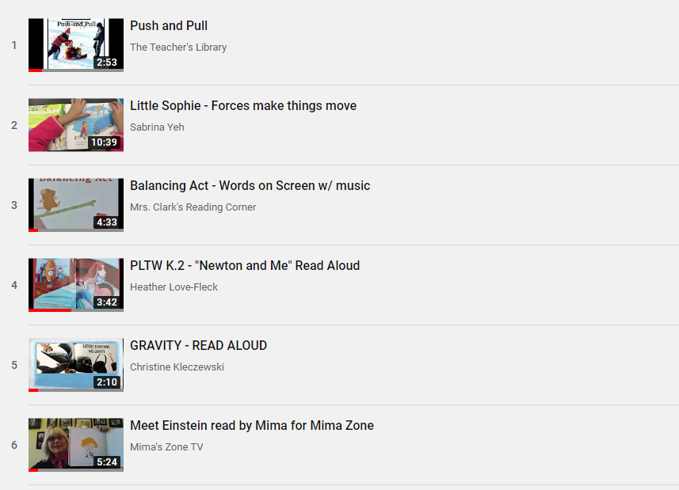

Listen to Reading
Standard(s):
R1.1.2
This Photo by Unknown Author is licensed under CC BY-SA-NC

Book Title: _________________________________

List 3 things you learned about forces, motion, or gravity from the story:
- _________________________________________________________________________________________________________________________________
___________________________________________

- _____________________________________________________________________________________________________________________________
___________________________________________

- ________________________________________________________________________________________________________________________________________________________________________

