Thanksgiving Playlist
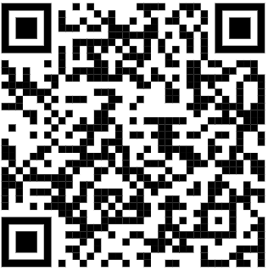
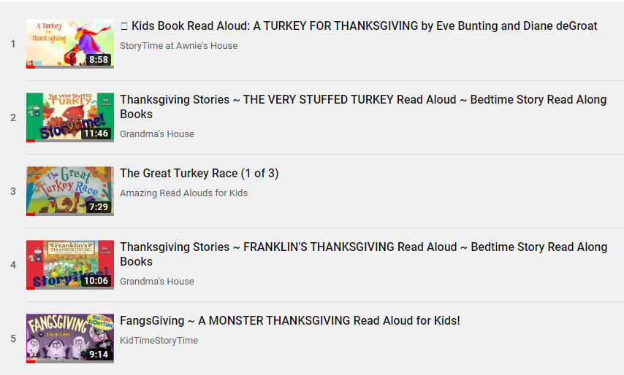

Listen to Reading
Standard(s):
RL.1.3
This Photo by Unknown Author is licensed under CC BY-SA-NC

Book Title: _________________________________
Choose one of the stories and write about one of the characters, the setting of the story and the beginning, middle, and end.

Character: ___________________________________
Character description: _____________________________________
___________________________________________________________________
___________________________________________________________________
Story Setting: _________________________________________________
__________________________________________________________________
Beginning: _______________________________________________________
____________________________________________________________________
____________________________________________________________________
Middle: ___________________________________________________________
____________________________________________________________________
____________________________________________________________________
End: ______________________________________________________________
____________________________________________________________________
____________________________________________________________________

