Comparison Bars

___________

___________
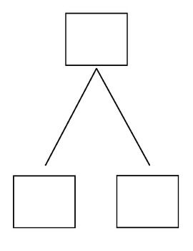
=

Write your equation

______________________
Label
Math Mountain

