Kindergarten Cluster 3 Centers
Math centers are intended to provide students with practice of recently-taught content, as well as spiraled review of concepts and skills from previously-taught Clusters. This specific collection of center activities focuses around the major work of Cluster 3: counting, cardinality, and comparing quantities.

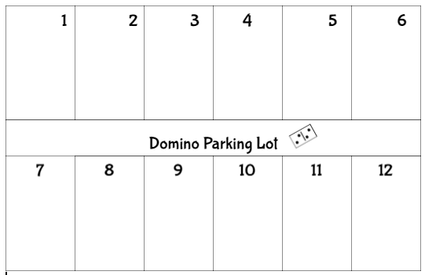 | Domino Parking Lot  Materials: regular dominoes, domino parking lot mat.  Select a domino and count the total number of pips (dots). Place the domino in the parking spot that matches the total number of dots. Dominoes with the same totals may be stacked on top of each other in the parking spot.  Note: Notice if students apply knowledge of perceptual subitizing while identifying the number of dots.
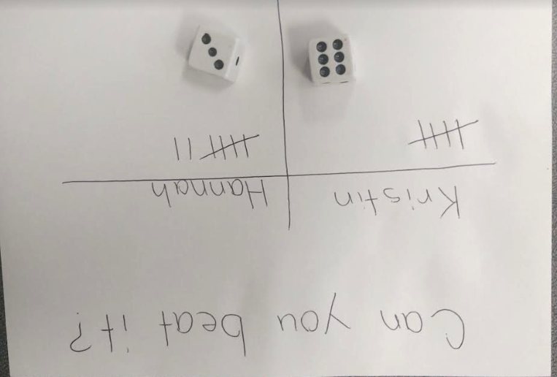 | Can You Beat My Number?  Materials: white board, dry-erase marker, die  Partner 1 rolls the die, determines the quantity rolled, and states the amount. Partner 1 asks Partner 2: Can you beat my number? Partner 2 rolls the die, determines the quantity rolled, and states the amount. The partner with the greater amount gets a tally or check mark under their name for that round. Play until one partner wins 10 rounds.  Option: Each partner gets a tens frame and chips to track rounds won.  Extension: Use two dice or a ten sided die.
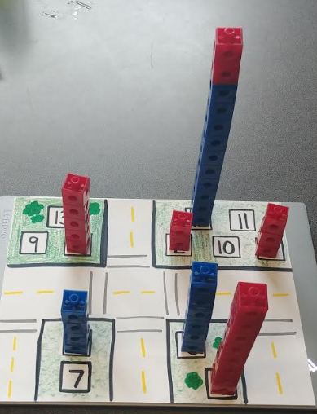 | City of Numbers  Materials: City of Numbers work mat, pop cubes  Use pop cubes to build towers to match the numbers on the City of Numbers work mat.  Optional: Laminate work mats before writing the numbers so numbers on mats can be modified for differentiation.
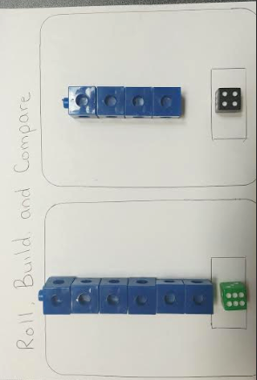 | Roll, Build and Compare  Materials: die, pop cubes  Partner 1 rolls the die, counts the pips, and builds a tower to represent the quantity. Partner 2 does the same. Partners compare their towers using statements such as:  - My tower is taller/shorter than your tower.  - _6_ is more than _4_.  - _4_ is less than _6_.  Extension: Use two dice or a ten-sided die.
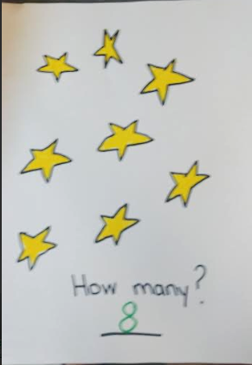 | Track & Count to Find “How Many?”  Materials: dry erase markers and several laminated cards displaying sets in a variety of arrangements. Sets may include drawings, stickers, googly eyes etc. Arrangements may be  - scattered (0-10 objects)  - straight line (0-20 objects)  - rectangular array (0-20 objects)  - circle (0-20 objects)  Use counting strategies to find the quantity on each card. Record the number.

City of Numbers

