Fencing Your Property
POSSIBLE SOLUTION:
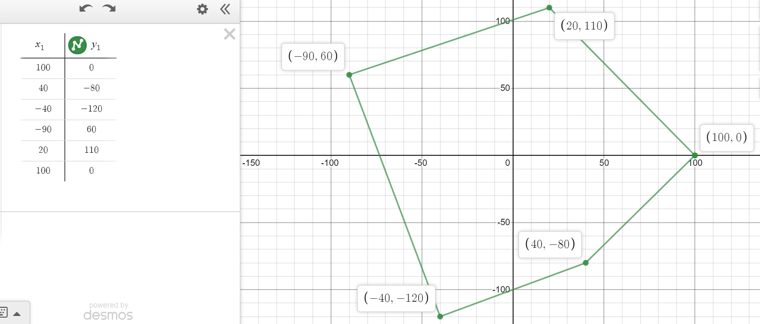
Perimeter (individual distances rounded to hundredths as calculations are done): 633.1 ft
Fence Masters: 633.1($12) = $7,597.20
Good Neighbor Fencing: $250 + (633.1-100)$15 = $8,246.50
Fence Masters has the better price.

