Next Steps Document- Kindergarten, Cluster 3
The intended purpose of this document is to provide teachers with a tool to determine student understanding and suggest instructional moves that may help guide a student forward in their learning of a concept or standard. This guide is not an exhaustive list of strategies.
Kindergarten: Cluster 3
Comparing Quantities with Counting and Spatial Relationships
NC.K.CC.1 Count to 100 50 by ones and by tens.

NC.K.CC.3 Write numbers from 0 to 20. Represent a number of objects with a written numeral 0-20, with 0 representing a count of no objects.

NC.K.CC.4 Understand the relationship between numbers and quantities.
● When counting objects, say the number names in the standard order, pairing each object with one and only one number name and each number name with one and only one object (one-to one correspondence).
● Recognize that the last number named tells the number of objects counted regardless of their arrangement (cardinality).
● State the number of objects in a group, of up to 5 objects, without counting the objects (perceptual subitizing).

NC.K.CC.5 Count to answer “How many?” in the following situations:
● Given a number from 1-20, count out that many objects.
● Given up to 20 objects, name the next successive number when an object is added, recognizing the quantity is one more/greater.
● Given 20 objects arranged in a line, a rectangular array, and a circle, identify how many.
● Given 10 objects in a scattered arrangement, identify how many.

NC.K.CC.6 Identify whether the number of objects, within 10, in one group is greater than, less than, or equal to the number of objects in another group, by using matching and counting strategies.

NC.K.MD.2 Directly compare two objects with a measurable attribute in common, to see which object has “more of/less of” the attribute and describe the difference.

NC.K.G.1 Describe objects in the environment using names of shapes, and describe the relative positions of objects using positional terms.

Not Yet | Students that are consistently scoring “Not Yet” could have a variety of errors. These errors may include not being able to count 10 objects in a line, array, or circle (K.CC standards). Students at this level may not yet be able to identify and describe measurable attributes and/or shapes (K.MD.2, K.G.1).
Next Steps:
For students who are not yet able to count a set of 10 objects in a line, circle, or array (K.CC.4, K.CC.5):
- Provide opportunities for students to count sets of objects within 5. Remind them to move counters one at a time as they count. Work with students to ensure that they are demonstrating tagging and one-to-one correspondence.
- Provide opportunities for students to count objects by placing counters/cubes on a number path or 10s chart (hundreds board with only numbers 1 to 10. Number paths and 10s charts are good resources since they include each written numeral which helps students to keep track of the number of objects they have.
- Play games that involve students pulling number cards (numbers and pictures) from a stack of cards and counting out that set with objects with the use of a number path or 10s chart. Discuss with students that when we count a set of objects the last number that we say is the total number of objects in that set. “When I counted the group I had 1, 2, 3, and 4. Since the last number I said was 4 that means that I have 4 counters.”

For students who are not yet able to orally start to describe shapes, positions, or measurable attributes (K.G.1, K.MD.2)
- Provide opportunities for students to explore shapes in small groups or individually with the teacher. Provide a sentence starter or choices to help students. Examples: “Is the triangle to above or below the square?” “The block is ______ than the piece of paper.”
- For both positions (K.G.1) and measurable attributes (K.MD.2) provide students with a list of a few words to include in conversations about attributes and the positions of shapes. In order to prevent overloading students keep the list to 3-5 words per week.

Progressing | Students who are “Progressing” are able to count a group of 10 objects in a line, array, or circle and use their counting skills to explore sorting and counting quantities after they sorted. In this cluster, students at the “Progressing” level are working towards demonstrating consistent evidence of their understanding of the Geometry and Measurement and Data concepts.
Next Steps:

For students who are progressing towards counting a set of 20 objects in a line, circle, or array or 10 counters in a scatter (K.CC.4, K.CC.5):
- Provide opportunities for students to count sets of objects within 10. Remind them to move counters one at a time as they count. Work with students to ensure that they are demonstrating tagging and one-to-one correspondence consistently.
- Provide opportunities for students to count objects by placing counters/cubes on a number path or 20s chart (hundreds board with only numbers 1 to 20. Number paths and 10s charts are good resources since they include each written numeral which helps students to keep track of the number of objects they have.
- Play games that involve students pulling number cards (numbers and pictures) from a stack of cards and counting out that set with objects with the use of a number path or 10s chart. Discuss with students that when we count a set of objects the last number that we say is the total number of objects in that set. “When I counted the group I had 1, 2, 3, and 4. Since the last number I said was 4 that means that I have 4 counters.”
- NCDPI Games for Fluency and Understanding
- Tools4NCTeachers Math Centers

For students who are progressing on standards related to comparing numbers (K.CC.6):
- Provide experiences for comparing two quantities using counters. Students can compare numbers by lining up counters where each set has a match. For example, if comparing four black cubes and three white cubes students may line them up and determine there are more more black cubes since there is one extra after matching them up.

- Build and compare: Students draw a number card and build that quantity with counters/cubes. Students draw a 2nd number card and also build that quantity. Students determine which quantity is larger and explain how they know.
- Find one larger, find one smaller: Students draw a number card and build that quantity with counters/cubes. Students then write a number that is smaller than that number and also write a number that is larger than that number.
- Lesson: More or Less

For students who are progressing at describing the relative positions of shapes and/or the measurable attributes of objects (K.G.4, K.MD.2):
- Provide opportunities for students to explore and hold objects. Have students describe them using a sentence starter or when given word choices. Examples: “Is the triangle to the left or right of the square?” “The block is ______ than the piece of paper.”

For students who are progressing at determining the difference when directly comparing the measurable attributes of two objects (K.MD.2):
- Work with students in small groups and individually on the process of identifying measurable attributes, measuring objects, and then determining the difference in those attributes. For example, when comparing the length of two pencils, students need to determine how they will measure the pencils and then line them up in a way that an end of each pencil is next to each other. Finally, students need to describe the difference using informal language such as, “The black pencil is longer than the white pencil.”

Meets Expectation | Students that are consistently scoring “Meets Expectation” in this cluster have met all standards with proficiency.
Next Steps:
For students who have demonstrated proficiency with concepts in this Cluster:
- Provide opportunities for students to work on counting with higher numbers (within 35 in a line, circle, array, or by allowing them to touch and move them as they count them).
- Provide opportunities for students to begin solving one-step addition word problems (K.OA.1, K.OA.2). Example: There are 3 birds in the nest. One more bird lands in the nest. How many birds are now there?

Five Frame

Ten Frame

Double Ten Frame

Primary Number Cards (Adapted from Investigations, TERC)

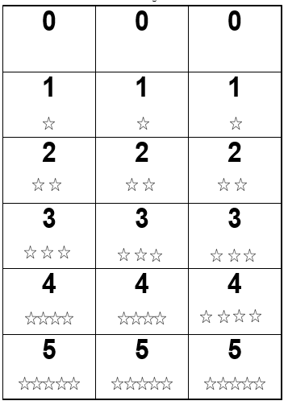

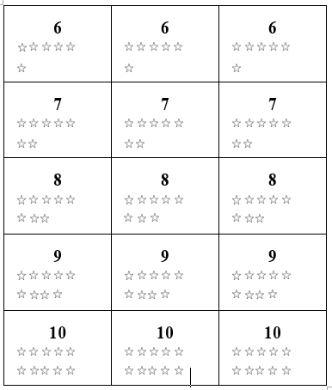

Number Path to 10 (Tens Chart)

1 | 2 | 3 | 4 | 5 | 6 | 7 | 8 | 9 | 10

Number Line

0 |  | 1 |  | 2 |  | 3 |  | 4 |  | 5 |  | 6 |  | 7 |  | 8 |  | 9 |  | 10

