Building 3D Shapes
Prior to this lesson, students should have worked with two-dimensional shapes. Additionally, they should have been introduced to three-dimensional shapes and their attributes with the lesson “Guess My Shape”.

In this lesson, students will use a variety of materials to build shapes and use math vocabulary to explain their shape.

NC Mathematics Standards:
Analyze, compare, create, and compose shapes.
NC.K.G.5 Model shapes in the world by:
- Building and drawing triangles, rectangles, squares, hexagons, and circles
- Building cubes, cones, spheres, and cylinder

Standards for Mathematical Practice:
3: Construct viable arguments and critique the reasoning of others.
5: Use the appropriate tools strategically.
6: Attend to precision.
7: Look for and make use of structure.

Student Outcomes:
- I can name solid shapes and use vocabulary to describe them.
- I can create solid shapes.
- I can compare attributes of solid shapes.
- I can identify flat shapes within solid shapes.

Math Language:

- two-dimensional (flat) shapes
- three-dimensional (solid) shapes
- Circle, rectangle, square, hexagon, triangle, sphere, cone, cube, cylinder
- Side/vertex, corner, angle, face, edge

Materials:
- Examples of real life 3D shapes (or a copy of page 4)
- A variety of building materials: modeling clay, marshmallows, gumdrops toothpicks, popsicle sticks, pipe cleaners, Wikki Stix, straws

Advance Preparation:
- Collect 3D objects to use as examples, or print page 4.
- Collect building materials for students.

Launch:
- Activate prior knowledge:
- Review names and attributes of 2-dimensional shapes using classroom materials (e.g., anchor chart, flash cards, math journals, or video 2D Shapes I Know)
- Discuss defining attributes of flat shapes such as sides, angles, and vertices/corners.
- Say: We have been learning about two-dimensional (flat) shapes. To review, create a flat shape using materials at your table. When you finish, describe your shape to your partner. Have your partner guess its name. Make sure both of you take a turn.
- This time may be used as a quick assessment, ensuring students are creating, identifying and using correct vocabulary describe shapes.
- Launch the task:
- Say: Look at the flat shape you created. You know so much about two-dimensional shapes. Knowing about two-dimensional shapes can be helpful when building three-dimensional shapes. Today, your math task is to make a three-dimensional (solid) shape. If you would like, you may use the same materials from your two-dimensional shape.
- Have students turn and explain the directions to their partners.

Explore:
- Allow 5-10 minutes for students to create their shapes. This exploration time is useful for observing and collecting formative data on students’ current level of understanding. If students are productively grappling, walk around asking questions to elicit thinking (see chart). If the class shows unproductive frustration, pull students back together. Redirect the entire class by asking questions to elicit thinking.

Observation | Questions to Ask
Student has difficulty getting started. | - What is the task asking us to do?  - Look at the three-dimensional objects on my table. What shapes do you see?  - Pick one of my shapes. What are words you could use to describe it?  - How can you form a ______ using your materials?
Student creates shape incorrectly. | - How can you describe your shape using math vocabulary?  - What shape did you make? Look at our classroom anchor chart. How does that shape look different from the one you created?  - What can you do to make your shape look like this example?
Students is unsure of the term “three-dimensional”. | - Look at this circle and this cylinder. How are they different?  - Look at this square and this cube. How are they different?  - The cylinder and cube are both three dimensional. What is the same about them? (Examples: They can be picked up and moved. They aren’t flat. They stand up on the table. They take up space.)  - How can you create a three-dimensional (solid) shape?
Student is building a shape using trial and error. | Note: Trial and error is a great strategy for this task. As students use trial and error, probe students to think about specific attributes of their shapes.  - What are the attributes of your three-dimensional shape?  - What flat shapes do you see in your solid shape?
Students quickly and correctly creates a shape. | - What are the attributes of your three-dimensional shape?  - What flat shapes do you see in your solid shape?  - You just made a _____. Can you make another one that looks different, or is made from a different material?

- As students work, select a few to share their shapes during the “Discuss” section of the lesson. Determine sequence in which students will share (e.g., justifications for knowing shapes progress from least to most sophisticated).

Discuss:
- Bring students together to share solutions.
  - Remind students of task.
  - Have students share their shapes with each other.
- Have pre-selected students to share.
  - As each student shares, direct attention to math language/vocabulary.
  - Ask questions to drawing attention to specific attributes of each shape.
  - Encourage students to explain strategies they used to create their shapes. Then, ask classmates to repeat those strategies. This promotes active listening, and encourages students to attend to other’s strategies.
- Have a few students share struggles they may have had to overcome during this task.
- The goal of this lesson is to create three-dimensional shapes, paying close attention to their attributes. Be sure to maintain focus on this goal during the class discussion. Ask questions to build connections between solid shapes and flat shapes within solid shapes.
  - What flat shape did you see in this cylinder? (circle)
  - What other solid shapes did we learn about that had circle faces?
- Close: Every day we see shapes within other shapes. Having a good understanding of shapes helps us become future mathematicians, engineers and scientist.

Evaluation of Student Understanding:
Informal Evaluation:
- Observe students create a three-dimensional shape.
- Ask students to identify the attributes of their shapes.

Meeting the Needs of the Range of Learners:
Interventions:
- If students have difficulty, it may be necessary to modify the materials they use (e.g., use modeling clay or magnetic shapes).
- Strategically pair students with proficient students

Extensions:
- Students record shapes, shape names, and attributes in math journals.
- Place materials in a center for students to create other shapes.
- Compare and contrast shapes in small groups of centers

Examples of 3-Dimensional Shapes
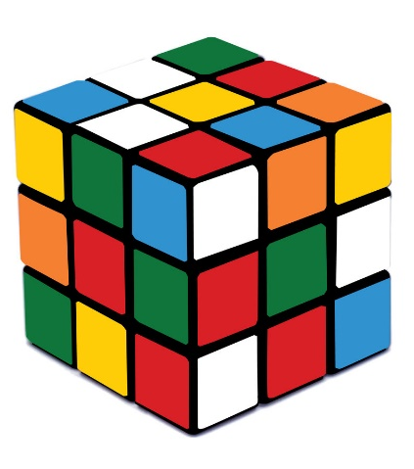  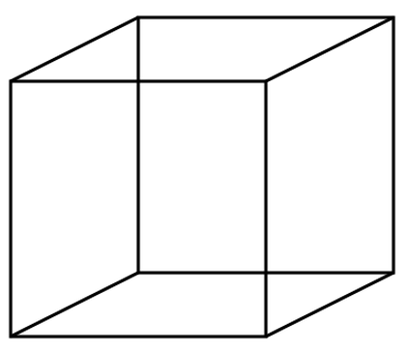 | 