NC.K.G.2 and NC.K.G.3
Naming 2-D & 3-D Shapes
Domain | Geometry
Cluster | Identify and describe shapes.
Standard(s) | NC.K.G.2 Correctly name squares, circles, triangles, rectangles, hexagons, cubes, cones, cylinders, and spheres regardless of their orientations or overall size.  NC.K.G.3 Identify squares, circles, triangles, rectangles, hexagons, cubes, cones, cylinders, and spheres as two-dimensional or three dimensional.
Materials | BLM of “Naming 2D and 3D Shapes Card” (cut out), collection of 3-D objects (cube, cone, cylinder and sphere)
Task | Show each shape or shape card one at a time to the student.  - Say: What is the name of this shape?  - Why do you think this is a _________? (use shape name stated by the child)  - Is this shape a 2-dimensional or 3-dimensional shape? How do you know?
 | A-triangle  B-Square (not a diamond)  C- Cylinder  D- rectangle  E-Triangle  F-cube | G-square  H-sphere  I-circle  J-cone  K-hexagon  L-rectangle

Continuum of Understanding
Not Yet Proficient | - Unable to name the shapes  - Unable to determine if shapes are 2-D and 3-D shapes
Progressing | - Names most shapes correctly  - Names regular shapes, but is not able to name irregular shapes or shapes in atypical orientations.  - Uses non-geometric attributes to describe/justify shape names (e.g., color, size, texture, etc.).  - Correctly determines if some shapes are 2-D or 3-D shapes
Meets  Expectation | - Names all of the shapes correctly.  - Uses geometric attributes to describe/justify shape names (e.g., number of sides, number of edges, number of corners, etc.)  - Correctly determines if shapes are 2-D or 3-D and can explain their rationale

Standards for Mathematical Practice
1. Makes sense of problems and perseveres in solving them.
2. Reasons abstractly and quantitatively.
3. Constructs viable arguments and critiques the reasoning of others.
4. Models with mathematics.
5. Uses appropriate tools strategically.
6. Attends to precision.
7. Looks for and makes use of structure.
8. Looks for and expresses regularity in repeated reasoning.

Naming 2-D & 3-D Shapes Cards

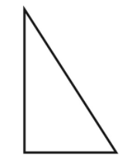  Card A | 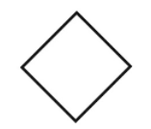  Card B | (Show the cylinder)  Card C
Card D | 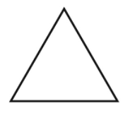  Card E | (Show the cube)  Card F
Card G | (Show the sphere)  Card H | Card I
(Show the cone)  Card J | 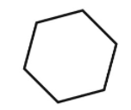  Card K | Card L

