NC.K.G.1, NC.K.G.2, and NC.K.G.3
Positional Words with 3-D Shapes
Domain | Geometry
Cluster | Identify and describe shapes.
Standard(s) | NC.K.G.1 Describe objects in the environment using names of shapes, and describe the relative positions of objects using positional terms.  NC.K.G.2 Correctly name squares, circles, triangles, rectangles, hexagons, cubes, cones, cylinders, and spheres regardless of their orientations or overall size.  NC.K.G.3 Identify squares, circles, triangles, rectangles, hexagons, cubes, cones, cylinders, and spheres as two-dimensional or three dimensional.
Materials | Blackline Master of 3-D shape cards (cut out)
Task | Say: I’m going to show you some pictures of some shapes from our environment.  - Show Card A. Say:  - Look at the traffic cone. Use your words to tell me where the soccer ball is on the paper.  - What shape is the soccer ball? (sphere)  - How do you know?  - Show Card B. Say:  - Look at the baseball. Use your words to tell me where the trashcan is on the paper.  - What shape is the trash can? (cylinder)  - How do you know?  - Show Card C. Say:  - Look at the soda can. Use your words to tell me where the alphabet block is on the paper.  - What shape is the alphabet block? (cube)  - How do you know?  - Show Card D. Say:  - Look at the dice. Use your words to tell me where the party hat is on the paper.  - What shape is the party hat? (cone)  - How do you know?  - Show students all the cards. Say:  - These pictures you’ve been looking are shapes you might see every day like cones, cubes, spheres and cylinders. Are these three dimensional shapes or two dimensional shapes.  - How do you know?

Continuum of Understanding
Not Yet  Proficient | - Cannot name any shapes correctly  - Connect describe the relative position of some objects using positional words  - Cannot classify shapes as 2-D and 3-D shapes
Progressing | - Names some shapes correctly  - Describes the relative position of some objects using positional words  - Has some understanding of the differences between 2-D and 3-D shapes
Meets  Expectation | - Names all of the shapes correctly.  - Correctly describes the relative position of objects using positional words  - Shows understanding of the differences between 2-D and 3-D shapes

Standards for Mathematical Practice
1. Makes sense of problems and perseveres in solving them.
2. Reasons abstractly and quantitatively.
3. Constructs viable arguments and critiques the reasoning of others.
4. Models with mathematics.
5. Uses appropriate tools strategically.
6. Attends to precision.
7. Looks for and makes use of structure.
8. Looks for and expresses regularity in repeated reasoning.

3-D Shape Cards

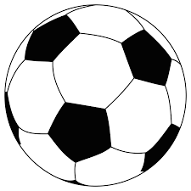  Task Card A | 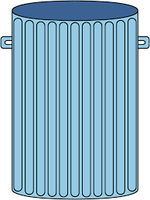  Task Card B
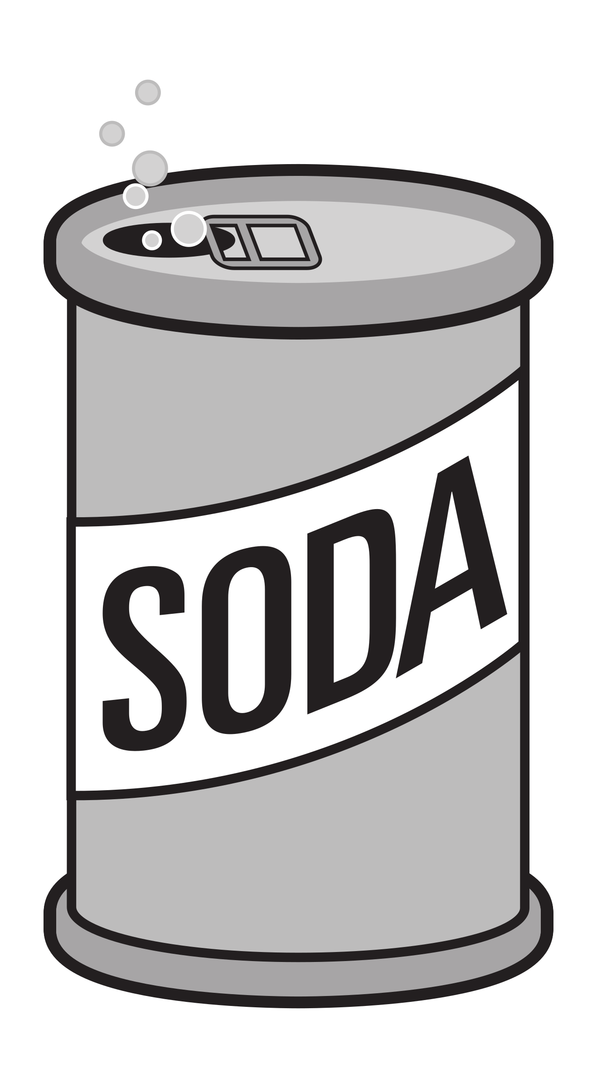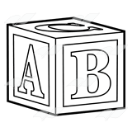  Task Card C | 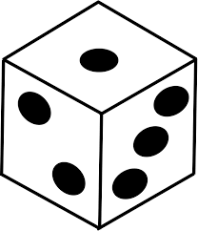  Task Card D

